Tuesday 22nd September 2026

Dear Parents and Carers,

RE: Ashmole Primary School Scholastic Book Fair October 2026

We are very excited to have our Book Fair arriving back at our school at the beginning of October. Come along, have a browse, see if there are any books that you would like to buy and celebrate reading at Ashmole Primary!
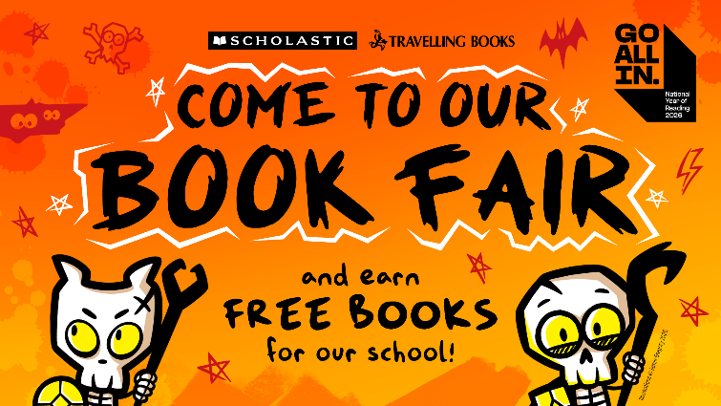
WHEN:
FRIDAY 2ND – WEDNESDAY 7TH OCTOBER

WHERE:
ASHMOLE PRIMARY SCHOOL HALL

TIME:
8:30am-9:00am and 3:30pm-4.00pm

There are over 200 titles for you and your child to choose from and with prices starting from only £2.99, there is sure to be a book for everyone.
Our event will be cashless and payments will be taken via a PayPal app. There will also be QR Codes available for you to pay as well. You are also able to pay online via this link: https://bookfairs.scholastic.co.uk/pay/1437475
Every book that you buy can help us to earn rewards to get FREE BOOKS for our school libraries! To date Ashmole Primary has received over £2,500 worth of free books – all thanks to you! We look forward to seeing you at the Book Fair!
Kind regards,
Mr Evaghoras
Literacy Lead

