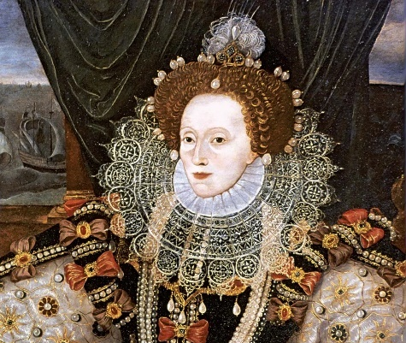
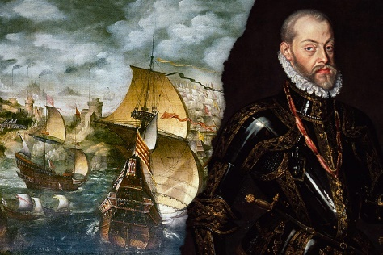
PE: We will cover sporting activities such as:
- Gymnastics – Matching & Mirroring
- Gymnastics – Creating Sequences
- Invasion Games: Dodgeball
- OAA - Orienteering

Games – Invasion - Hockey

D&T:
This term, we will be designing and crafting our own Tudor-style money pouches. We will develop skills of threading needles and joining textiles using a range of stitches.

RE:
We will be exploring the Big Question – What is real?
We will begin thinking about different beliefs about God or a higher being and how it is perceived. We will also be sharing our religious beliefs or worldviews.
Geography:

As geographers, our investigations are all based around the big question: What difference has 500 years made to Docklands? Where we will be exploring areas to explain:
- Where are London Docklands?
- How can we describe London Docklands?
- What did the area use to look like?
- How has it changed over time?
- How can we present the changes in data?

Art:
As artists, we will be investigating the work of portrait artists. The pupils will be using different techniques to draw portraits of historical figures such as Queen Elizabeth I and Sir Francis Drake - working from a variety of resources!

Music:
As musicians we will be lucky enough to study a new instrument and learn how to perform a range of musical pieces on the African Drums.

Science:
As scientists, we will be studying the topic of Electricity. We will explore how to associate the brightness of a lamp or volume of a buzzer with the number and voltage of cells in a circuit; give reasons for variations in how component function and recognise symbols in a simple circuit diagram.

The Tudors

History:
As historians, our investigations are all based around the big question: Why was Spain at War with the Tudors? We will take a journey back in time to find out:
- When and who were the Tudors?
- Where did they go?
- Who won the conflict with the Spanish? How?

In Computing, we will be focusing on the topics of:
- We are Toy Makers
We will design and develop a BBC micro:bit
powered modification to a soft toy to make the toy
interactive. We will learn how computers use programs to connect inputs and outputs. We will also plan and break down complex projects, design and evaluate solutions, work with physical components, and create programs for embedded systems.

In PSHE our topics will be:
- Me and my Relationships
Where the children will learn about relationships and respecting the views of other beliefs and cultures.
- Valuing Difference
Where the children will reflect on and give reasons for why some people show prejudiced behaviour and sometimes bully for this reason.
The children will learn about relationships and respecting the views of other beliefs and cultures.
Literacy:
We will be looking at thee works of various authors such as:
- Anthony Horowitz
- Michael Morpurgo
- Roald Dahl
To further develop to necessary skills and techniques for writing graphic novels and short stories in the style of significant children’s authors.

We will also be focusing on how to:
- Write diary entries
- Draft clear instructions
- Lay out formal letters
- Plan and create biographies
This term you can help your child at home by:

- Looking at maps of the world, discussing the similarities and differences between countries, including physical features, climate and population.
- Researching the Victorian Era and the Industrial Revolution
- Allowing children to use ‘Swiggle to search for relevant information on the internet whilst being aware of e-safety.
- Learning your times table to x12 and the related division facts -rapid recall fact, prime, cubed and squared numbers.
- Linking Maths concepts to everyday life by solving problems using the four operations (+, -, x, ÷.)
- Identifying different coins and notes and allowing children to become familiar with money by paying for items, counting out money boxes and calculating change.
- Encouraging your child to tell the time using both digital and analogue clocks.
In our Maths lessons, we will learn how to:

- Read, write, order and compare numbers up to 10 000 000 and determine the value of each digit
- Round any whole number to a required degree of accuracy
- Solve number and practical problems that involve all of the above
- Securing number facts, understanding shape, relationships and calculating
- Identify the value of each digit in numbers given to three decimal places and multiply and divide numbers by 10, 100, 1000.
- Use, read write and convert between standard units, converting measurements of length, mass and volume
- Solve problems involving the calculation and conversion of units of measure, using decimal notation up to three decimal places where appropriate.
- Calculating, measuring and understanding shape
- Multiply multi-digit numbers up to 4 digits by a two-digit whole number using the formal written method of long multiplication
- Multiply one-digit numbers with up to two decimal places by whole numbers
- Divide numbers up to 4 digits by a two-digit whole number using the formal written method of short division, and interpret remainders as a whole number, remainders, fractions, or by rounding, as appropriate for the context
- Use written division methods in cases where the answer has up to two decimal places

