
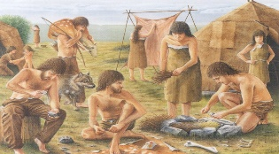
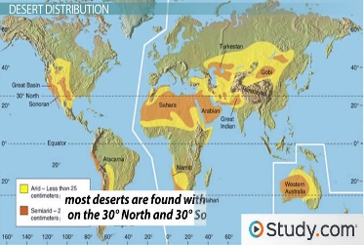

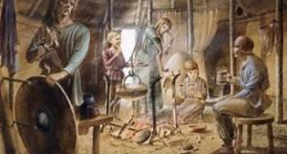
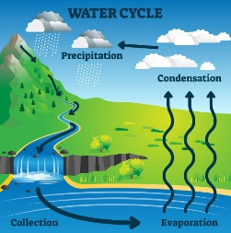
As design technologists, we will be introducing the use of electrical components in our Design and Technology lessons. The children will learn about the different parts in an electrical circuit and experiment with creating their own complete circuits to make a torch.

As scientists, we will be developing Scientific Enquiry skills. Children will be learning to:

Ask relevant questions and use different types of enquiry to find answers. They will be carrying out simple practical tests and fair comparisons.

They will be making careful observations and take accurate measurements using tools like thermometers and data loggers.
Children will use scientific language and create charts and tables to record findings.
YEAR 3 Autumn Term
Curriculum
Overview
In RE we will be learning about:
This term, children will be learning about big questions like “What is real?” and “What exists?”. They’ll explore the idea of angels in Christian stories and one other religion, learning how different people understand them. Using new words like angel, divine being, and ethereal, children will reflect on whether things we can’t see—like angels or God—might still be real.
.

As historians, the children will be ordering events in history and interpreting historical sources to build an overview of world history in the Prehistoric times. They will be learning about the Stone Age, Bronze Age and Iron Age, making comparisons to modern day life and describing the changes and consequences between these periods of time.
As geographers, Children will locate, identify and describe different biomes around the world. They will also explore why different biomes are important and what they provide for the animals and plants that live there. Children will be using subject-specific vocabulary alongside their locational knowledge.

As artists, we will be exploring Stone Age Art by observing different cave paintings in order to create our own Stone Age picture using a variety of techniques and textures. We will be experimenting with different grades of pencils to sketch animals from the Stone Age period.

In Spanish we will be learning about:
This term, children will begin their Spanish journey by learning key greetings, how to introduce themselves, numbers 1–10 and colours. They will also explore Spain and other Spanish-speaking countries, while developing their speaking, listening and pronunciation skills.
This term you can help your child at home by –
- Providing a range of books or resources from the internet that support our theme
- Encouraging your child to be responsible for organising their belongings to support their learning
- Reading regularly at home in order to develop fluency, expression and the enthusiasm for reading

In Music, we will be looking at rhythm, pulse and tempo of music through the song Let your spirit Fly. The children will also be learning to play the glockenspiel.

In Computing, our topic will be ‘We Are Programmers’ where the children will have the opportunity to carry out simple programming to create a short, basic animation.

In PE
Dance - We will be learning to respond to different stimuli and to learn a variety of dance skills and vocabulary.
Gymnastics – The focus of the learning is to apply 'excellent gymnastics' when exploring movements and balances in unison.
Games – We will be learning new skills to play hockey and tennis

In our daily Maths lessons we will be focussing on becoming masters of our curriculum by:
- Using a variety of resources and strategies to become confident at our knowledge of the place value of numbers 100 and 1000
- Developing our skills at estimating, reasoning and problem solving.
- Using mental and written strategies to complete calculations using +, -, x and ÷
- Being able to confidently add and subtract multiples of 1, 10 and 100.
- Adding and subtracting 3-digit numbers using mental and formal written methods.
- Learning different strategies to multiply and divide by 2, 3, 4 and 8.

In our daily English lessons we will be focussing on becoming masters of our curriculum by:
- Spelling with increasing accuracy
- Learning patterns within words, spelling rules and some exceptions to these
- The correct use of punctuation such as ., ? ! … : ; “”
- Developing and applying adventurous vocabulary and sentence openers
- Varying sentence structure with the use of conjunctions, adverbs and prepositions
- Writing for a given purpose relating to the theme: e.g. , instructional writing; creative story writing; diary entries, explanation texts, playscripts and persuasive letters
- Considering the narrative, setting, and purpose of our writing in order to engage the reader

In PSHE, our themes Me and my Relationships and Valuing Difference.
The children will be learning about cooperation and what it means to be cooperative. They will also be finding out about caring and respectful relationships. In the Valuing Difference topic, the children will learn to recognise and respect diversity as well as learning how to be respectful and tolerant.

