Ashmole Primary School Planning Overview- Autumn Term 2026 – Year 1
Values  As part of our ‘It’s Good to be Me!’ We will continually be celebrating excellent work and showing self-belief by completing more challenging tasks. We will demonstrate responsibility by taking on monitor roles within the classroom. | Main topic  After the October half term, we will each use our ‘Me Box’ to develop our enterprise skills of: self-confidence, team work and sharing.  This term our theme is ‘It’s Good to be Me!’.  ‘’It’s Good to be Me!’ will give all the children the opportunity to learn from a source very personal to themselves (their ‘Me Box’). They will be thinking about and discussing their family life, culture, things that are important to them and things that make them special. | Enrichment  To enrich the curriculum, we will be putting on a nativity performance for parents/carers.  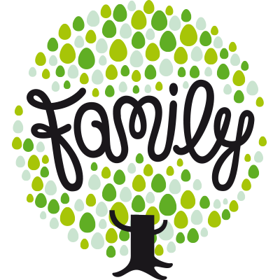

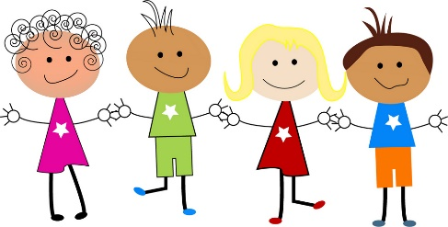
As design technologists our focus is ‘Food’. We will be exploring where foods come from and how different products have been created. We will identify our likes and dislikes through taste testing to design a healthy snack. We will demonstrate skills such as cutting, peeling and grating while following health and safety procedures.

As historians we will be:
investigating and interpreting the past by sequencing events relevant to ourselves. We will be using our ‘Me Box’ to generate vocabulary to communicate history from the time we were born.

investigating our environment by observing seasons throughout the year and sharing our ideas. We will also be looking closely at the changes to animals and plants. Linking into our theme, we will be exploring the four seasons and the changes that occur during each season. We will be investigating the differences that we see in the UK and finally we will investigate how to measure rainful.

As scientists will be:

As geographers we will be:
Learning about the world, looking closely at the seven contents and five oceans, the North and South Poles by exploring atlas’ and globes. We will be looking at different forms of locations and geographical features around the world such as rainforest and deserts.

we will be:

As artists we will be:
be creating self-portraits, focusing on adding detail to different parts of our face. We will explore using different types of paint and the identifying the different textures and effects we can create. We will also practise our ability to control a paintbrush and to mix paint colours.

