Reception Curriculum Overview 2026-2027 *Development Matters Framework

 | Autumn 1 | Autumn 2 | Spring 1 | Spring 2 | Summer 1 | Summer 2
 | Topic  Ourselves & Our Families  Seasonal Changes  Autumn | Topic  Celebrations & Festivals  Light & Dark  Seasonal Changes  Autumn/Winter | Topic  Food  Seasonal Changes  Winter | Topic  People Who Help Us  Seasonal Changes  Winter/Spring | Topic  Animals & Habitats  Seasonal Changes  Spring/Summer | Topic  Our World  The Next Step  Seasonal Changes  Summer
 | Core Texts  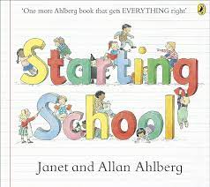  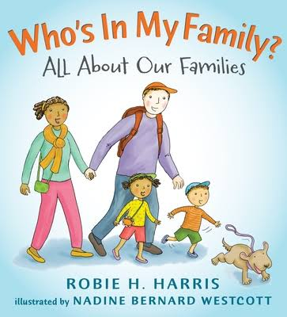  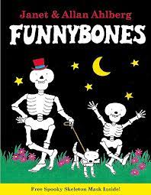  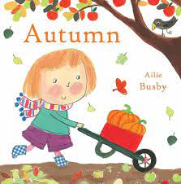 | Core Texts  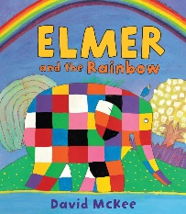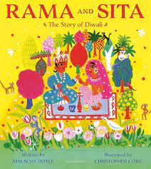  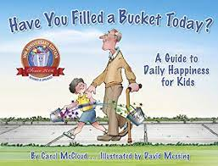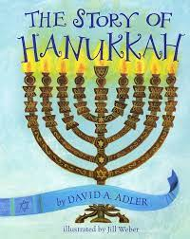  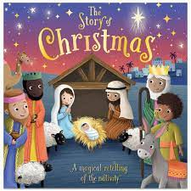 | Core Texts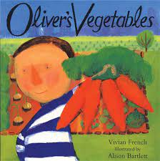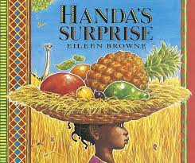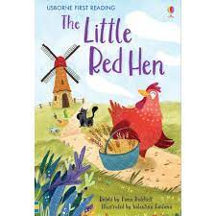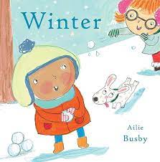 | Core Texts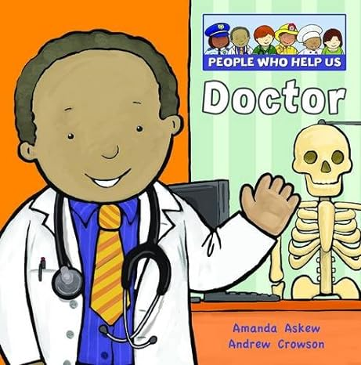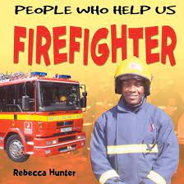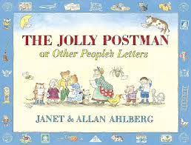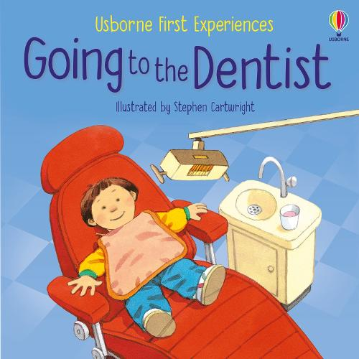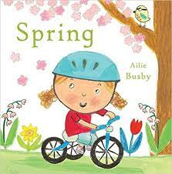 | Core Texts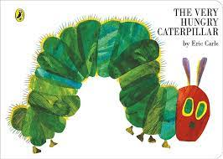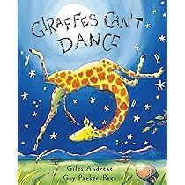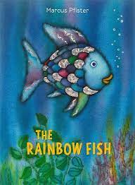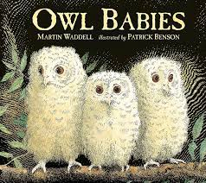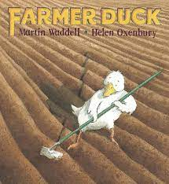 | Core Texts  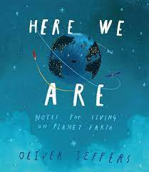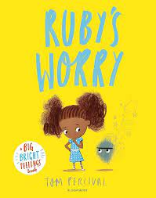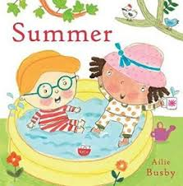
Key Vocabulary | - Myself  - Friendship  - Family  - Relatives  - Similarity Differences | - Shadows  - Light source  - Celebrations  - Religion  - Culture | - Wheat  - Crops  - Continent  - Africa  - Globe  - Atlas  - Soil  - Food groups  - Fruit  - Vegetables | - Occupation  - Letter  - Envelope  - Stethoscope  - Medicine  - Fire extinguisher | - Habitat  - Life cycle  - Growth  - Ocean  - Similarity  - Differences | - Transition  - Explore  - Adventures  - Discover  - Feelings
Personal, Social, Emotional Development  - Self - Regulation  - Managing Self  - Building Relationships  - PSHE - Scarf | Settling into a new environment.  Increasingly follow school rules and routines.  Becoming more outgoing with unfamiliar people, in the safe context of their setting.  Selecting and using activities and resources in the classroom and outdoor environment.  Building friendships.  Playing with one or more other children.  PSHE (SCARF) - Me and My Relationships | Expressing their feelings.  Becoming familiar with the ‘Zones of Regulation’.  Building constructive and respectful relationships with adults and peers.  Developing the ability to see themselves as a valuable individual.  PSHE (SCARF) - Valuing Difference | Continuing to follow school routines and introduce new routines into the school day e.g. merit assembly.  Considering the feelings of others.  Identifying and moderating their own feelings socially and emotionally.  PSHE (SCARF) - Being my Best | Thinking about the perspective of others.  Knowing and talking about different factors that support their overall health and well-being:  *physical activity  *healthy eating  *toothbrushing  *being a safe pedestrian  *having a good sleep routine  *sensible amounts of screen time  PSHE (SCARF) - Keeping Myself  Safe | Managing their own needs.  PSHE (SCARF) - Rights and  Responsibilities | Showing resilience and perseverance in the face of challenge.  PSHE (SCARF) - Growing and  Changing
Physical Development  - Gross Motor  - Fine Motor  - PE - Complete PE  Our continuous and enhanced provision provides the children with many opportunities to develop their gross and fine motor skills daily) | Using large muscle movements to wave flags and streamers, paint and make marks.  Exploring mark-making.  Revising & refining movement skills already acquired.  Developing good personal hygiene. | Being able to manage the full school day successfully.  Using core muscle strength to be able to sit on the carpet or at a table.  Exploring a range of tools e.g. paintbrushes, pencils, tweezers, scissors to develop fine motor control.  To begin to use a tripod grip. | Being increasingly independent when getting dressed e.g. for PE and when putting on a coat.  Confidently and safely using a range of large and small apparatus.  Developing letter formation (PenPals)  PE: Gymnastics - High, Low, Under, Over | Developing balance, coordination and agility.  Combining different movements with ease and fluency.  PE: Dance - Ourselves | Developing a range of ball skills including: throwing, catching, kicking, passing, batting and aiming.  Developing the foundations of a handwriting style which is fast, accurate and efficient.  PE: Ball Skills - Hands | Developing confidence, competence, precision and accuracy when engaging in activities that involve a ball.  PE: Ball Skills - Feet and Sports Day
Communication and Language  - Listening, Attention and Understanding  - Speaking | Statutory Baseline Assessment  Listening carefully to others.  Starting a conversation with an adult or a friend and continuing it for many turns.  Using new vocabulary.  Modelling and developing social phrases.  Focusing attention.  Understanding a question or instruction that has two parts. | Learning new vocabulary and using it.  Asking questions to find out more.  Engaging in story times and nonfiction books. | Learning why listening is important.  Using new vocabulary in different contexts.  Listening to and talking about stories to build familiarity & understanding.  Retelling familiar stories. | Articulating ideas and thoughts in well-formed sentences.  Using talk to help work out problems, organise thoughts and activities, and to explain how things work and why they might happen. | Describing events that have happened in some detail.  Listening to and talking about non-fiction.  Developing familiarity with new knowledge and vocabulary from non-fiction texts. | Learning rhymes, poems and songs.  Using connectives to connect ideas and actions together.
Literacy  - Comprehension  - Word Reading  - Writing  Phonics is taught daily using the Little Wandle Revised Letters and Sounds Scheme.  Each week, children will work on a 1-1 basis or in a small group to use their sounds to write about topic learning. | Phase 1:  Listening for sounds in the environment  Rhyming  Chunks of sounds  Phase 2 Sounds: s, a, t, p, i, n, m, d, g, o, c, k  Phase 2 Tricky Words: I, is  Recognising words with the same initial sound.  Saying sounds for individual letters.  Writing name.  Writing some letters accurately.  Engaging in extended conversations and learning new vocabulary. | Phase 2 Sounds: ck, e, u, r, h, b, f, l, ff, ll, ss, j, v, w, x, y, z, qu, ch, sh, th, ng, nk  Phase 2 Tricky Words: the, put, pull, full, as, and, has, his, her, go, no, to, into, she, he, of, push  Orally blending segments of sounds.  Beginning to segment and blend learned sounds to read simple CVC words.  Beginning to form recognisable letters.  Recognising and reading common exception words. | Phase 3 Sounds: ai, ee, igh, oa, oo, oo, ar, or, ur, ow, oi, ear, air, er  Phase 3 Tricky Words: was, you, they, my, by, all, are, sure, pure  Identifying letter groups (digraphs/trigraphs) and saying the sound.  Segmenting and blending sounds to be able to read short words.  Recognising and reading common exception words.  Spelling words by identifying the sounds and then writing the sounds with letters. | Reading simple phrases and sentences made up of words with known letter sound correspondences and a few exception words.  Forming lowercase and capital letters correctly. | Phase 4 Tricky Words: said, so, have, like, some, come, love, do, were, here, little, says, one, there, when, what, out, today  Re-reading books to build up confidence in word reading, fluency and understanding and enjoyment.  Writing short sentences that include words with known sound letter correspondences using a capital letter and full stop. | Re-reading what they have written to check that it makes sense.
Maths  - Number  - Numerical Patterns | Statutory Baseline Assessment  Counting to 10  Making amounts  Counting and matching  Numicon introduction  2D shapes and properties  Repeating patterns | Comparing numbers  One more than  One less than  Adding two groups together  3D shapes and properties  Days of the week  Routines  Capacity | Counting to 20  Estimating  Addition  Subtraction (less, fewer)  Length  Weight  Time | Missing numbers  Subitising  Counting in 2’s  2 more than  2 less than  Money  Number bonds  Subtraction  2D and 3D shapes - composing and decomposing | Subitising  Doubling  Halving  Sharing  Counting in 5’s  Counting in 10’s  Positional language  Subtraction - counting back | Counting to 30  Money  Graphs - pictograms, tally charts, bar charts
Understanding the World  - Past & Present  - People, Culture & Communities  - The Natural World | Zones of Regulation  Black History Month  Developing positive attitudes about the differences between people; celebrating diversity in our class.  Talking about members of our immediate family and our community.  Describing what we see, hear and feel whilst outside and in different environments.  RE - ‘What is Real’ | Guy Fawkes  Remembrance Day  Diwali  Comparing & contrasting characters from stories, including figures from the past.  Celebrating diversity in religion by recognising that people have different beliefs & celebrate special times in different ways.  Understanding that some places are special to members of our community.  RE – ‘Where do we come from?’ | Chinese New Year  Food (Balanced diet, fruit and vegetables from around the world)  Recognising some similarities and differences between life in this country and life in other countries.  Exploring the natural world around us.  Understanding the effect of changing seasons on the natural world.  RE – ‘How do we know?’ | People who help us  Naming and describing people who are familiar.  RE – ‘What do we know?’ | Life cycles & Habitats  Beginning to recognise some environments that are different to the one in which we live.  RE – ‘What is our goal?’ | Our world  Drawing information from a simple map  Commenting on images of familiar situations in the past.  RE – ‘How do we get there?’
Expressive Arts and Design  - Creating with Materials  - Being Imaginative & Expressive | Making imaginative and complex ‘small worlds’ with blocks and construction kits.  Drawing with increasing complexity and detail.  Exploring different materials freely.  Listening with increased attention to sounds.  Exploring and engaging in dance. | Developing storylines in pretend play.  Singing in a group; increasingly matching the pitch & following the melody.  Performing in a group. | Exploring, using and refining a variety of artistic effects to express their ideas and feelings.  Creating collaboratively, sharing ideas, resources and skills. | Returning to and building on previous learning, refining ideas and developing an ability to represent them.  Exploring and engaging in music making. | Listening attentively, moving to and talking about music, expressing feelings and responses. | Watching and talking about dance and performance art, expressing their feelings and responses.
Themed Weeks | Bike to School Week  Black History Month | Anti-bullying Week | RE Week  Computing Week  Children’s Mental Health Week  Performing Arts Week | Book Week  Science Week  Humanities Week | Walk to School Week  Maths Week | Art / DT Week  International Week  Sports Week
Visitors & Trips | (Home Visits) | Church  Pantomime |  | Postbox  Visits from doctors, police officers etc | Butterflies | Hertfordshire Zoo
Parent Events  Focus meetings to take place each week. | ‘Meet the Teacher’  Curriculum Evening  Phonics Workshop |  | Phonics workshop | Parents Evening | Reception Assembly | Open Evening

