In RE we will be learning about:
What major religions teach us about our goals in life and how our personal values are instilled in us. This is done through the stories of Adam and Eve, Rama and Sita and Hanukkah, and exploring the conquest of good over evil. We also take a trip to an Orthodox Cathedral and uncover the beauty of this ancient religion.

Roman landscapes and Volcanoes!
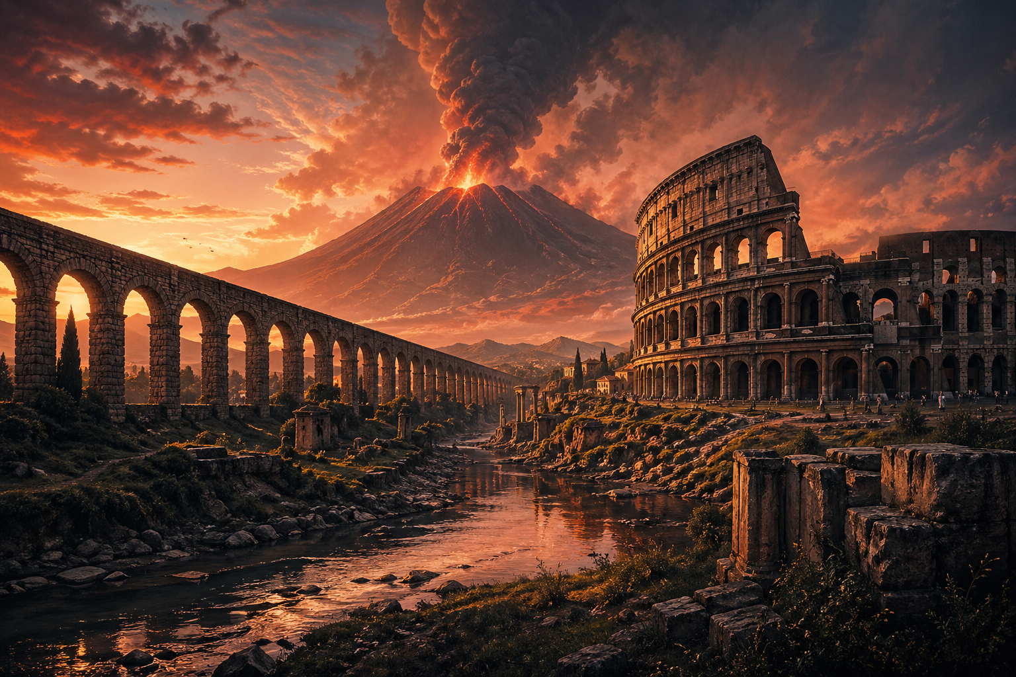
As design technologists we will be learning about:
The crafting skill of sewing! The children will get to practice their stitching whilst designing a bespoke personalised bookmark all jazzed up with their initials and individual design.
As scientists, we will be learning about;
“Sound” - the children will be exploring sound and how sounds are made. How sounds travel through a medium to the ear, we’ll find out how we can insulate and amplify sound and what the terms volume and pitch mean. They’ll also be focussing on the complexity of the inner workings of the human ear!
“Electricity” – the children will learn all about electrical safety, components in a circuit, explore conductors and insulators, learn about switches and then have a chance to apply their knowledge by making their very own circuits – crocodile clips and battery packs at the ready!

As artists we will be learning about:
The amazing artwork of two great artists who specialise in “mono-printing”; Yayoi Kusama and M.C. Escher. They will inspire the children when making their own prints using a variety of colours and methods.
As geographers we will be learning about:
The super power known as Volcanoes! Looming over any backdrop and commanding attention our studies of volcanoes covers magma, chambers, lava spouts, ash clouds and instant vaporisation as we delve deeply in to these amazing forces of nature – proving what a ‘hot’ topic they really are.
As historians we will be learning about:
Our focus ranges from the changes the Roman expansion had on our landscape here in our very own native Britain, the importance of road building and how it helped more their army quickly and efficiently, how their cities were laid out, how they watered their vast farms with aqueducts, why they built amphitheatres and what happened in them like naval battles and gladiator fights to what evidence of these innovations are left today as proof that the Romans were truly skilled master builders.
This term our theme is ‘Roman Landscapes and Volcanoes’. We will be learning about how the Romans changed the landscape around us forever with their architecture, innovation and skill further ‘cementing’ their legacy on our lives today. We will then be turning our attention to the devastating yet awe inspiring power of Volcanoes, and how these natural disasters impact on the environment and communities, both in the past and today.

In Music, we will be listening to and appraising a piece of music, and this time our attention turns to the classic song Blackbird by the Beatles!
In Computing we will be looking at the IT skills of designing in our topic “we are artists” and the use of hardware in the topic “we are meteorologists”.

In our daily English lessons, we will be focusing on becoming masters of our curriculum by:
-Continuing to discretely learn spelling patterns and rules to spell with accuracy.
-Continuing to use relevant punctuation correctly frequently in writing such as ., ? ! … : ; “”
-Confidently and independently applying a variety of techniques such as similes, metaphors, personification and alliteration.
-Extending sentences successfully using conjunctions, time connectives, prepositions and adverbs.
-Selecting appropriate writing techniques that are relevant for different writing styles in order to engage the reader, e.g. how to create an adventure story.
-Developing editing skills so that the children can reflect on their writing.
-The children will be writing our very own mystery stories and non-chronological reports all about volcanoes!!

In P.E the children will be focusing on the following:
Athletics – the children will be exposed to a range of track and field events with a focus on running techniques.
Invasion and strategy games – the children will get a chance to use their brains as well as their brawn to complete challenges and to work as a team rather than as individuals!

In PSHE (Personal, Social, Health Education), our first theme to help the children develop their own moral compass will be Being My Best, where the children will cover topics such as ‘what makes me, me’, ‘making choices’ and the essential skill of basic first aid. Keenly followed by our second topic of Growing and Changing, where some of the topics include ‘your feelings’, ‘togetherness’ and providing skills to deal with all the commotion surrounding ‘moving house’!!
This term you can help your child at home by:
- Continuing to read with your child daily, reading to your child and discussing the text together with a particular focus on inference and summarising ensuring your child understands what they are reading.
- Continuing to support your child in learning ALL their multiplication tables and practising the corresponding division facts. The times table booklet sent home will support you with these.
- Letting your child experience maths in practical ways such as:
- Asking them the time and looking at time intervals using TV schedules;
- Letting them handle coins and use them correctly in shops including checking their change;
- Letting them measure out amounts when you are cooking;
- Looking at time tables to work out journey times; and
- Looking at Roman Numerals and converting them into numbers we use today

In our daily Maths lessons, we will be building our knowledge of the following:
Decimals, including dividing a one-digit number by ten to make tenths and comparing and ordering decimals too. Money, by looking at how to convert between pounds and pence and vice versa, how to estimate with money and solving problems with money. Time, covering topics such as converting from analogue to digital time, questions on days, weeks and months and converting to and from the 24hr clock. Shape, covering everything from triangles to dodecahedrons, as well as lines of symmetry. Statistics, where they will be interpreting charts and drawing line graphs. Position and direction, where we will be plotting coordinates on maps!

