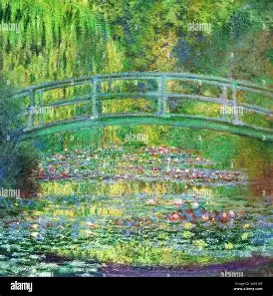
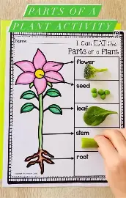
As scientists, children will explore two exciting topics: Plants and Light.
In the Plants unit, they will learn about the different parts of flowering plants and their functions, what plants need to grow, how water is transported, and how plants reproduce through pollination and seed dispersal. This builds on their learning from earlier years.
In the Light unit, children will learn how we see, understand that light reflects from surfaces, and explore how shadows form and change, as well as how to stay safe in sunlight. They will develop their scientific enquiry skills through observing and investigating.

In humanities we will be learning about:
Our Blue Planet, exploring oceans, rivers and the water cycle, as well as how these environments are changing and how we can help protect our world.
Children will also study Italy, answering key questions such as Where is Italy? What is the climate like? What volcanoes are found there? and why is Venice sinking? They will also learn about Italian food and tourism.
This learning will help children develop their understanding of the wider world and build key geographical skills.
YEAR 3 Summer Term
Curriculum
Overview


In Music, we will be learning how to play the ukulele and we will be working together to put on a performance which you will all be invited to.

In RE this term, children will explore what different religions and worldviews teach about what is good, right and valuable. They will consider questions such as What is good and evil? What should we strive for? and Where are we going in life?, while reflecting on their own values and learning to respect the views of others.
As artists, children will explore river landscapes inspired by Claude Monet, using colour, light and brush techniques to create their own paintings while developing key skills in colour mixing and evaluation.
As design technologists, they will design and make their own pizza box packaging, exploring frame structures and developing skills in measuring, assembling and evaluating, linked to our Italy topic.
This term you can help your child at home by:
- Providing a range of books or resources from the internet that support our theme
- Encouraging your child to be responsible for organising their belongings to support their learning
- Completing everyday maths activities such as telling the time, paying for items in a shop, weighing ingredients when cooking and estimating quantities
- Reading regularly at home in order to develop fluency, expression and the enthusiasm for reading
- Allowing your child to ‘navigate’ on journeys, giving them access to maps and encouraging the use of landmarks and directional language.
- Supporting your child in learning their times tables.

In Computing, the children will develop their data collection and presenting skills in the topics of We Are Communicators and We Are Opinion Pollsters. They will become more confident using e-mails to communicate and will design and create their own opinion polls.

In PE this term, children will build on previously learned skills while developing new ones through games, problem-solving activities and the use of different equipment. They will take part in Outdoor Adventure Activities, focusing on teamwork and problem solving, as well as Athletics, developing their running skills, speed and coordination.

In our daily Maths lessons, we will be focussing on becoming masters of our curriculum by:
- Using mental and written strategies to complete calculations using +, -, x and ÷
- Developing our ability to solve worded problems and investigating problems in real life
- Continue learning multiplication tables 2, 5, 10, 3, 4 and 8.
- Fractions - Adding and subtracting fractions. Finding fractions of amounts
- Money – recognising and converting pounds and pence. Adding and subtracting amounts and calculating change.
- Time – Recognising roman numerals, telling the time to the nearest 5 minutes. Working out time intervals and solving problems
- Shape – Naming and describing the properties of 2D and 3D shapes. Comparing angles and different types of lines
- Statistics – Interpreting pictograms and bar charts. Collecting and representing data.

In our daily English lessons, we will be focussing on becoming masters of our curriculum by:
- Spelling with increasing accuracy
- Learning patterns within words, spelling rules and some exceptions to these
- The correct use of punctuation such as:, ? ! … : ; “”
- Developing and applying adventurous vocabulary and sentence openers
- Varying sentence structure with the use of conjunctions, adverbs and prepositions
- Writing for a given purpose relating to the theme: e.g book review, formal letter, instructions, explanation text, character description and adventure story.
- Considering the narrative, setting, and purpose of our writing in order to engage the reader

In PSHE, our themes will be Being My Best and Growing and Changing. The children will be learning about types of food we can eat to stay healthy. We will also be finding out how we can celebrate and be proud of our own achievements and see ourselves as the fantastic people that we are. An important part of this topic is also learning about team work and how to work well with our peers and those around us. We will be learning about healthy relationships and also some basic first aid.

