As artists, we will be exploring weather through creative design by making our own weather dioramas in a shoebox. Children will use a range of materials, including clay, to create figures and features that represent different types of weather. They will carefully choose and mix paint colours to match the mood and appearance of their chosen weather, such as sunny, rainy, stormy, or snowy scenes. Through this, we will develop our modelling and painting skills while expressing ideas about the natural world.
As geographers, we will be using a variety of different maps to locate differing climate zones and different weather types. We will then be learning about how weather changes in different seasons and how this can be measured by meteorologists. We will then be exploring life in Africa. Learning all about location and comparing different African countries throughout the continent and using this to identify similarities to our lifestyle in the UK.

In RE, we will be exploring what different religions and worldviews teach about what is good, what has value, and what the ultimate goal in life might be. We will begin this topic with a visit to a Sikh temple, where we will learn about Sikh beliefs and practices. Throughout the unit, we will consider important questions such as: What is the goal (the good) that people should strive for? What do different traditions teach about ‘good’ and ‘evil’? and Where are we, or should we, be heading in life? We will share ideas and reflect on how these beliefs may influence the way people live their lives.
As scientists, we will continue to learn about habitats, learning how to identify that most living things live in habitats to which they are suited and describe how different habitats provide for the basic needs of different kinds of animals and plants. We will then explore the life cycle of a human and the growth we undertake as we age. Describing the basic needs of animals and humans.
Habitats of the world
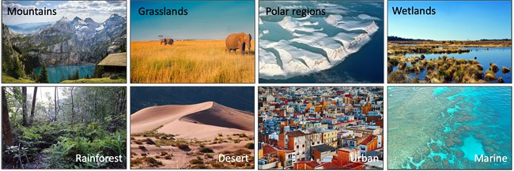
As design technologists, we will be exploring healthy eating and learning about the importance of “eating a rainbow.” We will investigate different fruits and vegetables, looking at their colours and the benefits they have for our bodies. We will design and create our own healthy food plates using a variety of ingredients, thinking carefully about balance and nutrition. We will then evaluate our final creations, reflecting on our choices and what we have learned about making healthy food choices.
This term our theme is ‘Habitats of the world’ We will be looking at the importance of weather and how different animals are adapted to survive in varying weather conditions. In Geography, we will be learning about climate zones and weather investigating why these countries have differencing weather conditions and how this effects lifestyles.
As musicians we will be identifying and controlling changes in pitch and creating short melodic patterns.
In Computing, we will be focusing on the topics ‘We are Animators’ and ‘We are Zoologists. We will be learning about stop- motion animation. We will learn to plan, film and add audio to our own stop motion film. We will also learn how to create spreadsheets and present date in graphs.
In PSHE, we will continue to focus on ‘Health and Wellbeing’ and Growing and Changing. The children will learn about being our best and also understanding how to keep ourselves clean and healthy. Through our topic ‘Growing and changing’ the children will learn about what our body does for us and how it grows and changes.
In our daily Maths lessons, we will be focussing on:
- Place value and ordering of numbers up to 100.
- Practising addition, subtraction, multiplication and division skills.
- Interpreting and constructing graphs
- Asking and answering questions about statistical data.
- Counting, partitioning and calculating.
- Understanding and using mathematical
- symbols e.g. +, -, x, ÷
- Investigating fractions- identifying halves, quarters and thirds
- Telling the time, identifying the hour and telling time to the nearest 5 minutes
- Mental calculation strategies and problem solving.

- .

This term you can help your child at home by –
• Encouraging a curiosity about things that live in the seas and oceans.
• Looking at maps of the world and discussing the features and characteristics of the continents and locating the different seas and oceans.
• Researching and locating information about the world from a range of sources.
• Allowing children to use ‘Ask Kids’ to search for relevant information on the internet.
• Playing games that involve sending and receiving skills.
• Linking Maths concepts to everyday life by solving problems using the four operations (e.g. +, -, x, ÷.)
• Identifying different coins and notes and allowing children to become familiar with money by paying for items, counting out money boxes and calculating change.
• Encouraging your child to tell the time using both digital and analogue clocks. Focussing on how to solve time problems, related to different time intervals.
In our daily English lessons, we will be focussing on becoming masters of our curriculum by:
- Practising the correct formation of cursive script handwriting.
- Using and developing a range of grammar skills to support writing.
- Writing postcards and diary entries based on the book Meerkat Mail.
- Writing stories based on the style of a familiar author.
- Learning a range of poems to perform and writing their own acrostic, haiku and shape poems.
- To plan and write letters

