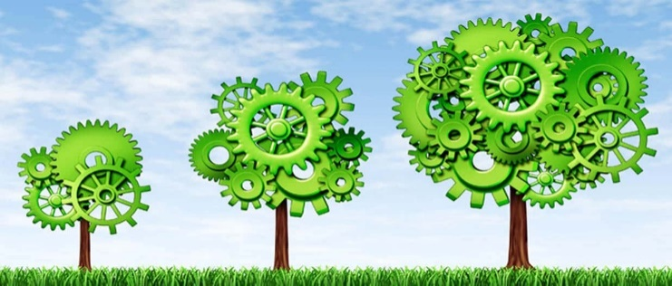
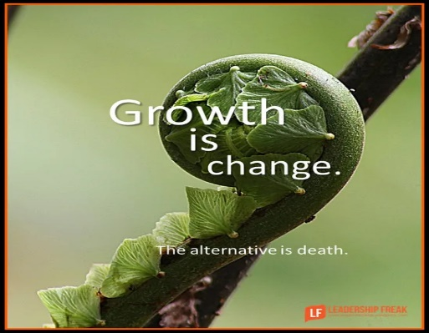
In RE we are going to be understanding what different religions and worldviews teach about what is good, of worth or value, and the ultimate goal that individuals should aim for. We will discuss what is meant by ‘good’ and ‘bad’ and the children will be encourage to reflect on their own moral decision making by looking at their own values and goals.
As artists, we will be learning all about the process of papier Mache. We will create our own papier Mache fruits linking to the fruits in the hungry caterpillar. Children will learn the process of papier Mache and will be looking closely at the colours and materials used. Children will also discuss how the fruits have grown and how the papier Mache changes over the process.
As historians, we will be looking closely at how the local area has changed from the past and comparing it with the present day. We will discuss how features have changed and evaluate how and if the changes have made the world a better place. We will be discussing the timeline of the local area and referring to specific years where features have been implemented or change has taken place.

This term our theme is ‘Growth and change.’ The children in Year 1 will begin the term looking at how the local area has changed since the past and exploring how plants grow. We will be comparing how features of houses have changed over time. Children will not only be studying different artefacts, they will also experience a Victorian house from the past. The children will look closely at how plants grow and will be actively growing and investigating the life cycle of their own plant. We will be looking after our own ducks and discussing their growth and how they change. The children will be creating animal hand puppets and fruit papier Mache linking into learning.

As scientists, we will begin to learn about plants and animals. Discussing different classifications of animals and will look closely at their features. We will then investigate the type of foods they eat. We will also become plant detectives and learn to identify the plants that grow in our local environment. Through studying different plants, we will investigate how plants grow and what is needed to keep them strong and healthy. We will continue to observe, identify and name animals around the school at different times of the year. We will also continue to investigate the changes that occur in our local environment.
As geographers, we will be introducing the use of a world map and using it to locate different cities. We will also examine the human and physical features of London and compare them to an island in the Indian Ocean. We will extend this further by studying the seasonal changes in the weather in the two locations.
As design and technologists, we will be designing and creating our own animal puppets. We will be focusing heavily on producing a well-presented final product by measuring, marking, cutting accurately and developing our sewing skills.
In English we will be focusing on –
Using a phonic approach to spelling unfamiliar words and develop word recognition.
Developing and understanding of sentence structure and punctuation, including question and exclamation marks. Writing our own stories. Using imaginative description ( similes , alliterations and adjectives)
Using time connectives ( first , nest , then , after , lastly) and conjunctions (then, but, so and, because, also) in descriptive writing.
Writing recounts factual and non-factual. Looking at poems and writing our own lines and stanzas or poetry.
Handwriting practise and introducing cursive joins.
In Computing, we will be will use GarageBand and Scratch Jr to create our very own music. We will learn how to use an iPad to record our voices and fun sounds. We will also be organising data into tables, which can be sorted and filtered to find information and used to enter data into a database.

In Music, we will be learning to play the recorder and performing a recorder concert for parents at the end. Children will also carry on singing simple songs and learning them from memory while using Charanga.
This term at home you can help your child by –
Hearing your child read and reading to your child every day, discussing your child’s understanding of the story and developing inference skills by asking how and why questions.
Practise writing tricky words specifically in sentences and discussing any spelling patterns together.
Sequencing events in their day, linking this to the time the event is taking place and ensuring a good understanding of being able to say o’clock and half past times on a clock face.
Practise counting in 2’s, 5’s and 10’s aloud and discussing the patterns they see.
Playing shops using 1p,2p,5p,10p, 20p, 50p and £1 coins and become familiar with money.
Discuss and practise correct formation of numbers and letters.
Assessing children’s phonics understanding, recapping trigraphs and unknown digraphs

In PSHE we will be focusing on being my best and growing and changing. We will understand how we can make ourselves the best version and what healthy habits we can take up. We will then move on to how our bodies change and grow as we are becoming more independent. In SRE we will be discussing how people change and grow over time. We will be understanding that there are different types of families and know who we can ask for help. In addition to this we will be learning about basic hygiene.
In Maths we will be focusing on –
Grouping and multiplication groups
Doubling and halving
Number bonds to 20
Understanding and using the operations of +, -, x and ÷ and applying to real life problems
Repeating patters, number sequences and missing numbers
Counting in 2’s, 5’s and 10’s
Telling the time o’clock, half past & quarter past
Solving simple money problems and beginning to give change
Investigating properties of 2D & 3D shapes
Fractions, finding halves and quarters of shapes and groups of objects
Identifying ½ and ¼ of shapes and quantities
Practising using positional language.
Practise using key mathematical vocabulary and reading number sentences in full

