As Geographers, the children will focus on the second element of our theme on the Romans; how did they change our landscape? In this series they can expect to learn about the architectural accomplishments of this amazing civilisation. What their expansion around the globe meant to the countries they conquered, with special focus on their impact on our very own shores here in England – Roman bath anyone?

As Scientists, we will be covering;
Conservation – The children will cover important topics such as the effects of global warming, deforestation and the use of fossil fuels on our environment, and what can we do as a society to reverse these issues? Is recycling and electric cars all we can do to help? Year 4 will be finding out soon!
States of Matter – Solids, liquids and gases will be investigated in this essential topic in Science. They will be able to enjoy experiments on evaporation and condensation, and seeing where different materials boiling, melting and freezing points are!!

As Design technologists, the children will be developing their cooking skills as we will be focusing on food and nutrition. Our D&T topic will link to our Romans theme and the children will be creating their own Roman dish!!
The children will start by researching different kinds of food from that period and evaluating these, before designing and making their own.

In RE we will be learning about:
How do we know? – or Epistemology as it’s more formally known. Discussions over what is ritual and what is belief, as well as what is faith and what is tradition will all be discussed and expanded on in this thought-provoking topic. All working towards the children understanding “where can we find the truth???”!!
As Artists, we will be focusing on portraits. We will be investigating different types of portraits before planning, designing and eventually creating our own. The children will use their knowledge and skills of sketching and painting to create their own paintings of themselves in the style of the famed and lauded Pablo Picasso!
The Romans!
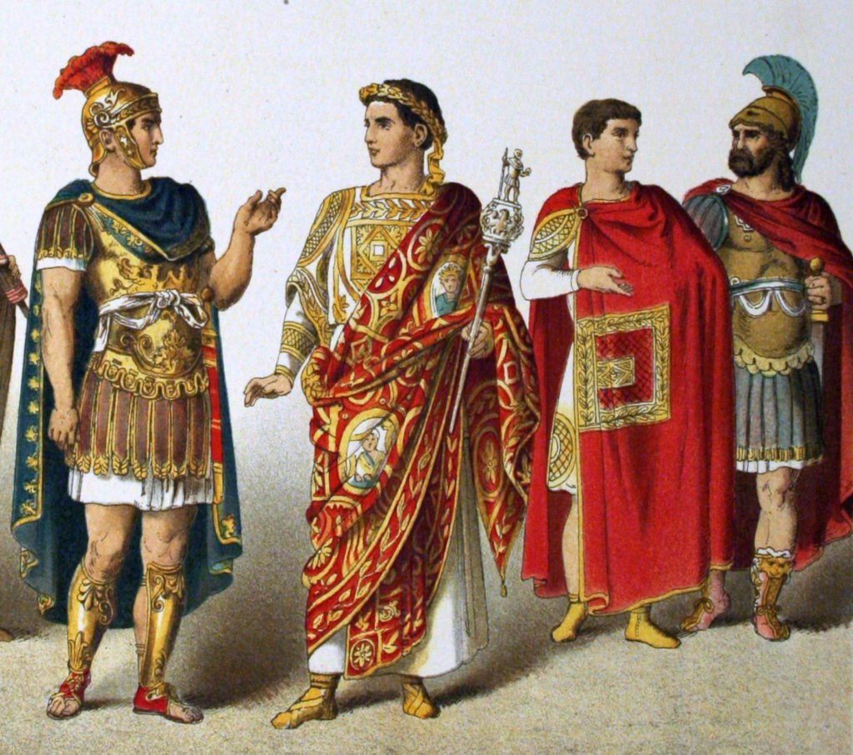
As Historians, we will be investigating and interpreting the past by using primary and secondary sources of evidence to find out about The Romans. We will be using evidence to find out about the past and analysing the impact that past events have had on present day. We will be studying major historical events and thinking about how the results of these impacted our country. During our topic, we will also be thinking about the kind of interesting lives the Romans lived!
This term our theme is ‘The Romans’. Our learning about the Romans will cover two broad themes; who were the Romans? and how did they change our landscape? We will be fully immersing ourselves into the topic by finding out how they lived, what they ate, who was in charge, how big their empire was, how did their empire eventually fall and everything in between!! This topic will be spread throughout our curriculum in all our subjects, for example we will be writing pieces as Emperors in Literacy and drawing self-portraits as plebs in Art!

In Music we will be listening to a range of different music genres, but focusing on the music of Bill Withers tapping in to his soul and gospel roots. We will also be learning African drumming – get ready for an amazing show parents!!

In Computing this term, our focus will be on creating digital music! Later in the term we will be learning about blogging. Can the children become blog sensations!?!

In our daily English lessons, we will be focusing on becoming masters of our curriculum by:
- Writing for a given purpose relating to the theme: e.g. non-chronological reports, instructions, persuasive letters, playwriting and stories using a film narrative and also stories with a familiar setting
- Learning patterns within words, spelling rules and some exceptions to these.
- Analysing writing similar to that which they are planning to write in order to understand and learn from its structure, vocabulary and grammar
- Focusing on our presentation and joining skills in Handwriting sessions.
- The correct use of various punctuation
- Developing adventurous vocabulary and sentence openers
- Varying sentence structure with the use of conjunctions, adverbs and prepositions
- Using a range of exciting sentence openers.
- Using relevant technical language for purpose eg when writing a persuasive letter linked to looking after the environment.

In P.E we will be building on skills already learnt and learning a range of new skills through the use of games, problem solving activities and new equipment.
Our main topics will be:
Gymnastics- where we will focus on bridges, direction and levels.
Tag Rugby- where we will be focusing on the rules of the game and skills involved.

In PSHE, we will be focusing on ‘Keeping Myself Safe’ and ‘Rights and Responsibilities’’.
The children will understand how to keep themselves safe, online as well as offline. Later in the term children will understand that humans have rights and responsibilities and focus on identifying some rights and the responsibilities that come with these. They will also be taught to recognise that everyone can make a difference within a democratic process, we hope to mould children that will be positive contributors to society.

This term you can help your child at home by –
- Ensuring they know that it is perfectly acceptable to make mistakes because this is how we learn
- Providing a range of books or resources from the internet that support our themes
- Practise times tables regularly, making sure to go back and repeat tables you have practised before
- Completing everyday maths activities such as telling the time, paying for items in a shop, weighing ingredients when cooking and estimating quantities
- Reading a wide range of writing regularly at home in order to develop fluency, expression and the enthusiasm for reading
- Look up words in a dictionary or thesaurus to find out what they mean or to learn new words meaning the same thing
- Highlight the value in online learning and research, whilst modelling how to stay safe online
- Knowing it is okay to stop if they are tired or lacking interest and try again at another time.

In our daily Maths lessons, we will be focusing on becoming masters of our curriculum by:
- Counting in multiples of 6,7,9,25 and 1000
- Rounding decimals with one decimal place to the nearest whole number
- Comparing and using negative numbers and numbers with decimal places.
- Continuing to add and subtract numbers with up to 4 digits using the formal written methods
- Estimating and using inverse operations to check answers calculation
- Multiplying two-digit and three-digit numbers by a one-digit number using formal written layout
- Dividing using formal written method of short division
- Adding and subtracting fractions.
- Converting between different measures
- Measuring and calculating perimeter.
- Interpreting statistics.

