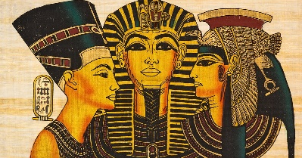
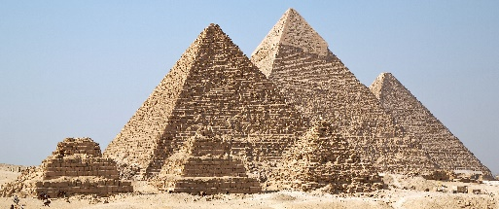
In RE we will be learning about:
In RE, children will explore how people know what they believe to be true, learning about different sources of knowledge in religions and worldviews, and reflecting on their own beliefs while respecting that others may think differently.
As artists, we will be focusing on Textiles during the Spring Term. The children will be finding out about the technique of printing. They will be looking at different fabrics and the different printing types that have been used. They will focus, in particular, on Egyptian block printing and creating their own patterns and designs.
As design technologists, we will be using our knowledge of the different food groups to carry out a taste test survey in order to design, evaluate and make a healthy lunchtime menu.

As historians, we will be investigating and interpreting the past by using primary and secondary sources of evidence to find out about Ancient Egyptian society. We will build up a chronological understanding of their civilisation by creating a timeline of events. We will learn about their beliefs and religious practices, how their society was constructed and their relevance to life today.

As geographers, we will be using maps and atlases to locate and investigate places both in our local area and the global climate. Our focus will be rivers where we will be looking at physical features around these areas. We will learn about how rivers are formed and their importance to settlements surrounding them, how we use rivers and will complete our learning by exploring how climate change is affecting our oceans and other water bodies.

As scientists, we will be covering;
Rocks Detectives where we will be comparing different types of rocks and identifying their properties and investigating how rocks have changed over time. We will also be investigating different types of soils as well as learning about fossils and exploring how they were formed.

Forces and Magnets The children will be learning about Forces and Magnets. They will explore contact and non-contact forces, investigate how objects move on different surfaces, and discover how magnets work. The children will learn about different types of magnets, identify which everyday objects are magnetic, and understand that magnetic forces can act at a distance. Through practical, hands-on investigations, they will also explore the many ways magnets are used in everyday life.

YEAR 3 Spring Term
Curriculum
Overview
In Music, we will be listening to a range of different music genres which include ‘Three little birds’ by Bob Marley and ‘The Dragon Song’ by Joanna Mangona and Pete Readman

In our daily English lessons, we will be focussing on becoming masters of our curriculum by:
- Spelling with increasing accuracy
- Learning patterns within words, spelling rules and some exceptions to these
- The correct use of punctuation such as:, ? ! … : ; “”
- Developing and applying adventurous vocabulary and sentence openers
- Varying sentence structure with the use of conjunctions, adverbs and prepositions
- Writing for a given purpose relating to the theme: e.g creative story writing; To write an explanation text; play scripts, Cinquains and Kennings poems. The children will also be writing a Newspaper report.
- Considering the narrative, setting, and purpose of our writing in order to engage the reader

In Computing, our topics will be ‘We Are Presenters’ where the children will have the opportunity to work with video cameras to shoot and review videos and ‘We are Vloggers’ where they will be planning and presenting a presentation.

This term you can help your child at home by –
- Providing a range of books or resources from the internet that support our theme
- Encouraging your child to be responsible for organising their belongings to support their learning
- Completing everyday maths activities such as telling the time, paying for items in a shop, weighing ingredients when cooking and estimating quantities
- Reading regularly at home in order to develop fluency, expression and the enthusiasm for reading
- Allowing your child to ‘navigate’ on journeys, giving them access to maps and encouraging the use of landmarks and directional language.

In P.E we will be building on skills already learnt and learning a range of new skills through the use of games, problem solving activities and new equipment.
Gymnastics –This term in gymnastics, children will develop ‘excellent gymnastics’ by exploring symmetrical movements and balances, focusing on control, body shape and precision.

In our daily Maths lessons, we will be focussing on becoming masters of our curriculum by:
- Using mental and written strategies to complete calculations using +, -, x and ÷
- Developing our ability to solve worded problems and investigating problems in real life
- Continue learning multiplication tables 2, 5, 10, 3, 4 and 8.
- Multiplying and dividing 2-digit numbers by 1-digit numbers
- Recognising and writing fractions, comparing and ordering fractions, adding and subtracting fractions and using numbers, words and diagrams to demonstrate fractions.
- Understanding the difference between volume and capacity and applying this knowledge to practical problems.
- Measuring and comparing lengths (m, cm,mm) mass (kg,g) and volume/capacity (l, ml)
- Calculating the perimeter of 2D shapes

In PSHE, we will be learning about keeping ourselves safe which includes aspects of internet safety, identifying people to help us if a situation is unsafe, the risks of ‘drugs’ in terms of cigarettes, alcohol and medicines. We will also be learning about Rights and Responsibilities in terms of looking after our environment and understanding the terms ‘income’ , ‘saving’ and ‘spending’.

