Friday 10th October 2025

Dear Parents and Carers,
This year, we are delighted to have introduced a new Religious Education (RE) scheme across our school. It is based on the new Barnet Agreed Syllabus for Religious Education, which provides an exciting and thoughtful approach to learning in this subject.
The new curriculum is based on a vision that recognises the importance of both religious and non-religious worldviews in shaping human life and experience. It encourages children to think deeply about the world around them, and to develop respect and understanding for the diverse beliefs and values that people hold. Learning is structured around the six ‘Big Questions’ that humans ask. These questions provide a framework through which children will explore ideas, reflect on different perspectives, and make sense of their own thoughts and experiences.
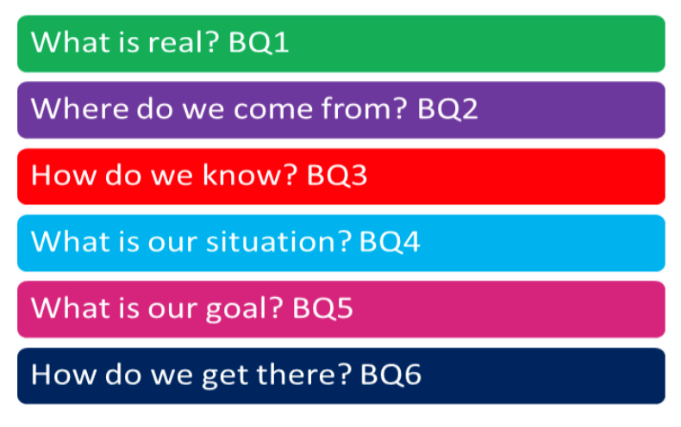
Throughout the year, we would love to involve our parent community wherever possible. If you are willing to volunteer your time to share your experiences, talk about your beliefs, or take part in our annual RE Week in January, we would be delighted to welcome you into school. Please speak to your class teacher or email me via office@ashmoleprimary.org if you are interested.
We look forward to working with you and hope that the children will come home excited to share their learning with you.
Yours sincerely,
Mrs Joyce
RE co-ordinator

