
RE at Ashmole Primary School

‘Religious Education provides a vital foundation for the spiritual development of children in preparing them for adult life’.

Intent

At Ashmole Primary School, we aim to deliver a carefully designed sequential approach to the teaching of RE that enables pupils to enter into a rich discourse about the religious and non-religious traditions that shape Great Britain and the world. This Religious Education (RE) Agreed Syllabus is based on the six big questions (BQs) from the academic work of Ann Taves. These questions intend to provide an opportunity for pupils to explore what it means to be human, and their situation within the wider diverse multi-religious and multi-secular world. Our curriculum aims to be both intellectually challenging and personally enriching. The intention is for the six Big Questions (BQs) to act as the ‘golden threads’ of learning that are woven throughout the Agreed Syllabus for all pupils at Ashmole Primary. Pupils’ progress is assessed in relation to the purpose and aims of the subject. Therefore, this primarily concerns how able the pupils are to hold balanced and well-informed conversations about religion or worldviews, as explored through the six Big Questions (BQs) of Ann Taves.
What is intended, the teaching of the six BQs, will be implemented in the lessons and experiences and then the impact will be monitored. The intention should be clear throughout this learning process.
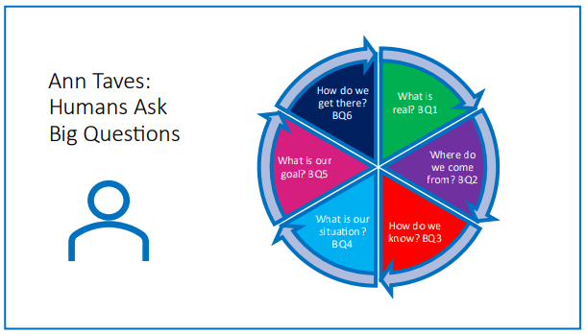

Implementation
- The RE curriculum at Ashmole Primary focuses on the six BQs to allow for the development of depth of learning and understanding, encouraging rich discourse.
- The sequential nature of this curriculum built on the six BQs allows the child to revisit the areas multiple times. This allows for an inclusive curriculum, where the child may develop an understanding of the six Big Questions as they progress.
- The six BQs allow for the needs of our school and community to be reflected. We will include the teaching of all religions and worldviews, whilst focusing on the main religions in our school and local community.
- Our Agreed Syllabus encourages the use of rich vocabulary, interesting artefacts including real live artefacts, visitors from the community, school visits to places of worship and community venues and the use of beautiful texts, stories, art, and music to bring the lesson alive to help enrich and challenge. (VAT of RE).
- Quantifiers such as ‘some, many, may’ are chosen when framing questions to avoid referring to ‘all Christians/ Hindu’s / Humanists’ to avoid misconceptions and generalisations. Open questions around diversity within one religion or within a worldview are encouraged to explore a plurality of voices within ‘lived’ religion and worldviews. The six BQ approach, especially BQ4 Situation, encourages the exploration of the diversity of ‘lived’ worldviews and the many branches, streams and ‘voices’ that may exist.
- Multi-religious and multi-secular exemplars are included to bring the lessons alive.
- Deep learning is encouraged through the VAT in RE pedagogy that builds rich learning through a clear focus on vocabulary, artefacts (including humans) and texts (including stories). Authoritative texts, information, facts, resources that are referred to in lessons are sourced from national associations and trusted RE websites that are representative of religion and worldviews and are respected by the Religious Education community.

Impact
The impact of the six Big Questions explored within the Religious Education curriculum are checked throughout the learning journey.
The impact statements reflect the intent statements, and the pupils will have had opportunities to explore the intent through their lessons (implementation) before the impact is monitored.
The impact will be checked multiple times throughout their time at Ashmole Primary, as the same six BQs are revisited throughout the RE journey.

Assessment
Children will be encouraged to consider their progress in developing religious knowledge and understanding through answering the questions posed in each BQ. Opportunities for peer and self- assessment will further inform the teacher and inform planning and further differentiated support for pupils. Progress will be recorded throughout the year and at the end of each year, we make a summative judgement about the achievement of each pupil. At this point teachers decide upon a ‘best fit’ judgement as to whether the pupil has achieved and embedded the expected learning outcomes, exceeded expectations or is still working towards the age-related expectation. These decisions are based on the professional knowledge and judgement that teachers possess about the progress of each pupil, developed over the previous three terms, which allows an informed and holistic judgement of attainment to be made. The subject leader will carry out learning walks, book scrutinies and offer support in teaching RE.

