
Ashmole Primary School

Ashmole Primary School
Relationships & Sex Education (RSE) Policy

Relationships and Sex Education is lifelong learning about physical, moral and emotional development. It is about understanding the importance of marriage for family life; stable and loving relationships, respect, love and care. It is also about the teaching of sex, sexuality and sexual health. It is not about the promotion of sexual orientation or sexual activity.

Introduction
Our children learn about sex and relationships from the very youngest age, even if we do not talk about it with them. Some of the things they learn are incorrect, confusing and frightening. In a world where sex is used to sell things from food to fast cars, and celebrities' lives become everyone's business, we should talk to our children to help them make sense of it all.

As well as this, in the UK we have the highest rates of teenage pregnancy in Western Europe. We also have high rates of sexually transmitted infections (STIs). Effective RSE does not encourage early sexual experimentation, but it does enable young people to mature, to build up their confidence and self-esteem and to understand the reasons for delaying sexual activity until they are ready.

Parents and carers are the key people for their child's learning about sex and relationships and schools should always work in partnership with home. Parents and carers need to know that the school's RSE programme will complement their role and support them in the education of their child regarding sex and relationships. Ashmole Primary School will ensure that parents’ and carers’ views are heard and that taught RSE is culturally appropriate and inclusive of all of our children.

As a primary academy we must provide relationships education to all pupils as per section 34 of the Children and Social Work act 2017. As we already deliver a comprehensive PSHE programme; we have reviewed and adjusted it to meet the new Department of Education (DfE) guidance (see Appendix 2-4). Relationships Education and Health Education is statutory for all Primary pupils (as of September 2020) and will be taught as part of our PSHE curriculum.

As a primary academy, we are not required to provide sex education, beyond the elements contained in the Science curriculum. Therefore, in teaching sex education we must have regard to guidance issued by the secretary of state as outlined in section 403 of the Education Act 1996. We have based our school’s relationships and sex education policy on the guidance document ‘Relationships Education, Relationships and Sex Education (RSE) and Health Education’ (DfE 2019). In this document, RSE is referred to as the emotional, social and cultural development of pupils, and involves learning about relationships, sexual health, sexuality, healthy lifestyles, diversity and personal identity. RSE involves a combination of sharing information and exploring issues and values. RSE is not about the promotion of sexual activity.

The Department recommends that all primary schools should have a sex and relationship education programme tailored to the age and the physical and emotional maturity of the children. It should ensure that both boys and girls know about puberty and how a baby is born – as set out in Key Stages 1 and 2 of the National Science Curriculum. All children, including those who develop earlier than the average, need to know about puberty before they experience the onset of physical changes. In the early primary school years, education about relationships needs to focus on respectful relationships, friendship, bullying and the building of self-esteem.

At Ashmole we teach about the importance of love, nurture and care in family life. However, “care needs to be taken to ensure that there is no stigmatisation of children based on their home circumstances.” Sex and relationships education is part of the personal, social, health, and economic (P.S.H.E.) education curriculum and the Science curriculum in our school. While we use sex and relationships education to inform children about sexual issues, we do this with regard to matters of morality and individual responsibility, and in a way that allows children to ask and explore moral questions. We do not use sex and relationship education as a means of promoting any form of sexual orientation.

Relationships education, which is statutory, focuses on teaching the fundamental building blocks and characteristics of positive relationships including:
- Families and people who care for me
- Caring friendships
- Respectful relationships
- Online relationships
- Being safe

(Please see Appendix 2 for statutory guidance)

These areas of learning are taught within the context of family life taking care to ensure that there is no stigmatisation of children based on their home circumstances (families can include single parent families, LGBT parents, families headed by grandparents, adoptive parents, foster parents/carers amongst other structures) along with reflecting sensitively that some children may have a different structure of support around them (for example: looked after children or young carers).

Delivery of RSE:
Relationships and Sex Education lessons are co-ordinated by the PSHE Education co-ordinator who is responsible for the overall planning, implementation and review of the programme.
We teach sex and relationships education in the context of the school’s aims and values framework. While sex and relationships education in our school means that we give children information about sexual behaviour, we do this with an awareness of the moral code and values, which underpin all our work in school.

In particular, we teach sex and relationships education with the belief that:

- Sex and relationships education should be taught in the context of stable relationships and family life
- Sex and relationships education is part of a wider social, personal, spiritual and moral education process;
- Children should be taught to have respect for their own bodies;
- Children should learn about their responsibilities to others, and be aware of the consequences of sexual activity;
- It is important to build positive relationships with others, involving trust and respect;
- It is vital to know the importance of sexual activity as part of a committed and loving relationship;
- Sexual abuse is common and children should know what to do if they are worried about any sexual matters.

RSE is taught within the personal, social, health and economic (PSHE) education curriculum. Biological aspects of RSE are taught within the science curriculum. Primary sex education will focus on:
- Preparing boys and girls for the changes that adolescence brings
- How a baby is conceived and born
For more information about our curriculum, see our curriculum map in Appendix 1.

A variety of approaches that cater for children’s different learning styles are used to ensure pupils are actively engaged in their learning. These include discussion, group work, drama and other active learning techniques. Children are taught in mixed ability, mixed gender and single sex groupings. Throughout the school, the correct scientific language is used for all body parts and teachers will respond to questions from children in an age-appropriate, sensitive manner.

We will follow a programme of study developed by Coram Life Education, ‘SCARF’ which has been developed from the PSHE Association’s Primary Scheme of Work, which is recommended by the Department for Education (see Appendix 1). Our programme of Study will be adapted where necessary to reflect the specific needs of the pupils but also reflects the universal needs shared by all pupils. Before pupils start Year 6, parents will be invited to a detailed consultation evening which will highlight the aspects of sex education that will be taught. Parents will be reminded that they have the right to withdraw their children from any aspects of sex education that are not compulsory in primary school.

The Role of Parents
The school is well aware that the primary role in children’s relationships and sex education lies with parents and carers. We wish to build a positive and supporting relationship with the parents of children at our school through mutual understanding, trust and, co-operation.

In promoting this objective we:
- Inform parents about the school’s sex and relationships education policy
- Are available for all parents and carers of children to discuss the RSE programme, to explain any issues arising, discuss how it is taught and to see the materials the school uses in its teaching.
- Answer any questions that parents may have about the education of their child.
- Take seriously any issue that parents raise with teachers or governors about this policy or the arrangements for sex and relationship education in the school.
- Inform parents about the best practice known with regard to sex and relationships education, so that the teaching in school supports the key messages that parents and carers give to children at home.
We believe that through this mutual exchange of knowledge and information, children will benefit from being given consistent messages about their changing body and their increasing responsibilities.
Parents have the right to withdraw their child from part of the ‘sex and relationships education’ but not that part which is delivered in the science curriculum. If a parent wishes their child to be withdrawn from sex education lessons, they should discuss this with the Head Teacher, and make it clear which aspects of the programme they do not wish their child to participate in. The school always complies with the wishes of parents in this regard. Parents cannot withdraw their children from ‘relationships education’ as this is a statutory requirement. Addressing moral and ethical issues that may arise from apparently unrelated topics in the National Curriculum subjects. Within this context of the subject it will not be deemed to be part of the sex education programme and therefore not subject to the parental right to withdrawal.

The Role of the Head Teacher
The Head Teacher liaises with external agencies regarding the school sex and relationships programme, and ensures that all adults who work with children on these issues are aware of the school policy, and that they work within this framework.

The Head Teacher monitors this policy on a regular basis and reports to governors, when requested, on the effectiveness of the policy.
The Head Teacher along with the PSHE coordinator will gain feedback from pupils on their learning experience of RSE and will ensure that delivery is amended accordingly.

Role of Other Members of the Community
We encourage other valued members of the community to work with us to provide advice and support to the children such as the school nurse. Provision is always in partnership with the teaching staff and is part of a planned programme of Relationships and Sex Education.

Confidentiality
Teachers conduct relationships and sex education lessons in a sensitive manner and in confidence. However, if a child makes a reference to being involved, or the likelihood of being involved in sexual activity, then the teacher will take the matter seriously and deal with it as a matter of child protection. Teachers will respond in a similar way if a child indicates that they may have been a victim of abuse. In these circumstances the teacher will talk to the child as a matter of urgency. If the teacher has concerns, they will draw their concerns to the attention of the Head Teacher. The Head Teacher will then deal with the matter in consultation with health care professionals. Any professional working in a classroom context in schools is governed by the school’s confidentiality policy. Health and other professionals working in a clinical context are bound by their own professional guidelines.

Appendix 1. SCARF Programme of Study- Mapping DfE requirements and additional PSHE elements to year groups.
Please note: This is a flexible guide and adjustments can and will be made to take children’s needs into account.

EYFS (Reception):

Me and My Relationships | Valuing Difference | Keeping Myself Safe
All about me, My special People, My feelings | Same and different, Different families and homes, Kindness and caring | Keeping my body safe, listening to my feelings, People who help keep me safe
Rights and Responsibilities | Being My Best | Growing and Changing
Looking after myself and my friends, Caring for my environment, Looking after money | Bouncing back (growth mindset), Healthy Eating, Exercise and sleep | Changes, Life stages, Changing body

Year 1 (1/3)
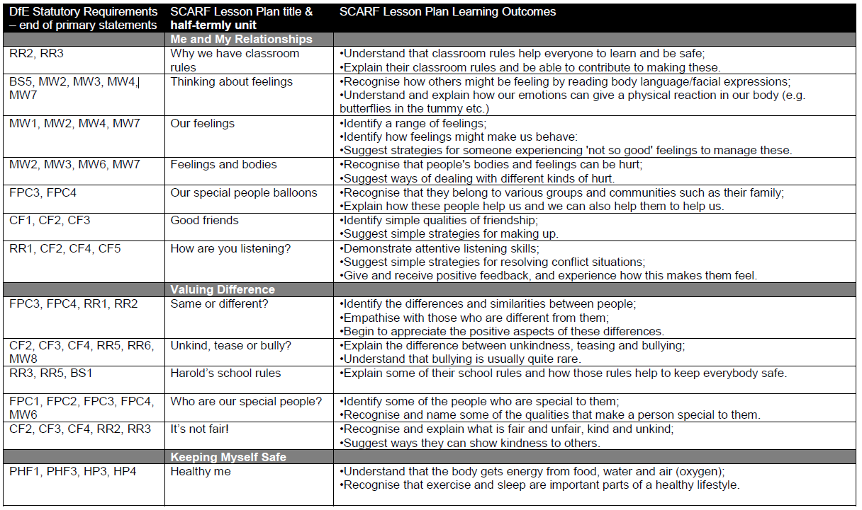

Year 1 continued (2/3)
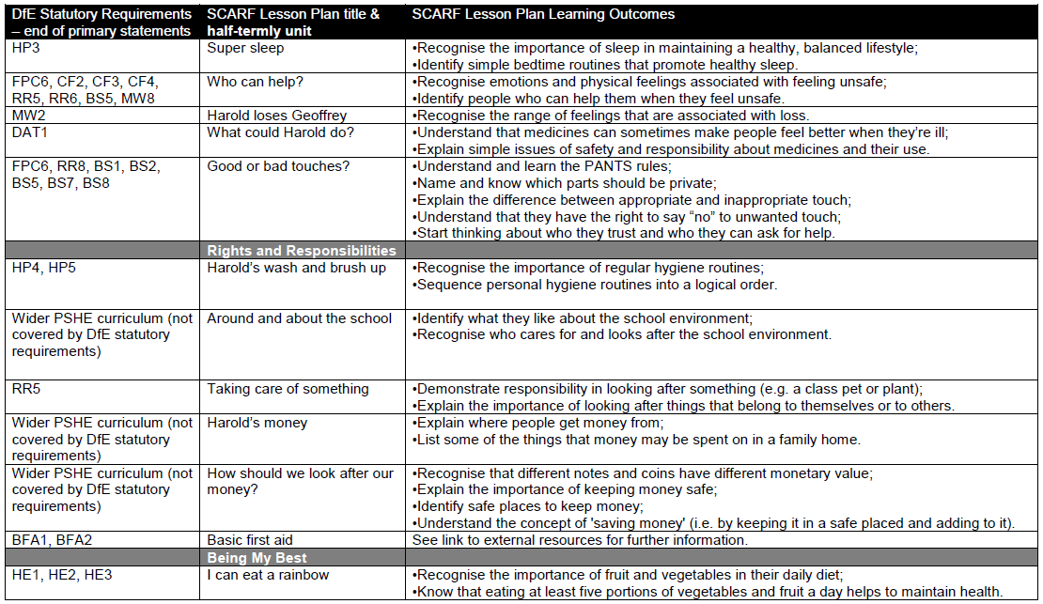

Year 1 continued (3/3)
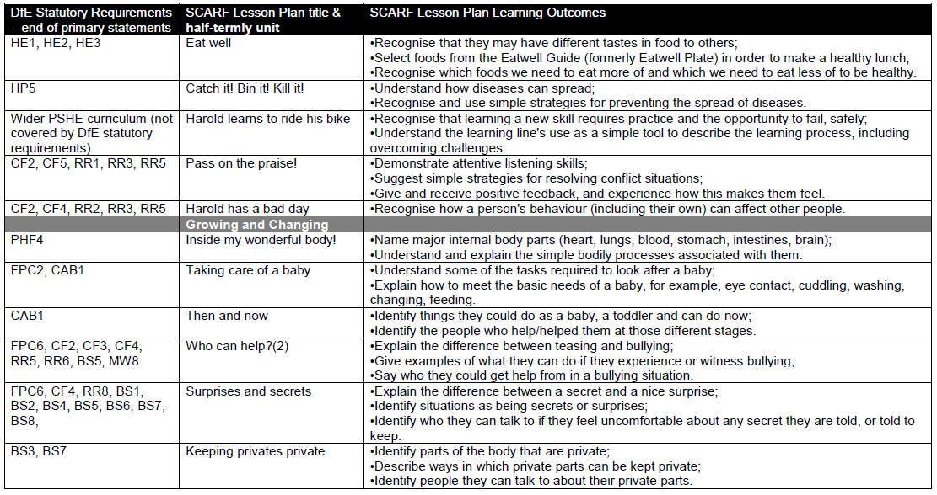

Year 2 (1/4)
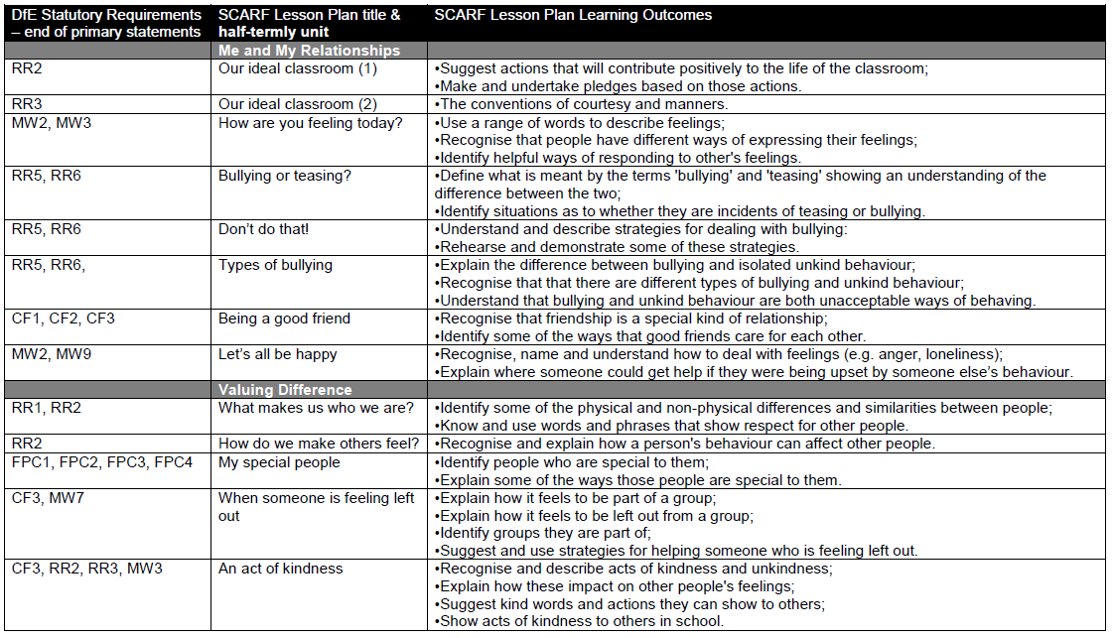

Year 2 continued (2/4)
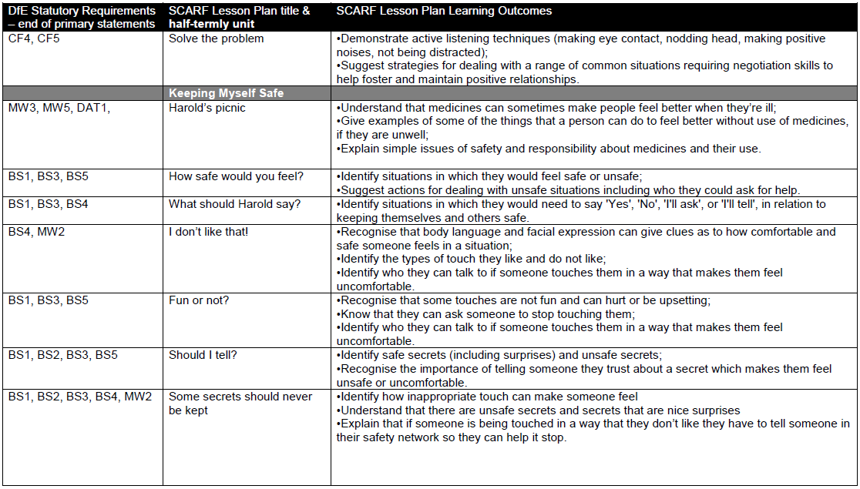

Year 2 continued (3/4)
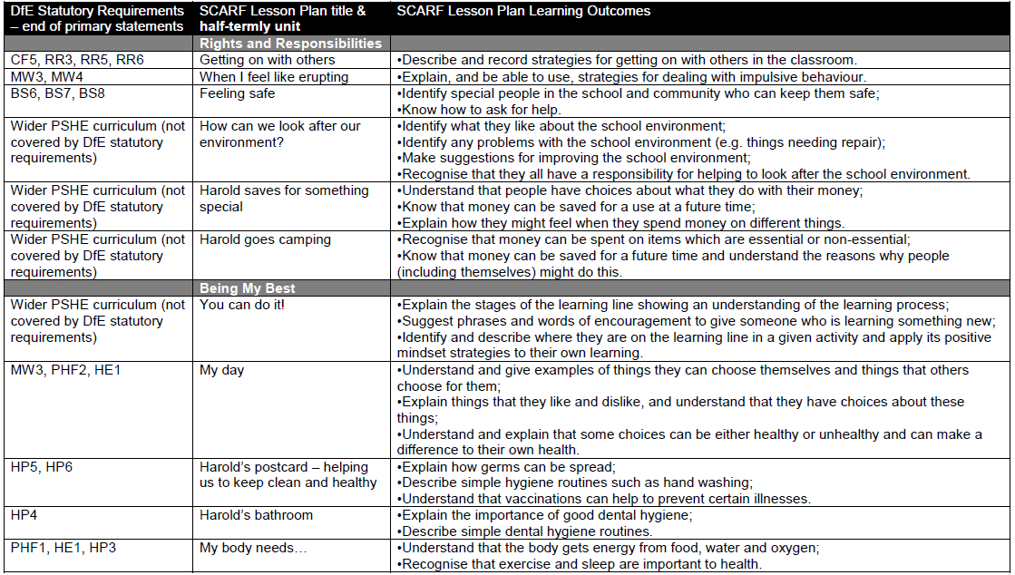

Year 2 continued (4/4)
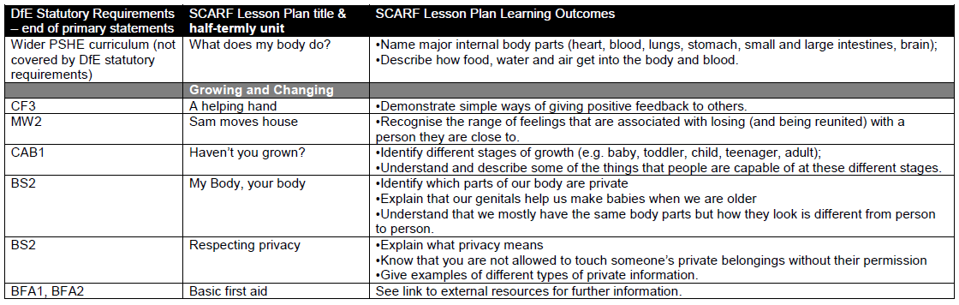

Year 3 (1/4)
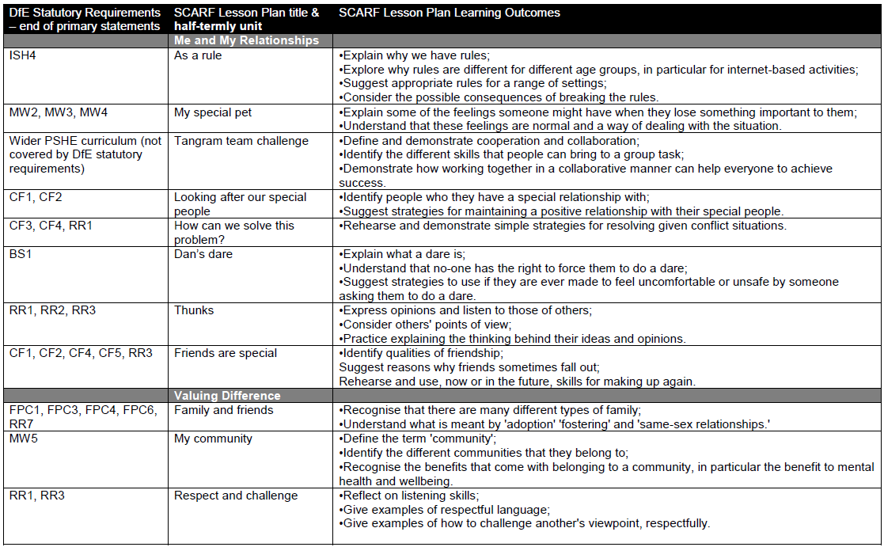
Year 3 continued (2/4)
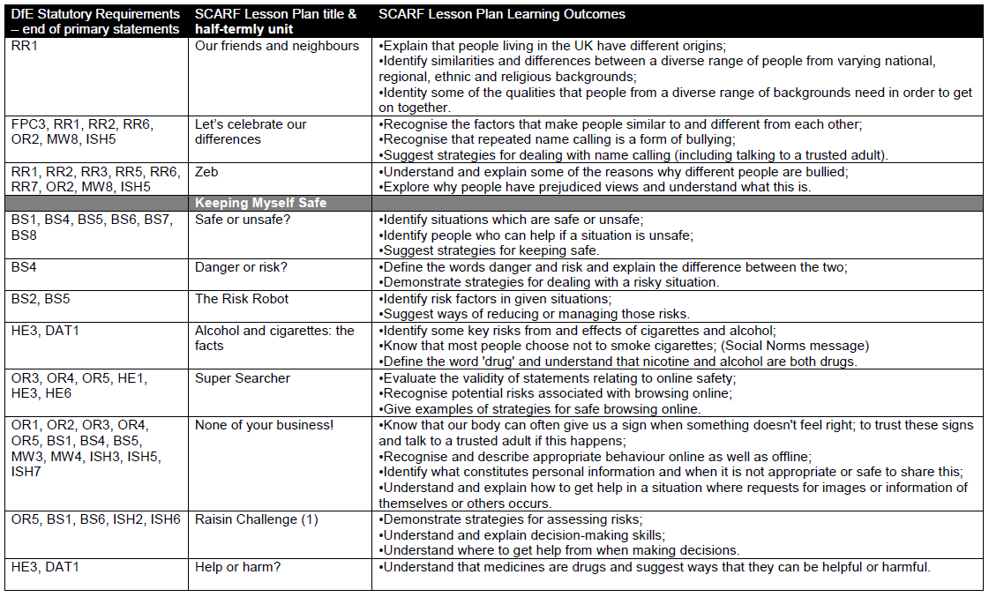
Year 3 continued (3/4)
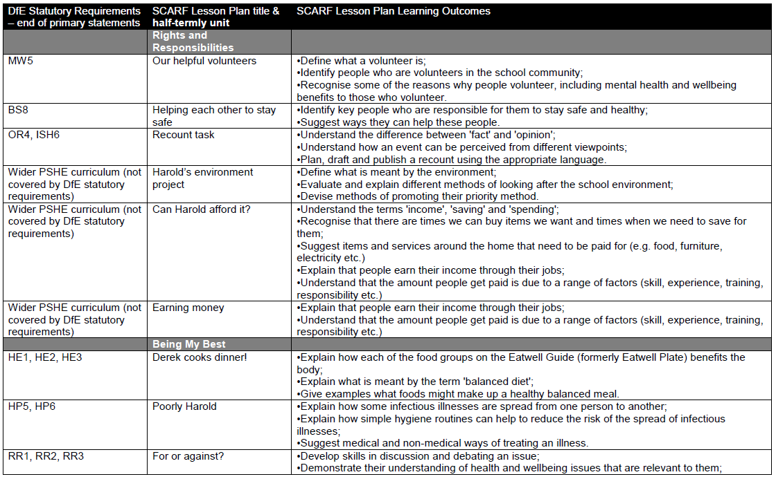
Year 3 continued (4/4)
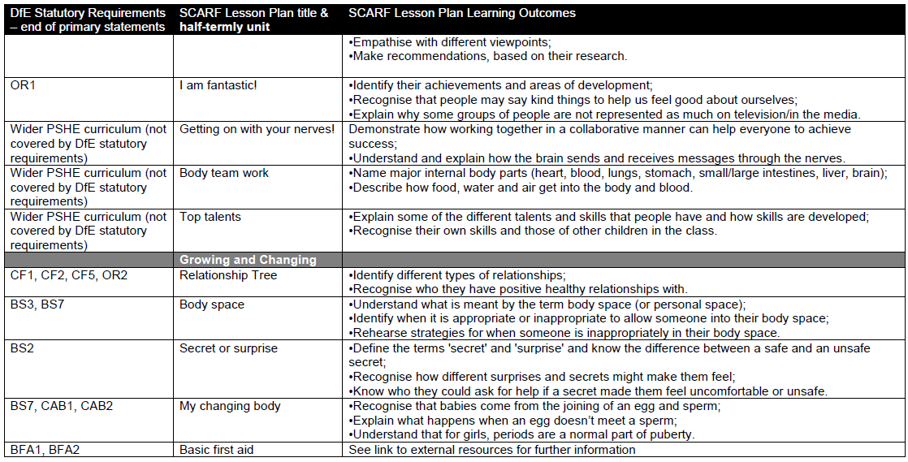

Year 4 (1/4)
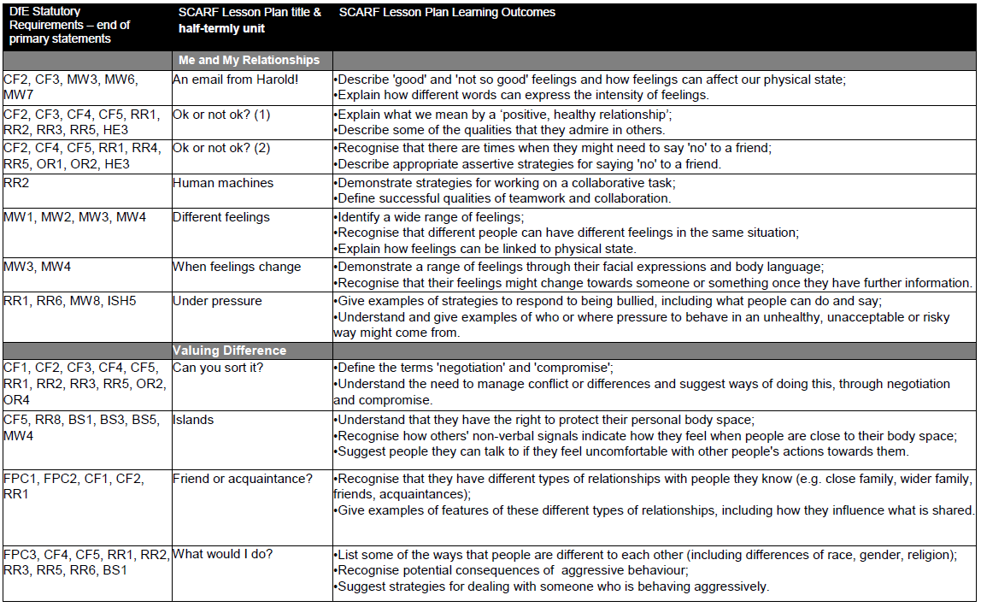
Year 4 continued (2/4)
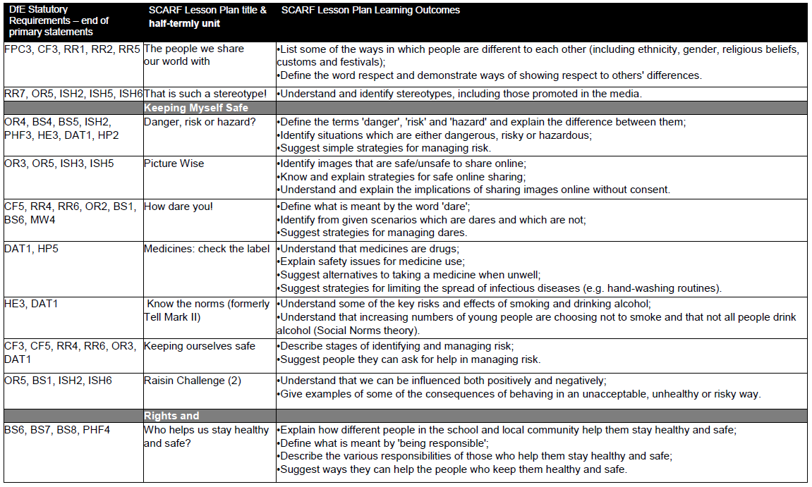
Year 4 continued (3/4)
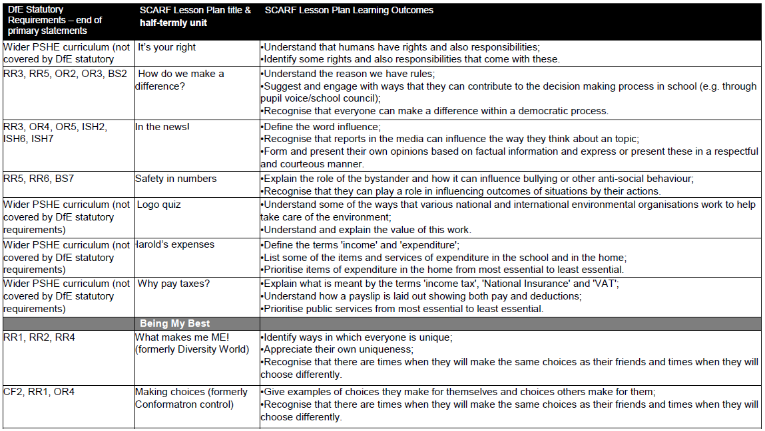

Year 4 continued (4/4)
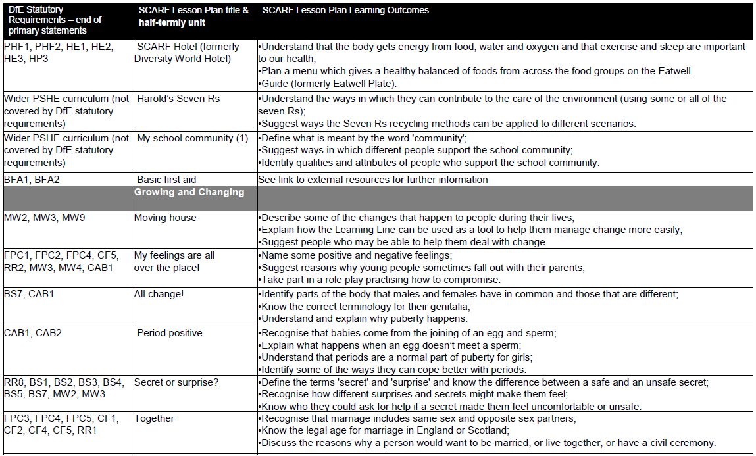
Year 5 (1/4)
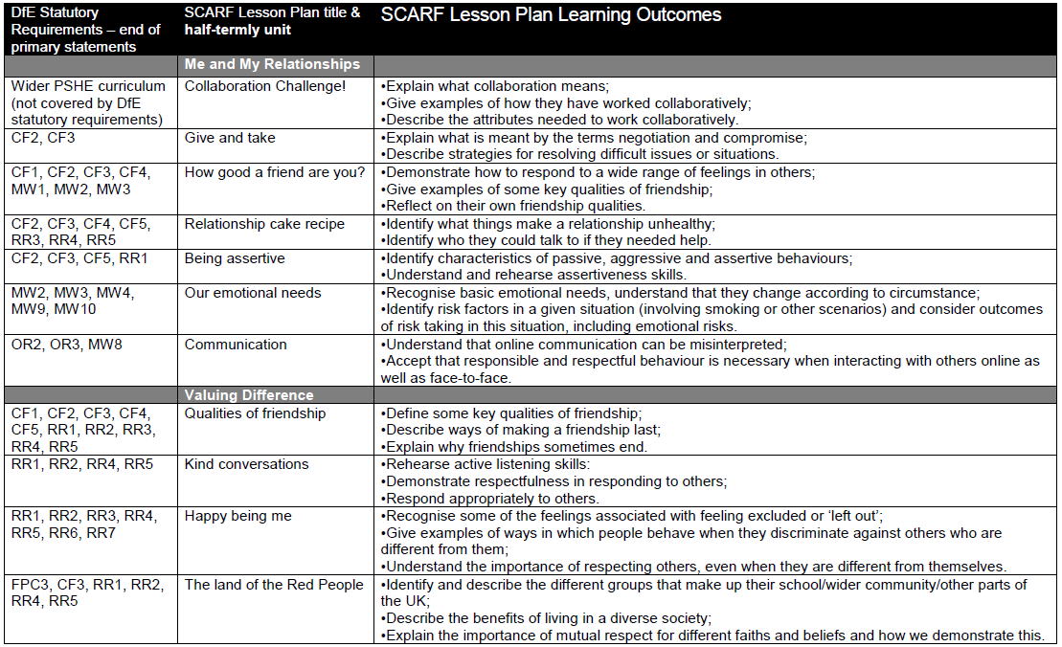
Year 5 continued (2/4)
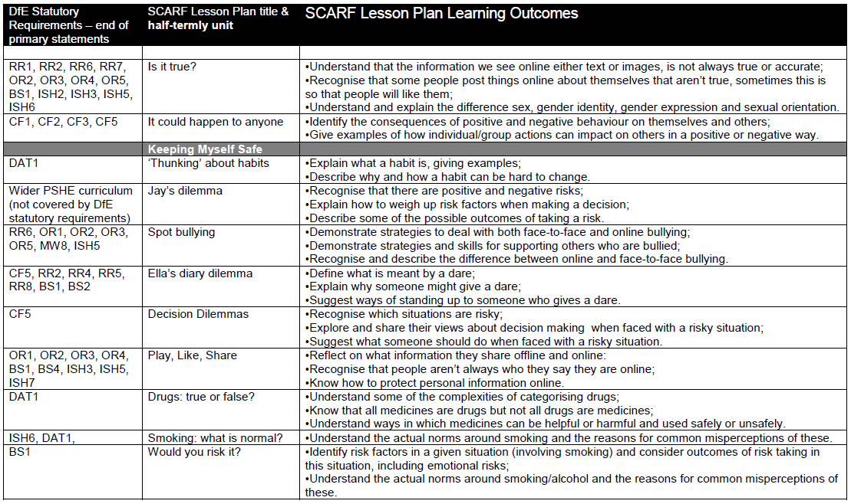
Year 5 continued (3/4)
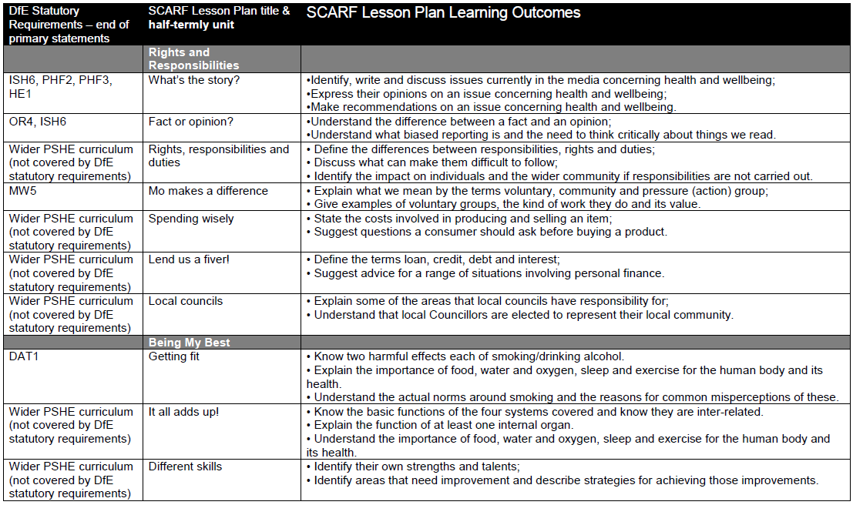

Year 5 continued (4/4)
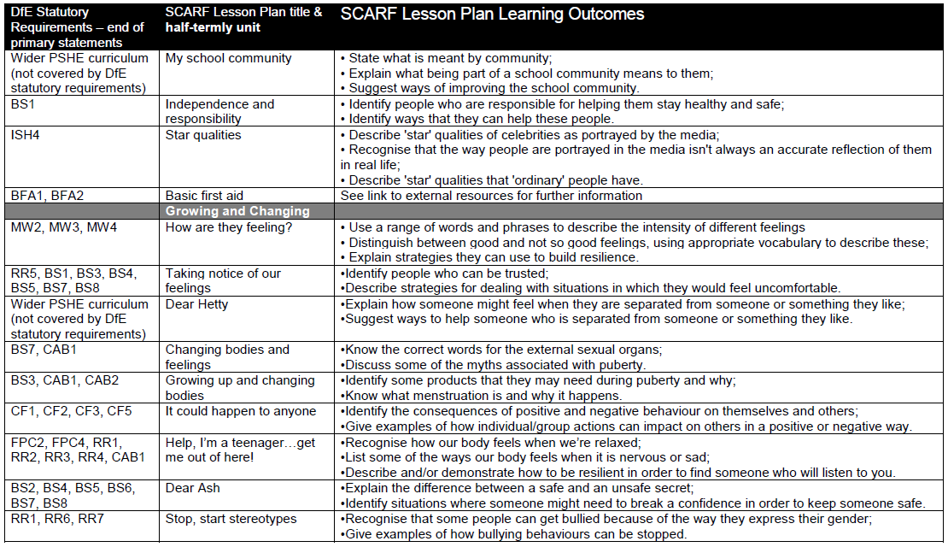

Year 6 (1/5)
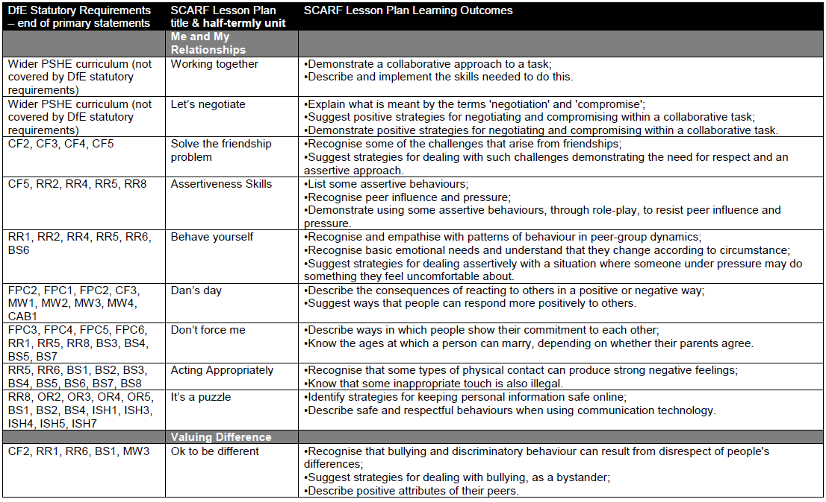
Year 6 continued (2/5)
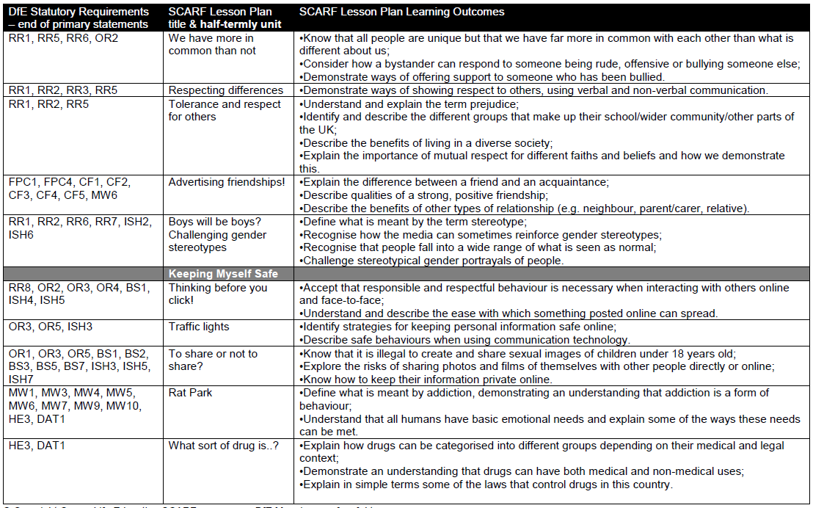
Year 6 continued (3/5)
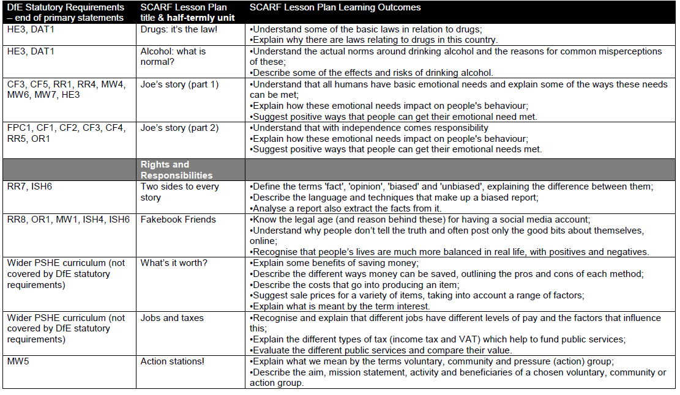

Year 6 continued (4/5)
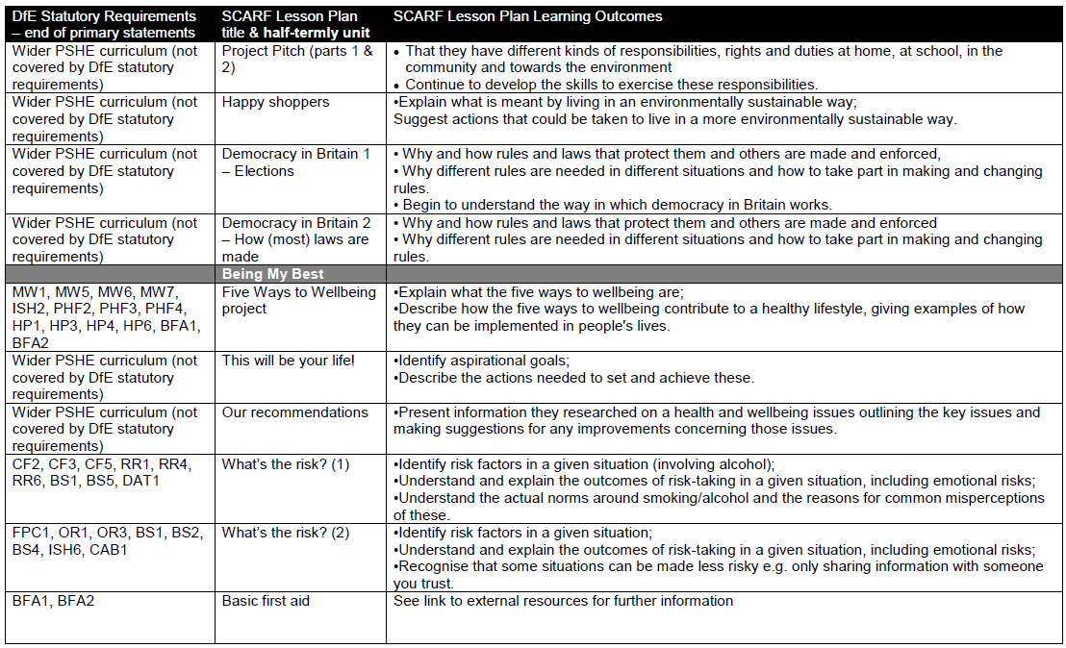
Year 6 (5/5)
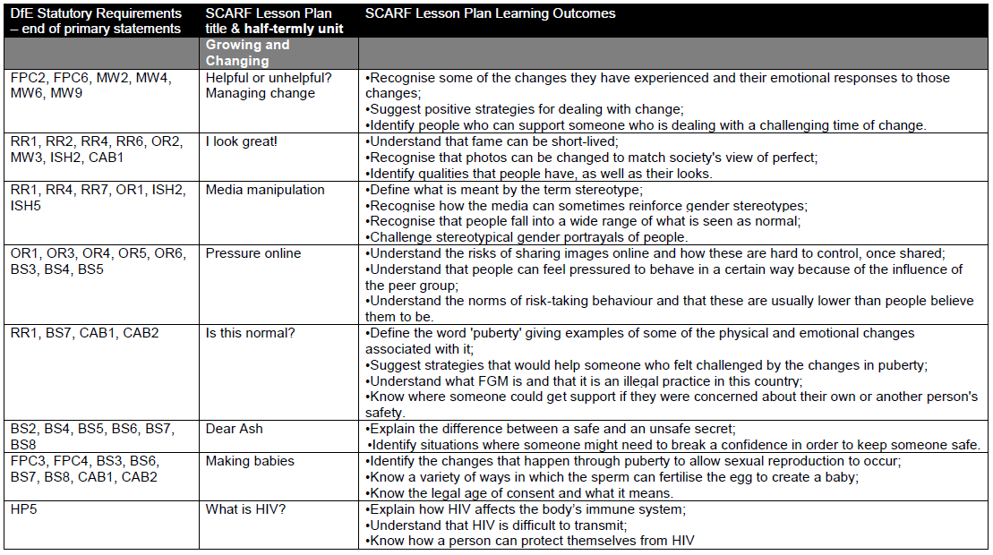
Appendix 2. Relationships Education Statutory Guidance for Primary Schools
By the end of primary school, pupils should know:
Topic | Pupils should know
Families and people who care about me | - That families are important for children growing up because they can give love, security and stability  - The characteristics of healthy family life, commitment to each other, including in times of difficulty, protection and care for children and other family members, the importance of spending time together and sharing each other’s lives  - That others’ families, either in school or in the wider world, sometimes look different from their family, but that they should respect those differences and know that other children’s families are also characterised by love and care  - That stable, caring relationships, which may be of different types, are at the heart of happy families, and are important for children’s security as they grow up  - That marriage represents a formal and legally recognised commitment of two people to each other which is intended to be lifelong  - How to recognise if family relationships are making them feel unhappy or unsafe, and how to seek help or advice from others if needed
Caring friendships | - How important friendships are in making us feel happy and secure, and how people choose and make friends  - The characteristics of friendships, including mutual respect, truthfulness, trustworthiness, loyalty, kindness, generosity, trust, sharing interests and experiences and support with problems and difficulties  - That healthy friendships are positive and welcoming towards others, and do not make others feel lonely or excluded  - That most friendships have ups and downs, and that these can often be worked through so that the friendship is repaired or even strengthened, and that resorting to violence is never right  - How to recognise who to trust and who not to trust, how to judge when a friendship is making them feel unhappy or uncomfortable, managing conflict, how to manage these situations and how to seek help or advice from others, if needed
Respectful relationships | - The importance of respecting others, even when they are very different from them (for example, physically, in character, personality or backgrounds), or make different choices or have different preferences or beliefs  - Practical steps they can take in a range of different contexts to improve or support respectful relationships  - The conventions of courtesy and manners  - The importance of self-respect and how this links to their own happiness  - That in school and in wider society they can expect to be treated with respect by others, and that in turn they should show due respect to others, including those in positions of authority  - About different types of bullying (including cyberbullying), the impact of bullying, responsibilities of bystanders (primarily reporting bullying to an adult) and how to get help  - What a stereotype is, and how stereotypes can be unfair, negative or destructive  - The importance of permission-seeking and giving in relationships with friends, peers and adults
Online relationships | - That people sometimes behave differently online, including by pretending to be someone they are not  - That the same principles apply to online relationships as to face-to face relationships, including the importance of respect for others online including when we are anonymous  - The rules and principles for keeping safe online, how to recognise risks, harmful content and contact, and how to report them  - How to critically consider their online friendships and sources of information including awareness of the risks associated with people they have never met  - How information and data is shared and used online
Being safe | - What sorts of boundaries are appropriate in friendships with peers and others (including in a digital context)  - About the concept of privacy and the implications of it for both children and adults; including that it is not always right to keep secrets if they relate to being safe  - That each person’s body belongs to them, and the differences between appropriate and inappropriate or unsafe physical, and other, contact  - How to respond safely and appropriately to adults they may encounter (in all contexts, including online) whom they do not know  - How to recognise and report feelings of being unsafe or feeling bad about any adult  - How to ask for advice or help for themselves or others, and to keep trying until they are heard  - How to report concerns or abuse, and the vocabulary and confidence needed to do so  - Where to get advice e.g. family, school and/or other sources

September 2025
Next review due September 2026

