Key Stage 2 – Addition
Y6
- Add several numbers of increasing complexity using columnar addition.

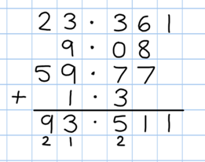

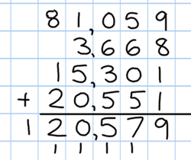

National Curriculum requirements:
Add whole numbers with more than 4 digits, using the formal written method of columnar addition.
Key Stage 2 – Subtraction
Y6
- Continue with compact columnar subtraction, including subtraction of decimals.

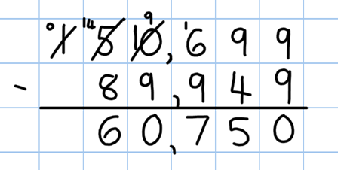

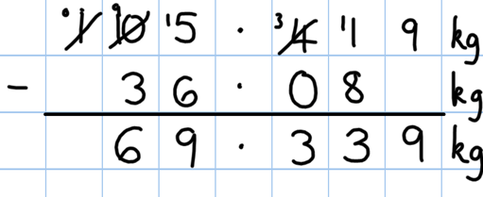

- Use estimation to check answers to calculations and to determine, in the context of a problem, levels of accuracy.

National Curriculum requirements:
Subtract numbers with more than 4 digits.
Key Stage 2 – Multiplication
Y6
• Recall and use multiplication tables up to 12x12
(Including multiplying by 0 and 1).

- Continue to practise short multiplication.

- Continue to practise long multiplication.
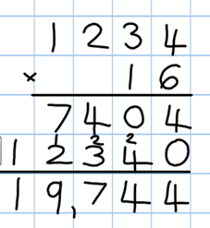

- Multiply decimals using the grid method and progressing on to short multiplication.

- Use estimation to check answers to calculations and determine, in the context of a problem, an appropriate degree of accuracy.

Video clips:
Moving from grid method to a compact method
Reinforcing rapid times table recall
Demonstration of long multiplication

National Curriculum requirements:
Multiply up to 4 digits by 2 digits using the formal written method of long multiplication.
Multiply numbers by 10,100, 1000 giving answers up to 3 decimal places.

Key Stage 2 – Division
Y6
- Consolidate short division.

- Children should be able to interpret remainders as whole number remainders, fractions or by rounding, as appropriate for the context.

- Introduce long division.

N.B: The above examples are taken from the National Curriculum for Mathematics appendix.

National Curriculum requirements:
Divide numbers up to 4 digits by a 2 digit number using the formal written method of short division where appropriate.

Divide up to 4 digits by a 2 digits whole number using the formal written method of long division.

Calculation: Fractions

ADDITION AND SUBTRACTION
YEAR 6
Add and subtract fractions with different denominators and mixed numbers, using the concept of equivalent fractions

MULTIPICATION AND DIVISION
Multiply simple pairs of proper fractions, writing the answer in its simplest form
e.g. ¼ x ½ = 1/8

Multiply one-digit numbers with up to two decimal places by whole numbers
Divide proper fractions by whole numbers
e.g. 1/3 ÷ 2 = 1/6

