Key Stage 2 – Addition
Y5
- Continue to use columnar addition, adding numbers with more than 4 digits.

3 2 8 7 9
+ 3 5 9 8 7
6 8 8 6 6

- Addition of money and decimals.
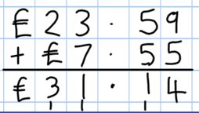

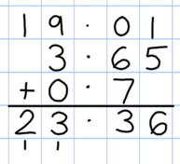

National Curriculum requirements:
Add whole numbers with more than 4 digits, using the formal written method of columnar addition.

Key Stage 2 – Subtraction
Y5
- Continue with compact columnar subtraction, including subtraction of decimals.

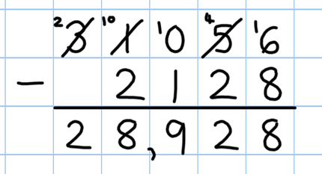

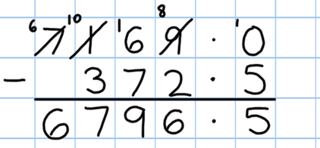

- Use rounding to check answers to calculations and to determine, in the context of a problem, levels of accuracy.

Video clip:
Moving to the compact column method of subtraction

National Curriculum requirements:
Subtract numbers with more than 4 digits.
Key Stage 2 – Multiplication
Y5
- Recall and use multiplication tables up to 12x12
(Including multiplying by 0 and 1).

- Continue to practise short multiplication.

- Use Grid Method to introduce long multiplication.

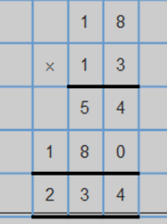
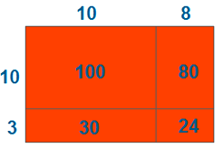

Video clips:
Moving from grid method to a compact method
Reinforcing rapid times table recall
Demonstration of long multiplication

National Curriculum requirements:
Multiply numbers up to 4 digits by a 1 digit number using the formal written method of short multiplication.

Multiply numbers up to 4 digits by a 2 digit number using the formal written method of long multiplication.

Multiple whole numbers and those involving decimals by 10, 100, 1000.

Key Stage 2 – Division
Y5
- Consolidate the use of the formal written method of short division.

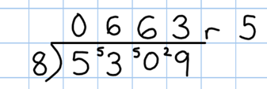

National Curriculum requirements:
Divide 2 digits by 1 digit.
Divide 3 digits by 1 digit.
Divide 4 digits by 1 digit.

Children interpret the remainders appropriately for the context.
e.g. as fractions, decimals or by rounding
98÷4 = 98/4 = 24r2 = 24 ½ = 24.5 rounded to 25

Divide whole numbers and those involving decimals by 10, 100, 1000.
Key Stage 2 – Division

Calculation: Fractions

ADDITION AND SUBTRACTION
YEAR 5
Add and subtract fractions with the same denominator and multiples of the same number
Recognise mixed numbers and improper fractions and convert from one form to the other and write mathematical statements > 1 as a mixed number
e.g. 2/5 + 4/5 = 6/5 = 11/5

MULTIPICATION AND DIVISION
Multiply proper fractions and mixed numbers by whole numbers, supported by materials and diagrams

