Key Stage 1 – Addition
Y2
Through practical activities in meaningful contexts and informal written methods.
- Fluent recall of bonds to 20 and within 20.

- Derive and use related facts up to 100.
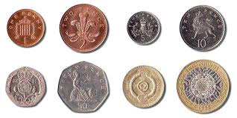
- Addition of money up to £1.

- Add numbers using concrete objects, pictorial representations and mentally.

- Show that addition of two numbers can be done in any order (commutative).
- Recognise and use the inverse relationship between addition and subtraction.

- Progressing to partitioned columnar method (in preparation for year 3).

National Curriculum requirements:
(using concrete objects, pictorial representations and mentally)
Add 2 digit numbers and ones.
Add 2 digit number and tens.
Add two 2 digit numbers.
Add three 1 digit numbers.

Key Stage 1 – Subtraction
Y2
Through practical and meaningful contexts.

- Fluent recall of bonds to 20 and within 20.

- Derive and use related facts up to 100
e.g. 10 – 7 = 3 so 100 – 70 = 30.

- Counting back by partitioning second number. Subtract the ones first to be in line with columnar subtraction.
46

36

28
- 8
E.g. 46 - 18
46 - 10 - 8

- 10

- Find the difference by counting up (only when the difference is small).
23 – 18 = 5

+1 +1 +1 +1 +1
16 17 18 19 20 21 22 23
- Recognise and use the inverse relationship between addition and subtraction

- Show that subtraction is not commutative (done in any order)

- Progressing to the partitioned columnar method in preparation for year 3

- Subtraction of money, including change.

National Curriculum requirements:
(using concrete objects, pictorial representations and mentally)
Subtract 2 digit numbers and ones.
Subtract 2 digit number and tens.
Subtract two 2 digit numbers.
Subtract three 1 digit numbers.

Key Stage 1 – Multiplication
Y2
Through practical activities and meaningful contexts using concrete objects, pictorial representations and arrays.
- Double numbers (by partitioning and recombining) 17 + 17.

- + 10 7 + 7
- Understand multiplication as repeated addition/groups/lots.
- Read arrays.
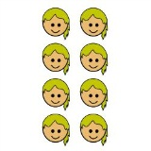
2x4 (2, 4 times)

- Repeated addition on a number line.
2 + 2 + 2 + 2 (4 groups of 2, 2 four times, 2 x 4)

0 1 2 3 4 5 6 7 8 9 10
4 + 4 (2 groups of 4, 4 two times, 4x2)

0 1 2 3 4 5 6 7 8 9 10
- Know the multiplication tables for 2, 5 and 10.
- Calculate mathematical statements within the multiplication tables using the multiplication (x) and equals (=) signs.
- Show that the multiplication of two numbers can be done in any order (commutative).

Video clips: Teaching for understanding of multiplication facts
Practical multiplication and the commutative law
National Curriculum requirements:
Solve problems involving multiplication using materials, arrays, mental methods and multiplication facts.

Y2
Through practical activities in meaningful contexts.
- Recall and use division facts for 2, 5 and 10 times tables.
- Continue to use division as sharing.
- Division as grouping.

- 15 children get into teams of 5 to play a game. How many teams are there?
How many groups of 5 in 15?

How many 5’s have been counted?

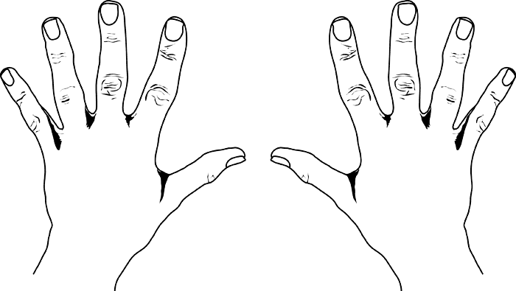
-  How many 2’s in 10?
- Understand ‘÷ 2’ as ‘half of’.
- Understand that division is not commutative.
- Recognise relationship between x and ÷
- Record using division (÷) and equals (=) signs.
- Use number lines to answer questions such as 20 ÷ 2 =
20
18
16
14
12
10
8
6
4
2
0

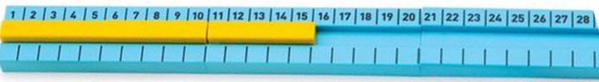

National Curriculum requirements:
Solve problems involving division using materials, mental methods and division facts.
Key Stage 1 – Division

