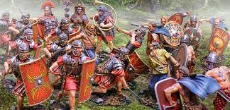
The Romans in Britain

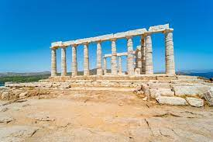
The Ancient Greeks
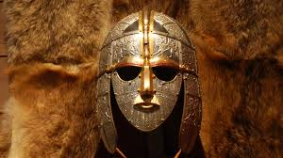
The Anglo-Saxons

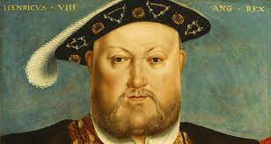
The Tudors
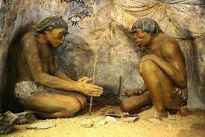
The Stone Age

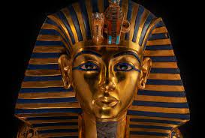
The Ancient Egyptians
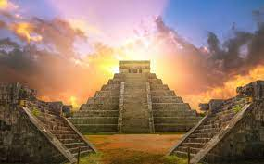
The Mayans

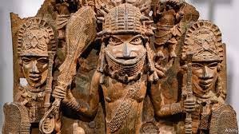
Benin
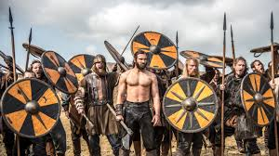
The Vikings

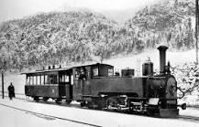The Second Industrial Revolution

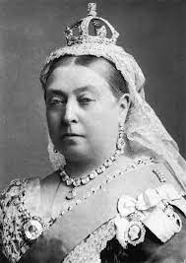

Queen Victoria
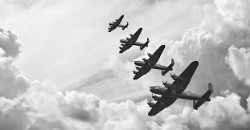

WWII
Stone Age – 15000 – 3000 BC
Ancient Egypt – 3100 – 800 BC
Ancient Greeks – 776-146
Romans – 43 – 420
Anglo-Saxons – 450-1066
Tudors – 1485 – 1603
The Mayans – 2000BC – 1697 AD
Benin – 900 – 1300
The Vikings – 793 – 1066
Queen Victoria – 1837 - 1901
Industrial Revolution – 1870 – 1914
WWII – 1939 - 1945

