COMMUNICATION & LANGUAGE
- To describe events that have happened in some detail.
- To use connectives to connect ideas and actions together.
- To respond to what they hear with relevant comments, questions or actions.
- To ask questions about why things happen e.g. who, what, when, how
- To use talk to organise, sequence and clarity thinking, ideas, feelings and events.
- To develop own narratives and explanations by connecting ideas or events.
- To recall parts of a story and anticipate key events.
- To listen and talk about non-fiction.
- To develop familiarity with new knowledge and vocabulary from non-fiction texts.
- To learn rhymes, poems and songs.
- To have a two-channelled attention.
- To follow instructions involving several ideas or actions.
- To be aware of listeners’ needs.
Describing events that

PERSONAL, SOCIAL & EMOTIONAL DEVELOPMENT
- To manage their own needs.
- To show resilience and perseverance in the face of challenge.
- To know how to keep safe and know what contributes to a healthy lifestyle.
- To develop confidence and independence.
- To be confident to try new activities and say why they like activities more than others.
- To develop their self-esteem and patience.
- To know how to establish relationships.
- To be sensitive to the needs of others.
- To know how to take turns and share.
- To know how to work as part of a group and with a partner.
- To be able to solve simple problems without aggression.
- To be able to take account of other children’s ideas when playing.
- To be able to adjust behaviour to different situations.
- To understand and follow the simple school rules.

PHYSICAL DEVELOPMENT
- To develop a range of ball skills including: throwing, catching, kicking, passing, batting and aiming.
- To develop confidence, competence, precision and accuracy when engaging in activities that involve a ball.
- To develop straight to move, jump and climb with confidence and competence.
- To move confidently in a range of ways.
- To move around safely, avoiding other children and obstacles.
- To show good control in large and small movements.
- To develop the foundations of a handwriting style which is fast, accurate and efficient.
- To use scissors and other simple tools safely and correctly.
- To dress and undress independently, fastening buttons and tying laces.
EYFS Summer Overview 2026

Mrs Powell & Miss Beth
Our topics this term will be:
ANIMALS AND HABITATS
OUR WORLD
THE NEXT STEP
LITERACY
In literacy, children will be supported in early reading and writing skills. The children will be supported and extended when appropriate. We use a range of books to support the children in learning to read, including Big Cat Collins scheme. Please encourage your children to read a variety of books at home, as well as books sent home from school. This term the children will be learning and reinforcing;
- To segment and blend phonemes orally.
- To hear and say the phonemes in words
- To segment and blend phonemes to read and spell.
- To link phonemes and letters.
- To know Tricky and High Frequency Words from Little Wandle Letters and Sounds Revised Phase 2, 3 and 4.
- To read simple words and sentences.
- To discuss what they have read.
- To write their own name, labels, captions.
- To write short sentences in meaningful contexts that can be read by themselves and others.
- To use finger spaces, full stops and capital letters.
- To extend sentences using connectives and adjectives.
- To use book language e.g. fiction, non-fiction, contents, index page.

Phase 4 Tricky Words: said, so, have, like, some, come, love, do, were, here, little, says, one, there, when, what, out, today.

MATHS
In maths, children will be supported in learning key number skills, exploring numerical patterns and investigating shape and measurement. This term the children will be exploring the following concepts:
- Subitising
- Doubling
- Halving
- Sharing
- Counting in 10’s
- Counting in 5’s
- Positional Language
- Subtracting by counting back
- Counting to 30
- Money
- Graphs – pictograms, tally charts, bar charts
Whilst also reinforcing;
- 1-1 correspondence
- Matching amounts and numerals correctly
- Finding 1 less and 1 more
- Ordering numbers and finding missing numbers
- Number bonds to 5 and 10
EYFS Summer Overview 2025
Miss Powell & Miss Burke
EXPRESSIVE ARTS & DESIGN

Listening attentively, moving to and talking about music, expressing feelings and responses.
Watching and talking about dance and performance art, expressing their feelings and responses.

BOOKS WE WILL BE READING:
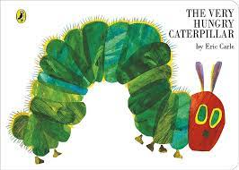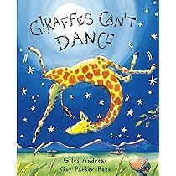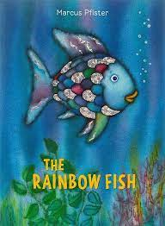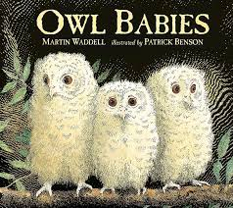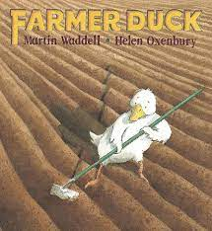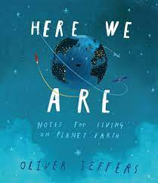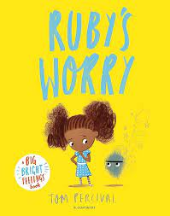
UNDERSTANDING THE WORLD
In this area of learning, the children will have many opportunities to explore their natural environment and world in which they live. They will learn and celebrate different cultures, religions and religious festivals and explore how things were similar or different in the past.
Topics:
Animals and Habitats
Our World
The Next Step

- Beginning to recognise some environments that are different to the one in which we live.
- To drawing information from a simple map
- To comment on images of familiar situations in the past.

HOW YOU CAN HELP AT HOME:
- Play ‘tricky’ word’ games.
- Encourage your child to write in their play and in everyday situations e.g. writing signs for the home environment, write lists/items to take on a trip, different toys in a box, ingredients for a cake. At this stage encourage your child to write the sounds that they can hear in words but don’t worry too much about the correct spelling. Ask your child to say the word that they want to write aloud so that they can hear the different sounds, using their ‘robot’ voice.
- Continue to look for and read numbers in the home and the environment up to 30 and beyond e.g. clocks, door numbers, car registrations, on money and tickets.
- Do problem solving activities with your child e.g. weighing ingredients when cooking, asking questions such as “We have four cakes how many more will we need when your friends come?”
- Count with your child, start by counting to 10 and back and when your child has mastered this, extend to 20 and then 30 and beyond.
- Count in twos, fives and tens.
- Support your child with early, practical addition and subtraction e.g. you have eight cars in this box and six cars in the other, how many are there altogether?
- Make something together by following a simple recipe.
- Compare the size of different things using the correct mathematical vocabulary e.g. taller, shorter, longer, heavier, lighter.
- Play turn taking, number and sound games e.g. board games, card games, lotto, bingo, I Spy.
- Visit your local park to climb and play outdoor games and ball games.
- If possible, visit places of interest to your child e.g. a station, famous London landmarks, zoo.
- Lastly, remember that maths is all around, there are lots of maths opportunities in children's daily life (see above). It’s best to seize these opportunities rather than asking your child to sit down with you for some ’maths time’.

