COMMUNICATION & LANGUAGE
This area will develop the children’s competence in communicating, speaking and listening. The children will have opportunities to use their skills in a range of situations and for a range of purposes.
- To participate in Show and Tell and be able to discuss things related to their interests
- To be able to listen to others
- To be able to follow instructions (including 2 part)
- To be able to maintain attention during an activity
- To be able to listen to stories and to recall parts of the story
- To be able to listen and respond to other people’s ideas
- To be able to use a range of tenses (play, playing, will play, played)
- To be able to ask questions to find out more about something of interest to them
- To be able to extend their vocabulary
- To be able to use language to imagine and recreate roles and experiences in play situations
- To be able to use talk to share ideas and feelings and organise thoughts and activities
Describing events that

PERSONAL, SOCIAL & EMOTIONAL DEVELOPMENT
This area provides the children with experiences which will help them to develop a sense of themselves and of others; respect for others, social skills and a positive disposition to learn.
- To begin to know how to keep safe
- To know how to work as part of a group and with a partner
- To know how to take turns and share
- To develop confidence and independence
- To enjoy carrying out small, simple tasks
- To start to establish friendships
- To be sensitive to the needs of others
- To develop patience
- To be able to solve simple problems without aggression
- To understand the school rules
- To begin to learn about what contributes to healthy living
PHYSICAL DEVELOPMENT
In this area the children will be given opportunities to be active and interactive to improve their skills of coordination, control, manipulation and movement.
- To develop strength to move, jump and climb with confidence and competence
- To experiment with different ways of moving
- To be able to move around safely, avoiding other children and obstacles
- To develop hand and arm strength in preparation for writing
- To hold a pencil correctly and to begin to form recognisable letters.
- To use scissors and other simple tools correctly
- To manage their own personal hygiene
- To dress and undress independently.
- To consider and manage risks when tackling new challenges e.g. the climbing frame
LITERACY
In literacy, children will be supported in early reading and writing skills. The children will be supported and extended when appropriate. We use a range of books to support the children in learning to read, including Big Cat Collins scheme. Please encourage your children to read a variety of books at home, as well as books sent home from school. This term the children will be learning;
- To be able to recognise rhythm and rhyme
- To discriminate sounds in the environment, instrumental sounds and body percussion sounds
- To be able to write their own name
- To be able to hear and say the initial sounds in words
- To be able to blend sounds orally
- To be able to segment sounds orally
- To be able to link sounds to letters
- To recognise phase 2 graphemes from Little Wandle
- To be able to blend VC and CVC words for reading
- To be able to segment VC and CVC words (using sounds from Phase 2 Little Wandle) for spelling
- To know the Tricky and High Frequency Words from Phase 2 Little Wandle
- To be able to make predictions in stories
- To know that print carries meaning and that in English print is read from left to right and top to bottom

Phase 2 Tricky Words: I, the, is, go, no, to, into, he, she, we, me, be, and, as, has, of, his, her, put, push, full, pull

MATHS
In maths, children will be supported in learning key number skills, exploring numerical patterns and investigating shape and measurement. This term the children will be exploring the following concepts:
- Counting to 10
- Making amounts
- Counting and matching
- Numicon introduction
- 2D shapes and properties
- Repeating patterns
- Comparing numbers
- One more than
- One less than
- Adding two groups together
- 3D shapes and properties
- Days of the week
- Routines
- Capacity
EYFS Autumn Overview 2025

Mrs Powell & Ms Beth
Our topics this term will be:
Ourselves and Our Families
Light and Dark
Celebrations and Festivals
Play turn taking games!
Support with early, practical subtraction and division using physical objects e.g. cars
Count to 10, then 20, then 30 and backwards!
Visit places of interest e.g. the zoo, London
Visit a local park to climb and practise throwing and catching!
Compare the sizes of things using vocabulary like smallest, biggest, taller, shortest
Look for and read numbers in the environment e.g. door numbers
Make something together by following a recipe!

Use a robot voice to sound out words!
Encourage your child to write in their play e.g. shopping list, class register!
At this stage, encourage the children to write the sounds that they can hear in the words.
Read with your child and to your child daily!
Play ‘tricky word’ games!
EYFS Autumn Overview 2025
Mrs Powell & Ms Beth
EXPRESSIVE ARTS & DESIGN
The children will be encouraged to be imaginative and to explore during play. They will be given opportunities to demonstrate their thoughts, ideas and feelings through a variety of art, music, dance and role play. They will work with a range of tools, materials and construction equipment.
- Making imaginative and complex ‘small worlds’ with blocks and construction kits.
- Drawing with increasing complexity and detail.
- Exploring different materials freely.
- Listening with increased attention to sounds.
- Exploring and engaging in dance.
- Developing storylines in pretend play.
- Singing in a group; increasingly matching the pitch & following the melody.
- Performing in a group.
BOOKS WE WILL BE READING:
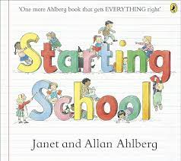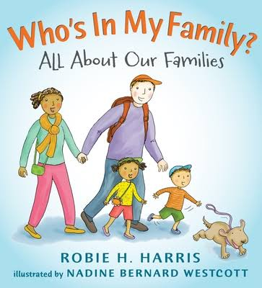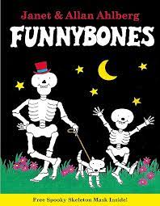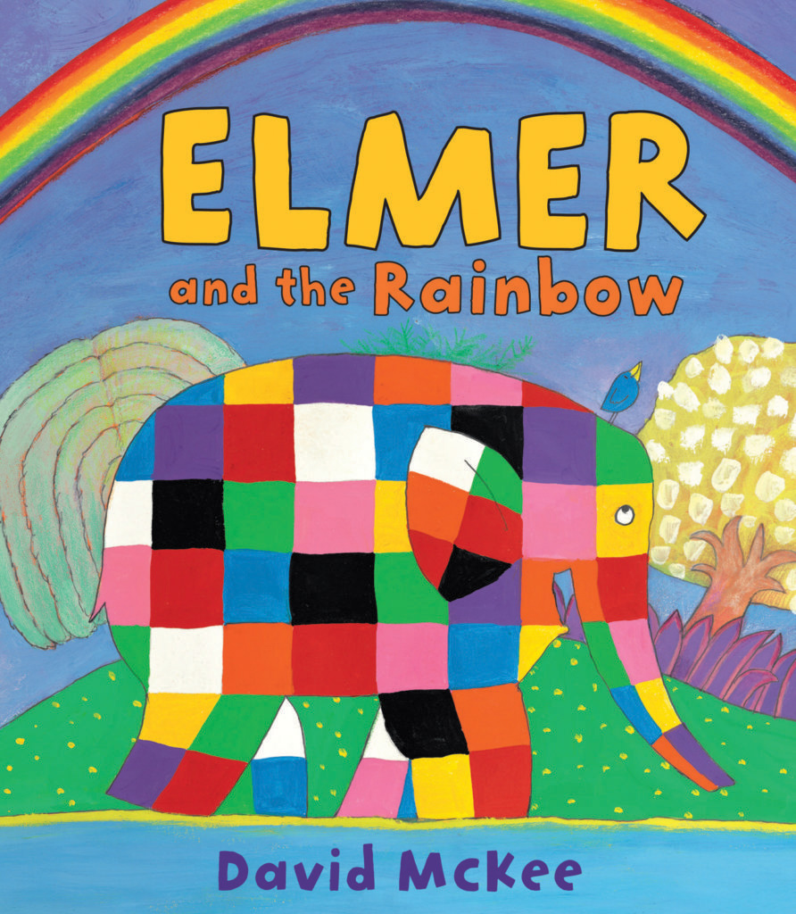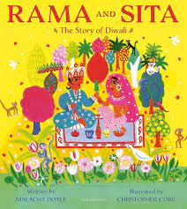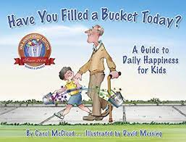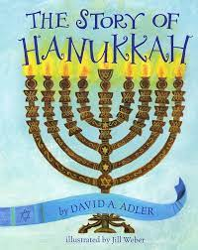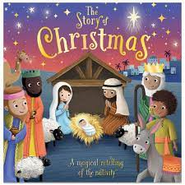

HOW YOU CAN HELP AT HOME:

UNDERSTANDING THE WORLD
In this area of learning, the children will have many opportunities to explore their natural environment and world in which they live. They will learn and celebrate different cultures, religions and religious festivals and explore how things were similar or different in the past.
Topics:
Ourselves and Our Families
Light and Dark
Celebrations and Festivals
- Developing positive attitudes about the differences between people; celebrating diversity in our class.
- Talking about members of our immediate family and our community.
- Describing what we see, hear and feel whilst outside and in different environments.
- Comparing & contrasting characters from stories, including figures from the past.
- Celebrating diversity in religion by recognising that people have different beliefs & celebrate special times in different ways.
- Understanding that some places are special to members of our community.

