Reception
Term | Autumn 1 | Autumn 2 | Spring 1 | Spring 2 | Summer 1 | Summer 2
Links to Development Matters | Physical Development (6)  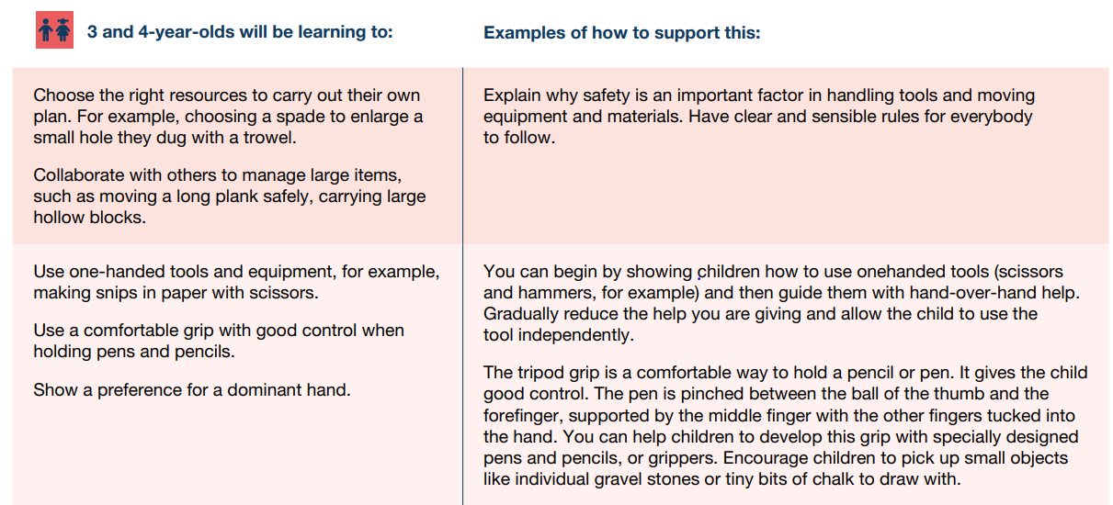  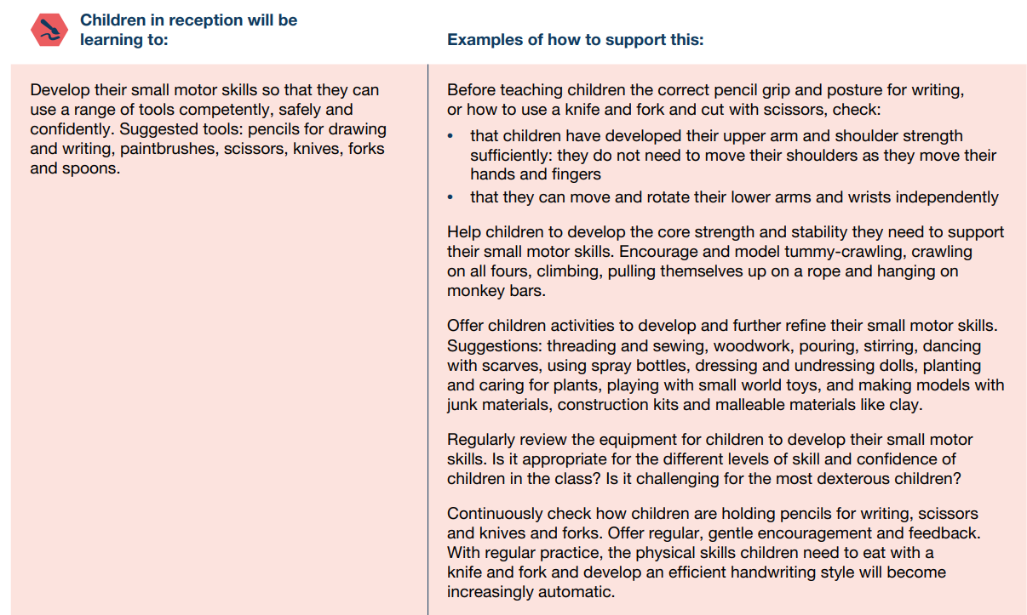  Understanding the World (9)  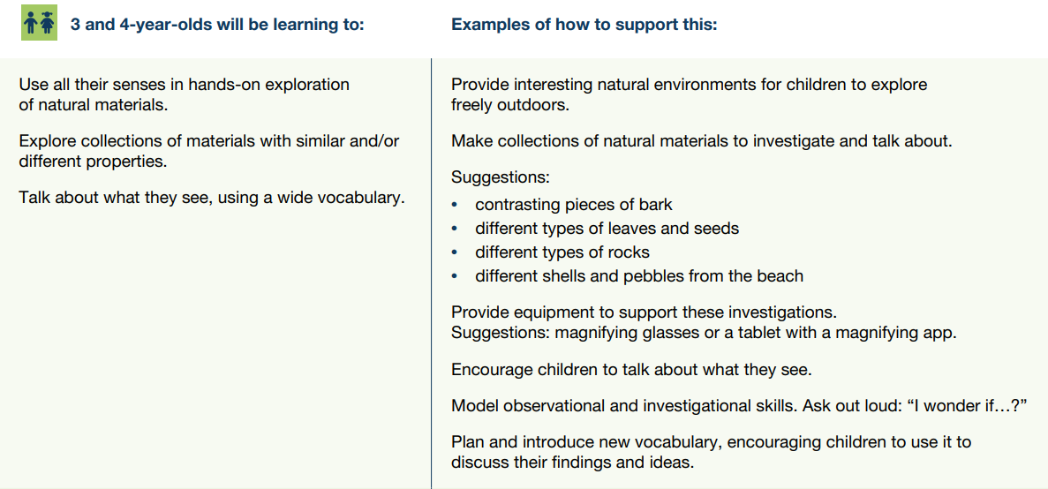  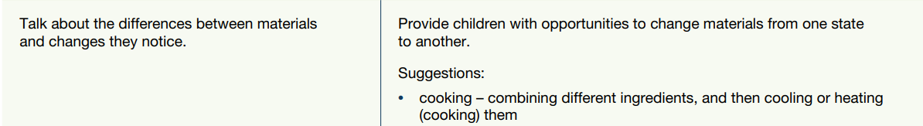  Expressive Arts and Design (10)  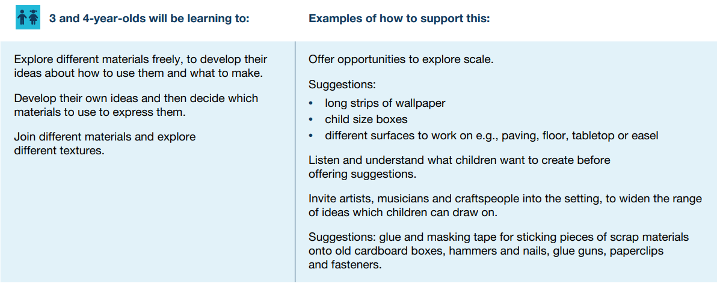  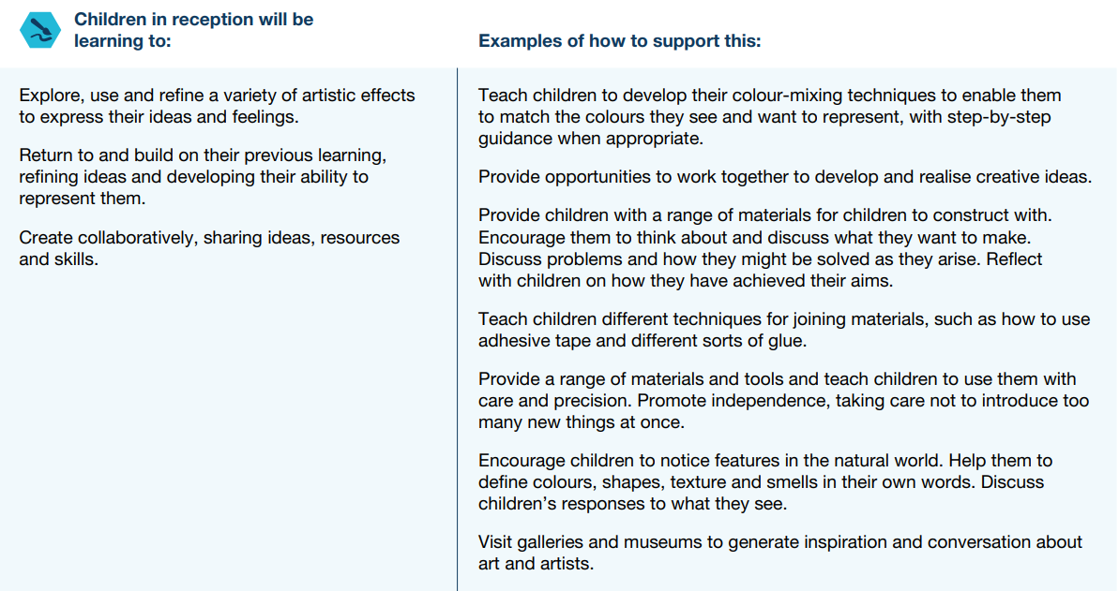

Year 1
Term | Autumn 1 | Autumn 2 | Spring 1 | Spring 2 | Summer 1 | Summer 2
Topic of the term | Where do we come from |  | Felt Explorers |  | Local Area – Food
D&T unit |  | Mechanisms - Making a pop-up card  Humanities link winter card or festival Xmas/ Diwali card.  Lesson 1 - Children to investigate ways to create a moving picture with mechanisms.  Lesson 2 - Children will explore the different possible ways of creating moving pictures using levers, pop ups and split pins.  Lesson 3 - Children to investigate and practice the skills to create the different mechanisms before selecting and designing their own card based on that mechanism.  Lesson 4 - Children to design a lever, split pin or pop up card.  Lesson 5 – Children to make the card that they designed.  Lesson 6 - Children to evaluate their end product. |  | Textiles - Felt puppet  Lesson 1 – To look at a variety of puppets, how they are designed and made.  Lesson 2 – To design own animal puppet and label the resources needed.  Lesson 3 – To learn how to do a running stitch and practice this skill.  Lesson 4 – To create hand puppet, cutting around material and using running stitch learnt.  Lesson 5 – To decorate the front of the puppet, sewing on different features of the animal.  Lesson 6 – To evaluate puppet. |  | Food - Healthy Snacks  Link with humanities  Lesson 1 - Children will taste a selection of the same fruit comparing different qualities. (CCL – Science senses – taste)  Lesson2 - Children will taste test a variety of fruit describing their properties.  Lesson 3 Children will investigate different healthy snacks and carry out a survey of what their peers like and would be popular.  Lesson 4 - Children will design 2 different healthy snacks suitable for the Christmas party.  Lesson 5 - Children will carry out a survey of which snacks will be most popular.  Lesson 6 - Children will plan the making process and sequence their making considering all ingredients and equipment for one of the healthy snacks.  Lesson 7 - Children will make their own healthy snack and then evaluate their snack.
Links to National Curriculum | Design  * Design purposeful, functional, appealing products for themselves and other users based on design criteria  * Generate, develop, model and communicate their ideas through talking, drawing, templates, mock-ups and, where appropriate, information and communication technology  Make  * Select from and use a range of tools and equipment to perform practical tasks [for example, cutting, shaping, joining and finishing]  * Select from and use a wide range of materials and components, including construction materials, textiles and ingredients, according to their characteristics  Evaluate  * Explore and evaluate a range of existing products  * Evaluate their ideas and products against design criteria Technical knowledge  * Build structures, exploring how they can be made stronger, stiffer and more stable  * Explore and use mechanisms [for example, levers, sliders, wheels and axles], in their products
Skills | Technical knowledge  * Build structures, exploring how they can be made stronger, stiffer and more stable  * Explore and use mechanisms [for example, levers, sliders, wheels and axles], in their products.  Cooking and nutrition  As part of their work with food, pupils should be taught how to cook and apply the principles of nutrition and healthy eating. Instilling a love of cooking in pupils will also open a door to one of the great expressions of human creativity. Learning how to cook is a crucial life skill that enables pupils to feed themselves and others affordably and well, now and in later life. Pupils should be taught to: Key stage 1  * Use the basic principles of a healthy and varied diet to prepare dishes  * Understand where food comes from.

Year 2
Term | Autumn 1 | Autumn 2 | Spring 1 | Spring 2 | Summer 1 | Summer 2
Topic of the term | Bright Lights, Big City |  | Perfect Penguins |  | Houses and Home
D&T unit |  | Mechanisms – Moving vehicles from the past. Wheels and axles. Links to GFOL  Lesson 1: Children will look at vehicles past and present to see how they have changed.  Lesson 2: Children will explore how to make different axels using different wheels and materials  Lesson 3: Children will design their own cart  Lesson 4 and 5: Children will make their cart that could have been used to transport goods during the GFOL  Lesson 6: Children will evaluate their finished product  Lesson 7: Making a healthy lunch (CCL History Florence Nightingale day – Making a hearty stew) |  | Mechanisms - Moving Penguins  Lessons 1 & 2: Children will take inspiration from design throughout history. Children will master practical skills and explore how products have been created from moving lever books. In the lesson children will explore different types of levers.  Lesson 3: Children will design 1st class levers that have a clear purpose and an intended user for a moving dinosaur.  To design their design for the class book background and dinosaur  Lessons 5 & 6: Children will make, evaluate and improve  refining the design as work progresses. Children will make their moving dinosaurs using levers and create their page of the story  Lesson 7: Children will evaluate their finished product (dinosaur lever page for the class book for reception) |  | Textiles – Picture Frame  Lessons 1: Children will take inspiration from design throughout history. Children will look at different photo frames made from different materials and different fixings and evaluate them.  Lesson 2: Children will master practical skills. Children will explore joining different materials straws, wood, paper etc. together to see what may create a good picture frame.  Lesson 3 & 4: Children will design, make, evaluate and improve. Children will design their picture frame using drawings and a computer programming software to design their aesthetics.  Lessons 5 & 6: Children will design, make, evaluate and improve. Children will master practical skills. Children will cut their frame and attach it together.  Lesson 7: Children will evaluate their finished product
Links to National Curriculum | Design  * Design purposeful, functional, appealing products for themselves and other users based on design criteria  * Generate, develop, model and communicate their ideas through talking, drawing, templates, mock-ups and, where appropriate, information and communication technology  Make  * Select from and use a range of tools and equipment to perform practical tasks [for example, cutting, shaping, joining and finishing]  * Select from and use a wide range of materials and components, including construction materials, textiles and ingredients, according to their characteristics  Evaluate  * Explore and evaluate a range of existing products  * Evaluate their ideas and products against design criteria
Skills | Technical knowledge  * Build structures, exploring how they can be made stronger, stiffer and more stable  * Explore and use mechanisms [for example, levers, sliders, wheels and axles], in their products.  Cooking and nutrition  As part of their work with food, pupils should be taught how to cook and apply the principles of nutrition and healthy eating. Instilling a love of cooking in pupils will also open a door to one of the great expressions of human creativity. Learning how to cook is a crucial life skill that enables pupils to feed themselves and others affordably and well, now and in later life. Pupils should be taught to: Key stage 1  * Use the basic principles of a healthy and varied diet to prepare dishes  * Understand where food comes from.

Year 3
Term | Autumn 1 | Autumn 2 | Spring 1 | Spring 2 | Summer 1 | Summer 2
Topic of the term
D&T unit |  |  | Food - Healthy and varied diet. Making a healthy lunch  Lesson 1 – To master practical skills - Recap on the food groups with a focus on Carbohydrates. Taste test a variety of carbohydrates that will be the base for their healthy lunchtime meal design – questionnaire/ survey for each food product.  Lesson 2 – To design, make evaluate and improve - Design a healthy lunchtime meal using vegetables found (traded) in Europe.  Lesson 3 and 4– To master practical - To learn how to use the cooking utensils correctly and hygienically and to assemble/ cook ingredients controlling the temperature.  Lesson 5 – To design, make evaluate and improve - Evaluate my end product- discuss likes and possible changes. |  | Electrical systems - Simple circuits and switches (including programming and control) Making a torch  Lesson 1: Children will take inspiration from design throughout history - They will discuss, investigate and dissemble different battery-powered products including torches to understand how they work. Battery powered and mains. They will investigate different types of switches, including those with toggles and casing to protect it from electricity. They will discuss the dangers of mains electricity.  Lesson 2: Children will master practical skills. They will create a simple circuits involving a lightbulb. They will make a variety of switches by using simple classroom materials – foil, paper fasteners, corrugated plastic etc. to test in a series of simple circuits  Lesson 3: Children will design, make evaluate and improve. They will design a simple circuit on the computer.  Lesson 4: Children will design, make evaluate and improve. Children will design and label their own torch.  Lesson 5 & 6: Children will design, make evaluate and improve when making their torch.  Lesson 7: Children will evaluate their finished product relating back to the success criteria | Food - Healthy and varied diet. Making a healthy lunch  Lesson 1 – To master practical skills - Recap on the food groups with a focus on Carbohydrates. Taste test a variety of carbohydrates that will be the base for their healthy lunchtime meal design – questionnaire/ survey for each food product.  Lesson 2 – To design, make evaluate and improve - Design a healthy lunchtime meal using vegetables found (traded) in Europe.  Lesson 3 and 4– To master practical - To learn how to use the cooking utensils correctly and hygienically and to assemble/ cook ingredients controlling the temperature.  Lesson 5 – To design, make evaluate and improve - Evaluate my end product- discuss likes and possible changes.
Links to National Curriculum
Skills | Technical knowledge  * Apply their understanding of how to strengthen, stiffen and reinforce more complex structures  * Understand and use mechanical systems in their products [for example, gears, pulleys, cams, levers and linkages]  * Understand and use electrical systems in their products [for example, series circuits incorporating switches, bulbs, buzzers and motors]  * Apply their understanding of computing to program, monitor and control their products  Cooking and nutrition  As part of their work with food, pupils should be taught how to cook and apply the principles of nutrition and healthy eating. Instilling a love of cooking in pupils will also open a door to one of the great expressions of human creativity. Learning how to cook is a crucial life skill that enables pupils to feed themselves and others affordably and well, now and in later life. Pupils should be taught to: Key stage 2  * Understand and apply the principles of a healthy and varied diet  * Prepare and cook a variety of predominantly savoury dishes using a range of cooking techniques  * Understand seasonality, and know where and how a variety of ingredients are grown, reared, caught and processed

Year 4
Term | Autumn 1 | Autumn 2 | Spring 1 |  | Spring 2 | Summer 1 |  | Summer 2
Topic of the term
D&T unit |  | Food Healthy and varied diet Making a Flat bread.  (Link with Humanities Greeks)  Lesson 1 – To take inspiration from design throughout history (to disassemble products) Introduction – taste a variety of Flat breads with different fillings. Evaluate thoughts on the different flat breads likes/dislikes/textures/flavours.  Lesson 2 – To master practical skills to make a Flat bread. Children to follow a simple recipe in a group to make a Flat bread.  Lesson 3 - To design a Flat bread for the school canteen, using my knowledge of Greek fillings and research from the first lesson. Children to design their own flat bread and annotate with equipment needed and ingredients.  Lesson 4 and 5 – To master practical skills to make the flat bread using my own design. Children to use the correct equipment and follow a recipe to make a flat bread – with their own filling. To then taste their final product – photo  Lesson 6 – To evaluate my work and write a step by step on how I created my flat bread. | Mechanical systems - Levers and linkages – making a storybook  Lesson 1 – To take inspiration from design throughout history. To explore examples of moving book, greeting cards, pop up books and moving parts. Look at the mechanisms used.  Lesson 2- To master practical skills. To experiment by making the different mechanisms.  Lesson 3- To design, make, evaluate and improve and to master practical skills. To plan how to make their book design.  Lesson 4 and 5 – To design, make, evaluate and improve and to master practical skills. Making the moving book using the mechanisms explored.  Lesson 6 – To design, make, evaluate and improve. Evaluate their end product – end of unit assessment. |  |  | Textiles – Batik skills. Punk fashion show.  Lesson 1 – To take inspiration from design throughout history. Children will research Punk design by Vienne Westwood. Creating a mood board.  Lesson 2 – To master practical skills. Children will practice batik skills by applying wax and dye to a design.  Lesson 3 – To design, make, evaluate and improve.  Children will design their thinking about its purpose and design criteria  Lesson 4 – To design, make, evaluate and improve - Children will begin to make their Anglo Saxon purse. They will cut out their purse shape and attached the purse together by stitching the seams together using a running stitch or over stich.  Lesson 5 - To design, make, evaluate and improve  Children will complete making their Anglo Saxon purse by adding their fastening.  Lesson 6 – To design, make, evaluate and improve. Children will evaluate their Anglo Saxon purse/container explaining their strengths, if it meets the original criteria, if it is fit for purpose, how they could make it better next time. – photo of finished product.
Links to National Curriculum | Design  * Use research and develop design criteria to inform the design of innovative, functional, appealing products that are fit for purpose, aimed at particular individuals or groups  * Generate, develop, model and communicate their ideas through discussion, annotated sketches, cross-sectional and exploded diagrams, prototypes, pattern pieces and computer-aided design  Make  * Select from and use a wider range of tools and equipment to perform practical tasks [for example, cutting, shaping, joining and finishing], accurately  * Select from and use a wider range of materials and components, including construction materials, textiles and ingredients, according to their functional properties and aesthetic qualities  Evaluate  * Investigate and analyse a range of existing products  * Evaluate their ideas and products against their own design criteria and consider the views of others to improve their work  * Understand how key events and individuals in design and technology have helped shape the world
Skills | Technical knowledge  * Apply their understanding of how to strengthen, stiffen and reinforce more complex structures  * Understand and use mechanical systems in their products [for example, gears, pulleys, cams, levers and linkages]  * Understand and use electrical systems in their products [for example, series circuits incorporating switches, bulbs, buzzers and motors]  * Apply their understanding of computing to program, monitor and control their products.  Cooking and nutrition  As part of their work with food, pupils should be taught how to cook and apply the principles of nutrition and healthy eating. Instilling a love of cooking in pupils will also open a door to one of the great expressions of human creativity. Learning how to cook is a crucial life skill that enables pupils to feed themselves and others affordably and well, now and in later life. Pupils should be taught to: Key stage 2  * Understand and apply the principles of a healthy and varied diet  * Prepare and cook a variety of predominantly savoury dishes using a range of cooking techniques  * Understand seasonality, and know where and how a variety of ingredients are grown, reared, caught and processed

Year 5
Term | Autumn 1 | Autumn 2 | Spring 1 | Spring 2 | Summer 1 | Summer 2
Topic of the term | The Vikings |  |  |  | Mayans
D&T unit | Structures  Shell structures – making a Viking house for model village of a Viking settlement  Lesson 1 – To take inspiration from design throughout history - To investigate and make annotated drawings of a range of Viking structures. What methods of construction were used? How does the frame structure meet the needs and purposes? How has the framework been strengthened? Reinforced?  Lesson 2 – To master practical skills by cutting safely and measuring accurately - To make different frameworks, cubes, cuboids, pyramids etc- use of triangulation to add strength to the structure. Evaluate things that work and do not work. Experiment with sawing materials.  Lesson 3 – To design, make, evaluate and improve ( design with the user in mind) Design on Viking building incorporating the techniques. Step by step plan- listing materials, sketches from different viewpoints, tools and relate to success criteria.  Lesson 4 and 5 – To master practical skills (develop a range of practical skills to develop a product) To make the structure using design and step by step. Wooden frame at the bottom and straw for the rest. To develop sawing skills.  Lesson 6 – To design, make, evaluate and improve my final product - Evaluate the structures against the criteria and create the class village, including key features of a Viking settlement including rivers- as a team. |  |  | Electrical systems  more complex switched and circuits (including programming, monitoring and control)  designing and making a fire alarm  To create an alarm system for our site manager  Lesson 1 – To take inspiration in design throughout history -use research to discuss a range of relevant products that respond to changes in the environment using a computer controlled programmes such as automatic night lights, alarm systems, security lighting.  Lesson 2 and 3 – To master practical skills -to explore a range of electrical systems that can be used to control their product, simple series circuit, a series circuit with two output devices and parallel circuits with two output devices and two separate switches. Children to practice methods for secure electrical connections.  Lesson 4- To design, make, evaluate and improve - To design a burglar alarm for our school site manager – children to annotate a circuit that they will use and label it with the electrical components and how they would work it as a system with input process, output, list of tools and equipment needed.  Lesson 5 – To master practical skills - Children to make their product.  Lesson 6 – To design, make, evaluate and improve -Evaluate final product – comparing to the original design specification and test it. Test effectiveness for intended user and purpose. |  | Food - Celebrating culture and seasonality - Cooking a Mayan meal  Lesson 1 – To master practical skills (To measure accurately and calculate ratios of ingredients to scale up or down from a recipe) – children to follow recipe to make a Mayan dish tortilla. Label ingredients used.  Lesson 2 - To master practical skills (To measure accurately and calculate ratios of ingredients to scale up or down from a recipe) - mixed beans with quinoa etc – children to compare the two dishes they have made – likes, dislikes.- label ingredients used linked to photo.  Lesson 3 – To take inspiration from designs throughout history (to create and refine a recipe) Children to design their own Mayan inspired dish – taking inspiration from lessons 1 and 2.  Lesson 4 and 5- To master practical skills (to demonstrate a range of cooking techniques and refine a recipe) children to make their Mayan dish. To then taste their dish and evaluate it ready to improve next week.
Links to National Curriculum | Design  * Use research and develop design criteria to inform the design of innovative, functional, appealing products that are fit for purpose, aimed at particular individuals or groups  * Generate, develop, model and communicate their ideas through discussion, annotated sketches, cross-sectional and exploded diagrams, prototypes, pattern pieces and computer-aided design  Make  * Select from and use a wider range of tools and equipment to perform practical tasks [for example, cutting, shaping, joining and finishing], accurately  * Select from and use a wider range of materials and components, including construction materials, textiles and ingredients, according to their functional properties and aesthetic qualities  Evaluate  * Investigate and analyse a range of existing products  * Evaluate their ideas and products against their own design criteria and consider the views of others to improve their work  * Understand how key events and individuals in design and technology have helped shape the world
Skills | Technical knowledge  * Apply their understanding of how to strengthen, stiffen and reinforce more complex structures  * Understand and use mechanical systems in their products [for example, gears, pulleys, cams, levers and linkages]  * Understand and use electrical systems in their products [for example, series circuits incorporating switches, bulbs, buzzers and motors]  * Apply their understanding of computing to program, monitor and control their products.  Cooking and nutrition  As part of their work with food, pupils should be taught how to cook and apply the principles of nutrition and healthy eating. Instilling a love of cooking in pupils will also open a door to one of the great expressions of human creativity. Learning how to cook is a crucial life skill that enables pupils to feed themselves and others affordably and well, now and in later life. Pupils should be taught to: Key stage 2  * Understand and apply the principles of a healthy and varied diet  * Prepare and cook a variety of predominantly savoury dishes using a range of cooking techniques  * Understand seasonality, and know where and how a variety of ingredients are grown, reared, caught and processed

Term | Autumn 1 | Autumn 2 | Spring 1 | Spring 2 | Summer 1 | Summer 2
Topic of the term  Year 6 |  | Tudor  Textile Purses |  | WW2  Vehicles – create a Tank using motors |  | How has our local shop changed over time  Packaging Design – Product development.
D&T unit |  | 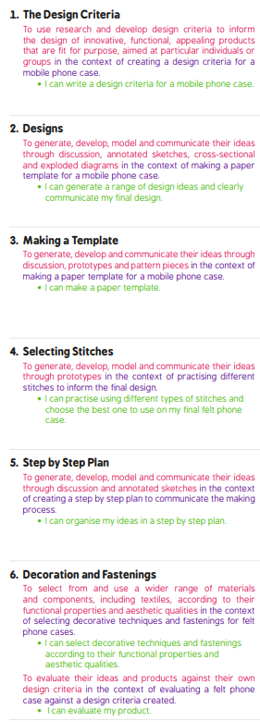 |  | 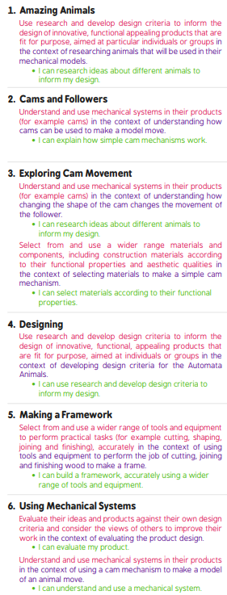 |  | 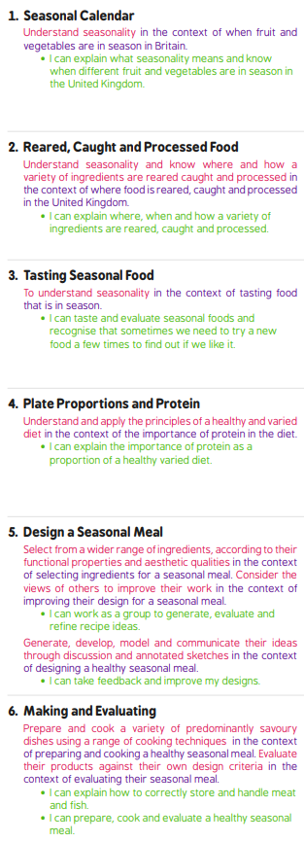
Links to National Curriculum | Design  * Use research and develop design criteria to inform the design of innovative, functional, appealing products that are fit for purpose, aimed at particular individuals or groups  * Generate, develop, model and communicate their ideas through discussion, annotated sketches, cross-sectional and exploded diagrams, prototypes, pattern pieces and computer-aided design  Make  * Select from and use a wider range of tools and equipment to perform practical tasks [for example, cutting, shaping, joining and finishing], accurately  * Select from and use a wider range of materials and components, including construction materials, textiles and ingredients, according to their functional properties and aesthetic qualities  Evaluate  * Investigate and analyse a range of existing products  * Evaluate their ideas and products against their own design criteria and consider the views of others to improve their work  * Understand how key events and individuals in design and technology have helped shape the world
Skills | Technical knowledge  * Apply their understanding of how to strengthen, stiffen and reinforce more complex structures  * Understand and use mechanical systems in their products [for example, gears, pulleys, cams, levers and linkages]  * Understand and use electrical systems in their products [for example, series circuits incorporating switches, bulbs, buzzers and motors]  * Apply their understanding of computing to program, monitor and control their products.  Cooking and nutrition  As part of their work with food, pupils should be taught how to cook and apply the principles of nutrition and healthy eating. Instilling a love of cooking in pupils will also open a door to one of the great expressions of human creativity. Learning how to cook is a crucial life skill that enables pupils to feed themselves and others affordably and well, now and in later life. Pupils should be taught to: Key stage 2  * Understand and apply the principles of a healthy and varied diet  * Prepare and cook a variety of predominantly savoury dishes using a range of cooking techniques  * Understand seasonality, and know where and how a variety of ingredients are grown, reared, caught and processed.

