19th September 2025

Dear Parents and Carers,

RE: Ashmole Primary School Scholastic Book Fair October 2025

We are very excited to have our Book Fair arriving back at our school at the beginning of October. Come along, have a browse, see if there are any books that you would like to buy and celebrate reading at Ashmole!
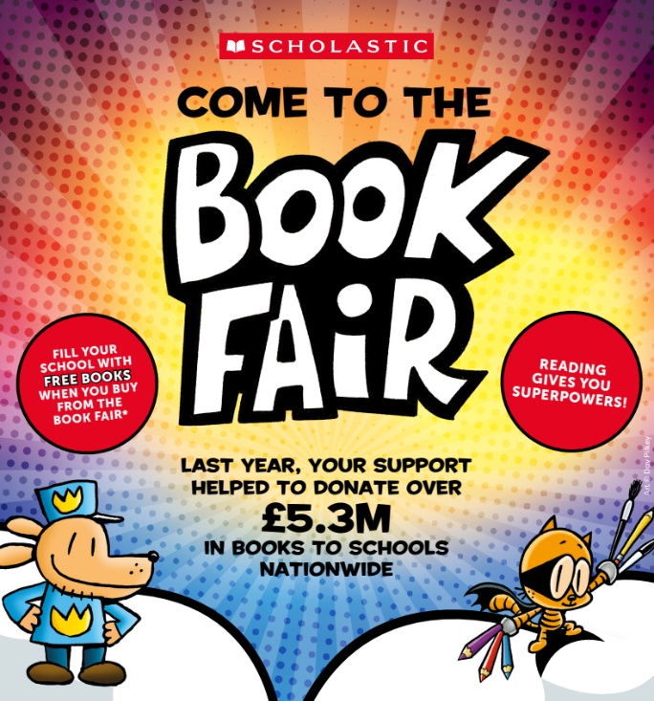
WHEN:
FRIDAY 3RD OCTOBER – WEDNESDAY 8TH OCTOBER 2025

TIME:
8:30am-9:00am and 3:15pm-3:45pm

WHERE:
ASHMOLE PRIMARY SCHOOL HALL
There are over 200 titles for you and your child to choose from and with prices starting from only £2.99, there is sure to be a book for everyone.
Our event will be cashless and payments will be taken via a PayPal app. There will be QR Codes available for you to pay as well. You are also able to pay online via this link: https://bookfairs.scholastic.co.uk/pay/1437475
Every book that you buy can help us to earn rewards to get FREE BOOKS for our school libraries! We look forward to seeing you at the Book Fair!
Yours faithfully

Mrs Powell
English Subject Leader

