Ashmole Primary School Planning Overview- Autumn Term 2025 – Year 1
This term our theme is ‘It’s Good to be Me!’.
‘’It’s Good to be Me!’ will give all the children the opportunity to learn from a source very personal to themselves (their ‘Me Box’). They will be thinking about and discussing their family life, culture, things that are important to them and things that make them special.

Values  As part of our ‘It’s Good to be Me!’ We will continually be celebrating excellent work and showing self-belief by completing more challenging tasks. We will demonstrate responsibility by taking on monitor roles within the classroom. | Main topic  After the October half term, we will each use our ‘Me Box’ to develop our enterprise skills of: self-confidence, team work and sharing.  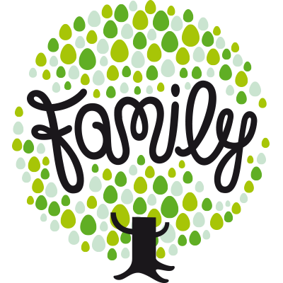 | Enrichment  To enrich the curriculum, we will be putting on a nativity performance for parents/carers.

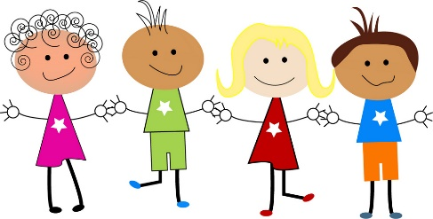
As historians we will be:
investigating and interpreting the past by sequencing events relevant to ourselves. We will be using our ‘Me Box’ to generate vocabulary to communicate history from the time we were born.

As scientists will be:

we will be:

As artists we will be:
be creating self-portraits, focusing on adding detail to different parts of our face. We will explore using different types of paint and the identifying the different textures and effects we can create. We will also practise our ability to control a paintbrush and to mix paint colours.

As design technologists our focus is ‘Food’. We will be exploring where foods come from and how different products have been created. We will identify our likes and dislikes through taste testing to design a healthy snack. We will demonstrate skills such as cutting, peeling and grating while following health and safety procedures.

investigating our environment by observing seasons throughout the year and sharing our ideas. We will also be looking closely at the changes to animals and plants. Linking into our theme, we will be exploring the four seasons and the changes that occur during each season. We will be investigating the differences that we see in the UK and finally we will investigate how to measure rainful.

As geographers we will be:
investigating places by sharing the adventures of Barnaby Bear as he travels around the world comparing them to places visited by the children. We will be looking at different forms of transport, locations and geographical features of the places visited by Barnaby. We will explore the map of the UK and locate capital cities.

