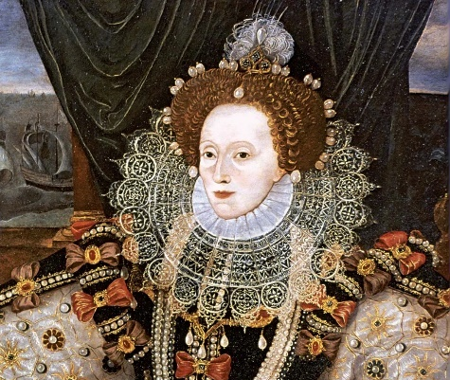
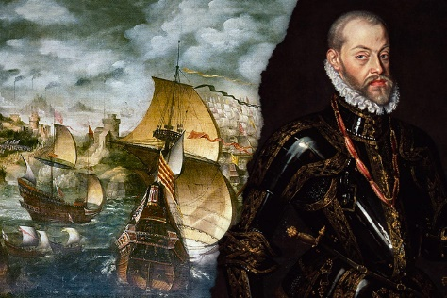
D&T: This term, we will be designing and crafting our own Tudor-style money pouches. We will develop skills of threading needles and joining textiles using a range of stitches.

RE:
In Religious Education, we will explore Big Questions about what different religions and worldviews teach about reality and where we come from. We will look at the nature of the ultimate reality within different worldviews and understand the origins of religious and worldview beliefs . The children will be able to reflect on their own personal view of reality and where we come from.

Science:Electricity
The children will learn how to describe parts of an electrical circuit, explore voltage, learn about circuits, build a set of traffic lights and apply knowledge of conductors and insulators
Light
The children will explore how light travels, explore reflection, investigate shadows and explore the light phenomena.

PE: We will cover sporting activities such as:
- Gymnastics – Matching & Mirroring
- Outdoor Education: Comms & Tactics
- Invasion Games: Tag Rugby
- Dance: Carnival-themed

Games – Invasion - Hockey

Geography:

As geographers, our investigations are all based around the big question: What difference has 500 years made to Docklands? Where we will be exploring areas to explain:
- Where is London Docklands?
- How can we describe London Docklands?
- What did the area use to look like?
- How has it changed over time?
- How can we present the changes in data?

Art:
As artists, we will be investigating the work of portrait artists. The pupils will be using different techniques to draw portraits of historical figures such as Queen Elizabeth I and Sir Francis Drake - working from a variety of resources!

Music:
As musicians we will be lucky enough to study a new instrument and learn how to perform a range of musical pieces on the African Drums.

The Tudors

History:
As historians, our investigations are all based around the big question: Why was Spain at War with the Tudors? We will take a journey back in time to find out:
- When and who were the Tudors?
- Where did they go?
- Who won the conflict with the Spanish? How?

bui
In Computing, we will be focusing on the topics of:

- We are Game Developers
- We are Computational Thinkers.
We will use sequence, selection and repetition in programs; work with variables and various forms of input and output. We will also use logical reasoning to explain how some simple algorithms work and to detect and correct mistakes.

Literacy:
We will be looking at the works of various authors such as:
- Anthony Horowitz (Stormbreaker)
- Michael Morpurgo (Kensuke’s Kingdom)
- Roald Dahl (Boy)
- Shakespeare (Macbeth)
We will be learning to:
- Write diary entries
- Write instructions
- Write letters formal and informal
- Plan and create biographies and autobiographies
- Write narratives
- Use flashbacks
- Write newspaper reports
- Create a graphic novel
- Write non- chronological reports
- Analyse and write poetry
We will also be practising our handwriting, spellings and grammar in specific allocated lessons during the week.
This term you can help your child at home by:

- Allowing children to use ‘Swiggle to search for relevant information on the internet whilst being aware of e-safety.
- Learning your times table to x12 and the related division facts -rapid recall fact, prime, cubed and squared numbers.
- Linking Maths concepts to everyday life by solving problems using the four operations (+, -, x, ÷.)
- Identifying different coins and notes and allowing children to become familiar with money by paying for items, counting out money boxes and calculating change.
- Encouraging your child to tell the time using both digital and analogue clocks.
- Supporting your children in learning their weekly spellings.
- Reading with your child and checking they have completed their reading journals.
In PSHE our topics will be:
- Me and my Relationships
Where the children will learn about relationships and respecting the views of other beliefs and cultures.
- Valuing Difference
Where the children will reflect on and give reasons for why some people show prejudiced behaviour and sometimes bully for this reason.
The children will learn about relationships and respecting the views of other beliefs and cultures.
In our Maths lessons, we will learn how to:

- Read, write, order and compare numbers up to 10 000 000 and determine the value of each digit
- Round any whole number to a required degree of accuracy
- Solve number and practical problems that involve all of the above
- Securing number facts, understanding shape, relationships and calculating
- Identify the value of each digit in numbers given to three decimal places and multiply and divide numbers by 10, 100, 1000.
- Use, read write and convert between standard units, converting measurements of length, mass and volume
- Solve problems involving the calculation and conversion of units of measure, using decimal notation up to three decimal places where appropriate.
- Calculating, measuring and understanding shape
- Multiply multi-digit numbers up to 4 digits by a two-digit whole number using the formal written method of long multiplication
- Multiply one-digit numbers with up to two decimal places by whole numbers
- Divide numbers up to 4 digits by a two-digit whole number using the formal written method of short division, and interpret remainders as a whole number, remainders, fractions, or by rounding, as appropriate for the context
- Use written division methods in cases where the answer has up to two decimal places

