As scientists, we will be exploring the key concepts of evolution and inheritance, including animal characteristics and fossils. We will also be learning about our own inherited traits!.

In RE, we will be further deepening our understanding of how members of the Hindu community contributed to the building of the Mandir and how serving the community is a way of showing devotion to God.

As athletes, we will further develop our skills and tactics in:
Throwing Football
Jumping Rounders
Running Dodgeball
Memory Box
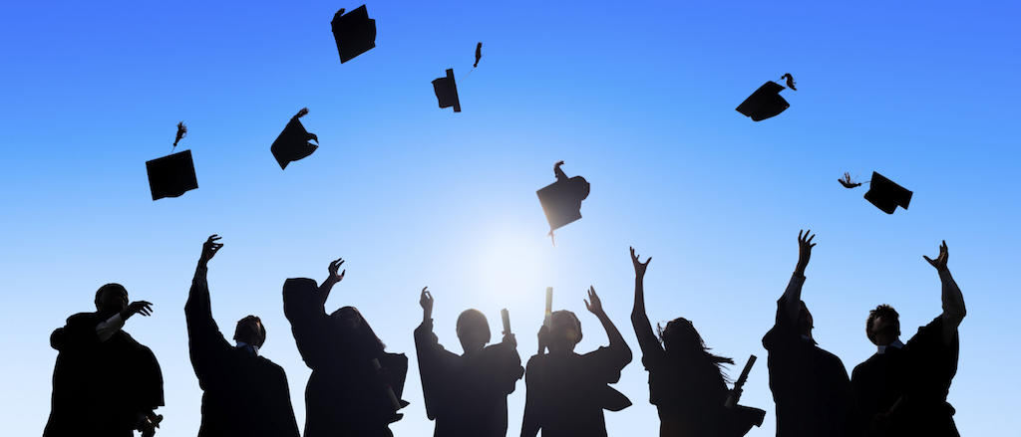

In DT we will be exploring the properties of seasonal food and using research and design skills to prepare healthy, savoury meals.

In our daily English lessons, we will focus on further developing our literacy skills in:

- Writing stories that contain mythical, legendary or historical characters and events.

- Writing persuasively with well-balanced arguments, opinions and evidence.

- Writing carefully-constructed explanations.

- Using older literature to write in the style of other authors.
As artists, we will be thinking about our experiences throughout primary school and assembling our memory boxes. We will showcase our skills in still life art to create range of graphic representations of the memories evoked from this end of year project.
As historians, we will be looking back at our time in primary school to collaborate in creating a memory book of our work, memoirs, souvenirs and photos of our favourite experiences.

This term our theme is ‘Memory Box.’ We will be spending our final term looking back over our time growing and learning at Ashmole primary School as part of our transition into secondary education.
As musicians, we will be working on the Summer Production through learning a number of songs as a class, in small groups and as solos. Pupils will develop their confidence and technique as singers and sing songs in unison and in parts. They will work on a song as a class to be performed at the leaver’s assembly.

In computing, we will be using and combining a variety of software on a range of digital devices to design and create a range of programs, systems and content that accomplish given goals, including collecting, analysing, evaluating and presenting data and information.

As geographers, we will be looking at the causes of global warming and what greenhouse gases are. We will explore, compare and discuss the natural causes of climate change (such as orbital change, solar variation and volcanic eruptions), as well as the evidence and effects of human involvement.

In our daily Maths lessons, we will focus on:

- Multiplying and dividing fractions

- Ratio and proportion

- Geometry

- Coordinates

- Translation and reflection

- Statistics and measurement

- Pie charts, line graphs and conversion

Once these areas of learning are covered and consolidated, we will look forward to tackling a range of themed projects throughout the final stages of Year 6.

This term you can help your child at home by:

- Collecting photos of previous learning/experiences across your child’s progression through primary school.

- Researching the causes and effects of global warming.

- Encouraging your children to revise their multiplication tables to x12 and the related division facts (e.g. rapid recall fact, prime, cubed and square numbers).

- Exploring the benefits of healthy eating and exercise. Then encourage your children to prepare healthy meals with a range of ingredients and cooking utensils.

- Discussing with your children some of the ways in which people’s emotions can change as they are growing up and what it is caused by.
In PSHE, we will be exploring the topics of:

Being My Best: Talking about how we can overcome problems and challenges on the way to achieving our goals.

Growing & Changing: Talking about some of the emotional changes associated with ‘puberty’ and how people may feel when their bodies change.

