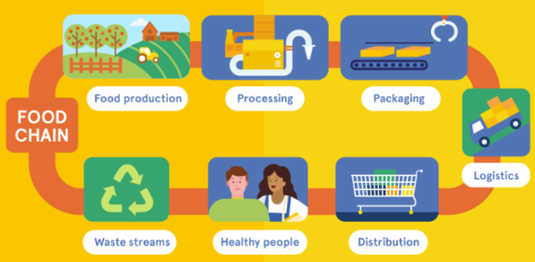
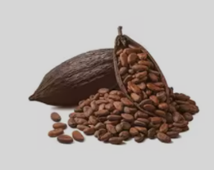

In humanities, we will learning and investigating the impact of transportation of ‘The food on our plate’ and how it could have a negative impact on our climate and the carbon footprint. We will learn about sustainability and buying foods which are locally grown. We will be exploring the concept of fair-trade and its impact on people and communities around the world investigating the journey of everyday products such as chocolate and other foods, tracing their origins from farm to shop.
We will be exploring the history of transportation for goods and link this to the importance of rivers. We will compare the lives of fair-trade farmers with the non-fair-trade systems developing empathy and understanding of global inequality.
As artists, we will be exploring the expressive potential of clay, inspired by the sculptures of Henry Moore. We will be focusing on shape and texture and learning key techniques such as coiling, pinching and joining. Through sketching and observational drawing, we will develop an understanding of the human figure and natural forms. We will experiment with tools to create texture and refine finishes.
As design technologists, we will be introducing the use of electrical components in our Design and Technology lessons. The children will learn about the different parts in an electrical circuit and experiment with creating their own complete circuits to make a torch.

As scientists, we will be covering;
Magnets and Forces
We will be
- Exploring contact and non-contact forces.
- comparing how things move on different surfaces
- Exploring different types of magnets
- Exploring the properties of magnets and everyday objects that are magnetic
- Understanding that magnetic forces can act at a distance
- Exploring the everyday uses of magnets
Light and Shadows
We will be
- Identifying the difference between light sources and non-light sources
- Exploring the light that comes from the sun and how to stay safe
- Exploring materials which are reflective
- Discovering how shadows are formed
- Investigating how shadows change throughout the day
- Investigating how you can change the size of a shadow

.

In RE we will be learning about: The Torah and Stories of Judaism – We will be learning about the Jewish religion and the importance of the Torah. We will link these ideas to consider what is of value in the children’s own lives. We will also be learning about philosophy and humanism.

YEAR 3 Summer Term
Curriculum
Overview
In P.E we will be building on skills already learnt and learning a range of new skills through the use of games, problem solving activities and new equipment.
Health & Well-Being – Mindfulness: Pupils will learn how to execute meditative balances and relaxation techniques to help combat feelings of anxiety.
Athletics- Pupils will develop their ability to run and jump as fast/far as possible with the correct techniques and throw for distance exploring the most effective technique.

In our daily Maths lessons, we will be focussing on becoming masters of our curriculum by:
- Using mental and written strategies to complete calculations using +, -, x and ÷
- Developing our ability to solve worded problems and investigating problems in real life
- Continue learning multiplication tables 2, 5, 10, 3, 4 and 8.
- Fractions - Adding and subtracting fractions. Finding fractions of amounts
- Money – recognising and converting pounds and pence. Adding and subtracting amounts and calculating change.
- Time – Recognising roman numerals, telling the time to the nearest 5 minutes. Working out time intervals and solving problems
- Shape – Naming and describing the properties of 2D and 3D shapes. Comparing angles and different types of lines
- Statistics – Interpreting pictograms and bar charts. Collecting and representing data.

In PSHE, our themes will be Being My Best and Growing and Changing. The children will be learning about types of food we can eat to stay healthy. We will also be finding out how we can celebrate and be proud of our own achievements and see ourselves as the fantastic people that we are. An important part of this topic is also learning about team work and how to work well with our peers and those around us. We will be learning about healthy relationships and also some basic first aid.

This term you can help your child at home by –
- Providing a range of books or resources from the internet that support our theme
- Encouraging your child to be responsible for organising their belongings to support their learning
- Completing everyday maths activities such as telling the time, paying for items in a shop, weighing ingredients when cooking and estimating quantities
- Reading regularly at home in order to develop fluency, expression and the enthusiasm for reading
- Allowing your child to ‘navigate’ on journeys, giving them access to maps and encouraging the use of landmarks and directional language.
- Supporting your child in learning their times tables.

In our daily English lessons, we will be focussing on becoming masters of our curriculum by:
- Spelling with increasing accuracy
- Learning patterns within words, spelling rules and some exceptions to these
- The correct use of punctuation such as:, ? ! … : ; “”
- Developing and applying adventurous vocabulary and sentence openers
- Varying sentence structure with the use of conjunctions, adverbs and prepositions
- Writing for a given purpose relating to the theme: e.g. book review, formal letter, instructions, explanation text, character description and adventure story.
- Considering the narrative, setting, and purpose of our writing in order to engage the reader

In Computing, the children will develop their data collection and presenting skills in the topics of We Are Communicators and We Are Opinion Pollsters. They will become more confident using e-mails to communicate and will design and create their own opinion polls.

In Music, we will be learning how to play the ukulele and we will be working together to put on a performance which you will all be invited to.

