As scientists, we will continue to learn about habitats, learning how to identify that most living things live in habitats to which they are suited and describe how different habitats provide for the basic needs of different kinds of animals and plants. We will then explore the life cycle of a human and the growth we undertake as we age. Describing the basic needs of animals and humans.
As artists, we will be investigating natural dyes and dying techniques to create a textile collage based on different weather patterns. We will also be using different techniques to create clay models inspired by weather.
Habitats of the world
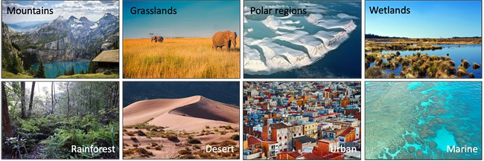
In RE, we will be learning all about Buddhism, starting the topic with a visit to the London Buddhist Centre. We will learn about the festival of Wesak and explore the traditions and customs associated with the Buddhist religion. We will also be exploring the traditions and customs associated with growing up in a Christian family and share experiences to learn what these might mean to some Christians.
As geographers, we will be using a variety of different maps to locate differing climate zones and different weather types. We will then be learning about how weather changes in different seasons and how this can be measured by meteorologists. We will then be exploring life in Africa. Learning all about location and comparing different African countries throughout the continent and using this to identify similarities to our lifestyle in the UK.

As design technologists we will be designing and making a picture frame made from wood to be used to place our end of year photo in. We will use materials and a variety of techniques to make and strengthen the frame. We will then evaluate the end product.

This term our theme is ‘Habitats of the world’ We will be looking at the importance of weather and how different animals are adapted to survive in varying weather conditions. In Geography, we will be learning about climate zones and weather investigating why these countries have differencing weather conditions and how this effects lifestyles.
As musicians we will be identifying and controlling changes in pitch and creating short melodic patterns.
In Computing, we will be focusing on the topics ‘We are Animators’ and ‘We are Zoologists. We will be learning about stop- motion animation. We will learn to plan, film and add audio to our own stop motion film. We will also learn how to create spreadsheets and present date in graphs.
In PSHE, we will continue to focus on ‘Health and Wellbeing’ and Growing and Changing. The children will learn about being our best and also understanding how to keep ourselves clean and healthy. Through our topic ‘Growing and changing’ the children will learn about what our body does for us and how it grows and changes.
In our daily Maths lessons, we will be focussing on:
- Place value and ordering of numbers up to 100.
- Practising addition, subtraction, multiplication and division skills.
- Interpreting and constructing graphs
- Asking and answering questions about statistical data.
- Counting, partitioning and calculating.
- Understanding and using mathematical
- symbols e.g. +, -, x, ÷
- Investigating fractions- identifying halves, quarters and thirds
- Telling the time, identifying the hour and telling time to the nearest 5 minutes
- Mental calculation strategies and problem solving.

- .

This term you can help your child at home by –
• Encouraging a curiosity about things that live in the seas and oceans.
• Looking at maps of the world and discussing the features and characteristics of the continents and locating the different seas and oceans.
• Researching and locating information about Christopher Columbus from a range of sources.
• Allowing children to use ‘Ask Kids’ to search for relevant information on the internet.
• Playing games that involve sending and receiving skills.
• Linking Maths concepts to everyday life by solving problems using the four operations (e.g. +, -, x, ÷.)
• Identifying different coins and notes and allowing children to become familiar with money by paying for items, counting out money boxes and calculating change.
• Encouraging your child to tell the time using both digital and analogue clocks. Focussing on how to solve time problems, related to different time intervals.
In our daily English lessons, we will be focussing on becoming masters of our curriculum by:
- Practising the correct formation of cursive script handwriting.
- Using and developing a range of grammar skills to support writing.
- Writing postcards and diary entries based on the book Meerkat Mail.
- Writing stories based on the style of a familiar author.
- Learning a range of poems to perform and writing their own acrostic, haiku and shape poems.
- To plan and write letters

