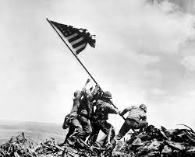
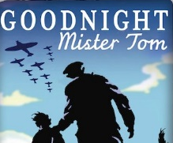
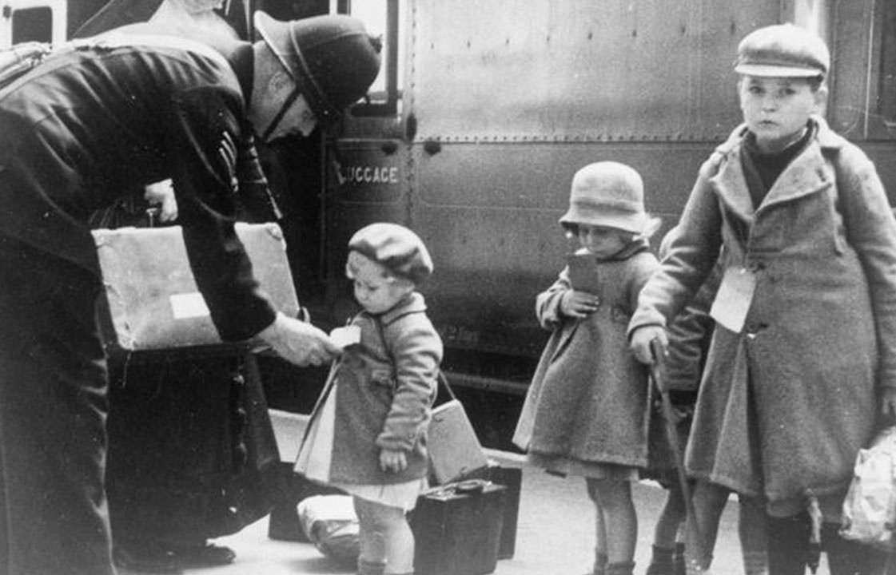
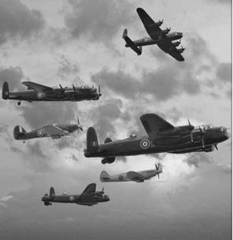
Science:
As scientists, we will be learning about electricity. We will explore how to associate the brightness of a lamp or volume of a buzzer with the number and voltage of cells in a circuit; give reasons for variations in how component function and recognise symbols in a simple circuit diagram.
History:
As historians, we will be investigating WW2. We will learn about WW2 and the impact it had on every-day life, significant dates and the stages of the war. We will find out about evacuation and men and women’s roles; we will investigate images as a source for historical enquiry and show their understanding through art.

Geography:

We will be looking at geographical influences on the Battle of Britain – understanding how the layout of Europe, particularly the British Isles, affected the Battle of Britain itself and why it was significant.

D&T: we will be working on Mechanical Models
- using research and developing design criteria to inform the design of innovative, functional, appealing products that are fit for purpose.
- generating, developing, modelling and communicating our ideas through discussion, annotated sketches, cross-sectional and exploded diagrams, prototypes, pattern pieces and computer-aided design
-using a wider range of tools and equipment to perform practical tasks [for example, cutting, shaping, joining and finishing], accurately
functional properties and aesthetic qualities.
In Music we will be working on how to:
-sing a basic (simple intervals and range of less than an octave) part in tune and in time.
-perform simple parts (using only basic rhythms and no more than an octave range) accurately, fluently and in time with others.
-perform in time and in tune with a group when performing simple pieces.

-experiment with using voice, technology and instruments creatively, investigating ideas and techniques.

-listen to and evaluate music from a range of traditions showing understanding of the musical outcome and context.

In PE we will cover:
Invasion games (Dodgeball)
Net/wall games (Tennis)
Gymnastics (Creating sequences)
Health-related exercise

Games – Invasion - Hockey

In RE we will learn about: Islam & Christianity
- Understanding that the purpose of Hajj is important to Muslims and the significance of being part of a community.

- Understanding that Christians celebrate Easter and that Lent is important to them.

World War II

This term our theme is ‘WW2.’ We will be looking at the importance of the WW2 Era and how the discoveries have impacted on our lives now.

Literacy:
We will be focusing on and exploring the themes of texts such as:
- Goodnight Mr Tom
- Rose Blanche
- Carrie’s War

Throughout the term, the children will be developing skills to:
- write stories/novels in the style of significant children’s authors
- form balanced arguments
- write diary entries and letters inspired by reading across the curriculum
- use older literacy to write in the style of an author
- create free-verse poetry

This term you can help your child at home by:

- Researching the Second World War, its impact on world history and the evolution of global geographical changes since then.
- Allowing children to search for relevant information on the internet whilst being aware of e-safety.
- Encouraging children to use SATs-based resources to help them prepare for their end-of-KS2 exams.
- Allowing your children to explore Microsoft Makecode for micro:bit.
- Learning your times table to x12 and the related division facts -rapid recall fact, prime, cubed and squared numbers.
- Linking Maths concepts to everyday life by solving problems using the four operations (+, -, x, ÷.)
- Identifying different coins and notes and allowing children to become familiar with money by paying for items, counting out money boxes and calculating change.
- Encouraging your child to tell the time using both digital and analogue clocks.

In Computing, we will be focusing on the topics of:
- We are Publishers
- We are Connected
We will use sequence, selection and repetition in programs; work with variables and various forms of input and output. We will also use logical reasoning to explain how some simple algorithms work and to detect and correct mistakes.

In PSHE our topics will be:

- Keeping Safe
The rules and principles for keeping safe online, how to recognise risks, harmful content and contact, and how to report them
- Rights and Respect
To recognise reasons for rules and laws; consequences of not adhering to rules and laws.
In our daily Maths lessons, we will be focusing on:

Ratio:
- Solve problems involving the relative sizes of two quantities
- Solve problems involving similar shapes where the scale factor is known or can be found

Algebra:
- Use simple formulae
- Express missing number problems algebraically

Decimals:
- Add and subtract fractions with different denominators and mixed numbers, using the concept of equivalent fractions
- Associate a fraction with division and calculate decimal fraction equivalents for a simple fraction

Area, perimeter & volume:
- Calculate the area of parallelograms and triangles.
- Recognise that shapes with the same areas can have different perimeter.
- Calculate and estimate and compare the volume of cubes and cuboids using standard units.
- Illustrate and name parts of circles.

