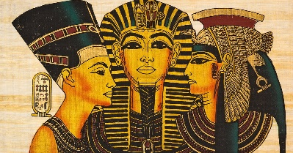
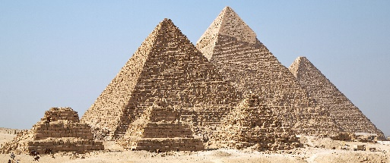
In RE we will be learning about:
Living as a Muslim -
The children will be learning about the religion of Islam and the Muslim festival of Ramadan. They will be learning about where and how Muslims pray and about their beliefs.
.

As historians, we will be investigating and interpreting the past by using primary and secondary sources of evidence to find out about Ancient Egyptian society. We will build up a chronological understanding of their civilisation by creating a timeline of events. We will learn about their beliefs and religious practices, how their society was constructed and their relevance to life today.

As geographers, we will be using maps and atlases at a range of scales to locate and investigate places both in our local area and the geography of Egypt. Our focus will be rivers where we will be looking at physical features around these areas. We will learn about how rivers are formed and their importance to settlements surrounding them and the effects of flooding and uses of the River Nile.

As artists, we will be focusing on Textiles during the Spring Term. The children will be finding out about the technique of printing. They will be looking at different fabrics and the different printing types that have been used. They will focus, in particular, on Egyptian block printing and creating their own patterns and designs.
As design technologists, we will be using our knowledge of the different food groups to carry out a taste test survey in order to design, evaluate and make a healthy lunchtime menu.

As scientists, we will be covering;
Scientific Enquiry – The children will learn how to:
- Ask relevant questions and use different types of scientific enquiries to answer them.
- Set up simple practical enquiries, comparative and fair tests.
- Make systematic and careful observations.
- Use a range of equipment.
- Gather, record, classify and present data in a variety of ways.
- Record findings using simple scientific language, drawings, labelled diagrams, bar charts and tables.
- Use results to draw conclusions, suggest improvements and raise further questions.
- Identify differences and similarities or changes related to scientific ideas.
- Use evidence to answer questions and support their findings.

Animals, including humans – The children will learn how to identify that animals including humans need the right types and amount of nutrition, and that they cannot make their own food; they get nutrition from what they eat. They also learn how to identify that humans and some other animals have skeletons and muscles for support, protection and movement.

YEAR 3 Spring Term
Curriculum
Overview
In Music, we will be listening to a range of different music genres which include ‘Three little birds’ by Bob Marley and ‘The Dragon Song’ by Joanna Mangona and Pete Readman

In our daily English lessons, we will be focussing on becoming masters of our curriculum by:
- Spelling with increasing accuracy
- Learning patterns within words, spelling rules and some exceptions to these
- The correct use of punctuation such as:, ? ! … : ; “”
- Developing and applying adventurous vocabulary and sentence openers
- Varying sentence structure with the use of conjunctions, adverbs and prepositions
- Writing for a given purpose relating to the theme: e.g instructional writing; creative story writing; non-chronological reports; leaflets and Kennings poems
- Considering the narrative, setting, and purpose of our writing in order to engage the reader

In Computing, our topics will be ‘We Are Presenters’ where the children will have the opportunity to work with video cameras to shoot and review videos and ‘We are Vloggers’ where they will be planning and presenting a presentation.

This term you can help your child at home by –
- Providing a range of books or resources from the internet that support our theme
- Encouraging your child to be responsible for organising their belongings to support their learning
- Completing everyday maths activities such as telling the time, paying for items in a shop, weighing ingredients when cooking and estimating quantities
- Reading regularly at home in order to develop fluency, expression and the enthusiasm for reading
- Allowing your child to ‘navigate’ on journeys, giving them access to maps and encouraging the use of landmarks and directional language.

In P.E we will be building on skills already learnt and learning a range of new skills through the use of games, problem solving activities and new equipment.
Dance – We will be responding to different stimuli to add drama and emotion to a ‘weather’ dance.
Games – We will be introducing new skills through games such as Tennis and Netball.

In our daily Maths lessons, we will be focussing on becoming masters of our curriculum by:
- Using mental and written strategies to complete calculations using +, -, x and ÷
- Developing our ability to solve worded problems and investigating problems in real life
- Continue learning multiplication tables 2, 5, 10, 3, 4 and 8.
- Multiplying and dividing 2-digit numbers by 1-digit numbers
- Recognising and writing fractions, comparing and ordering fractions, adding and subtracting fractions and using numbers, words and diagrams to demonstrate fractions.
- Understanding the difference between volume and capacity and applying this knowledge to practical problems.
- Measuring and comparing lengths (m, cm,mm) mass (kg,g) and volume/capacity (l, ml)
- Calculating the perimeter of 2D shapes

In PSHE, we will be learning about keeping ourselves safe which includes aspects of internet safety, identifying people to help us if a situation is unsafe, the risks of ‘drugs’ in terms of cigarettes, alcohol and medicines. We will also be learning about Rights and Responsibilities in terms of looking after our environment and understanding the terms ‘income’ , ‘saving’ and ‘spending’.

