As scientists, we will be covering;
Where does all that food go? – The children will be discussing the importance of a balanced diet and pay particular attention to the different food groups and what they do for us. We will also be learning about the digestive system, with a particular focus on the role of our teeth doing this process.
Human impact- Children will be taught to recognise litter and the different forms of pollution. We will look at how some materials take a long time to break down (if they break down at all) and so will continue to be a problem if left in the environment.

As design technologists, the children will be developing their cooking skills as we will be focusing on food and nutrition. Our D&T topic will link to our Science theme and the children will be creating their own bread.
The children will start by researching different kinds of bakery products and evaluating these, before designing and then making their own.

As geographers, the children will be focusing on Changing Weather. Throughout the topic, the children will work to understand key vocabulary and be able to explain in their own words and they will become confident when applying those words to describe key processes in what is changing all across the world. We will also investigate the impact that this is having on the Rainforest.

In RE we will be learning about:
Religions of the Book- Where we will focus on the Qu’ran and the Bible. Sacred Texts/Books, Teaching and authority
We will make links to all religions and encourage children to find patterns when doing so.

As artists, we will be focusing on the skill of painting. We will be investigating different types of paintings before creating our own. The children will use their knowledge and skills of sketching and painting to create their own paintings of the rainforest.
The Romans!
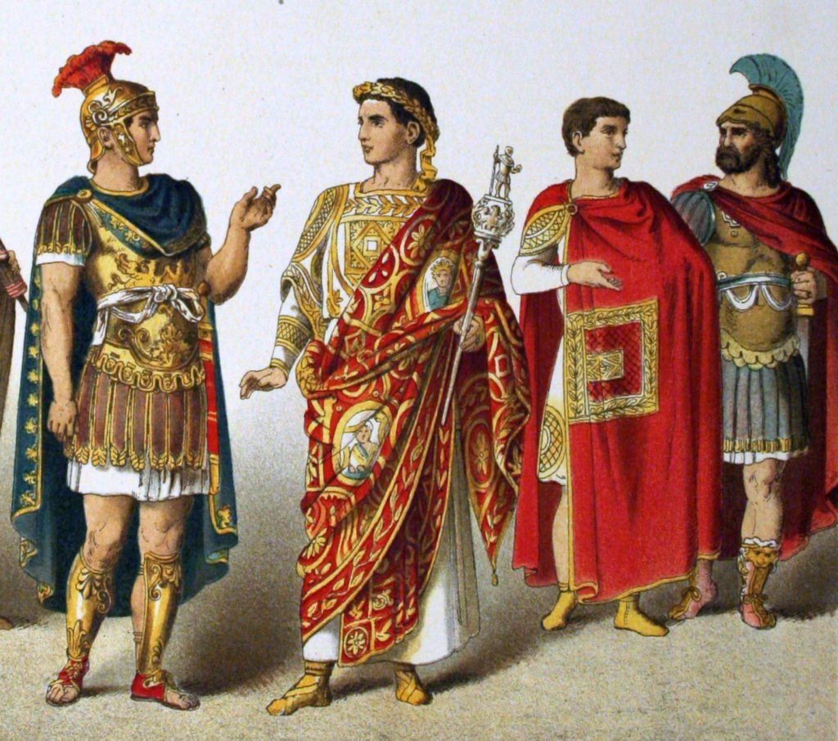
As historians, we will be investigating and interpreting the past by using primary and secondary sources of evidence to find out about The Romans. We will be using evidence to find out about the past and analysing the impact that past events have had on present day. We will be studying major historical events and thinking about how the results of these impacted our country. During our topic, we will also be thinking about the kind of interesting lives the Romans lived!
This term our theme is ‘The Romans’. We will be learning about the Romans by delving deep into a period in time many centuries ago. The children will also be using their skills and creativity to create their bread. In our Changing Weather topic, the children will develop a deeper understanding of the processes in the cycle and how it all directly impact us. In Science, we will be looking at why humans need food and its journey through our body! As well as Human impact on the environment, such as littering.

In Music, we will be listening to a range of different music genres. We will be focusing on rap, soul and gospel.
We will also be learning African drumming.

In our daily English lessons, we will be focusing on becoming masters of our curriculum by:
- Writing for a given purpose relating to the theme: e.g. non-chronological reports, instructions, persuasive letters, playwriting and stories using a film narrative and also stories with a familiar setting
- Learning patterns within words, spelling rules and some exceptions to these.
- Analysing writing similar to that which they are planning to write in order to understand and learn from its structure, vocabulary and grammar
- Focusing on our presentation and joining skills in Handwriting sessions.
- The correct use of various punctuation
- Developing adventurous vocabulary and sentence openers
- Varying sentence structure with the use of conjunctions, adverbs and prepositions
- Using a range of exciting sentence openers.
- Using relevant technical language for purpose eg when writing a persuasive letter linked to looking after the environment.

In Computing this term, our focus will be on creating digital music! Later in the term we will be learning about computer networks. Specifically, editing and writing.

In P.E we will be building on skills already learnt and learning a range of new skills through the use of games, problem solving activities and new equipment.
Our main topics will be:
Gymnastics- where we will focus on bridges.
Football- where we will be focusing on the rules of the game and skills involved.

In PSHE, we will be focusing on ‘Keeping Myself Safe’ and ‘Rights and Responsibilities’’.
The children will understand how to keep themselves safe, online as well as offline. Later in the term children will, understand that humans have rights and responsibilities and focus on identifying some rights and the responsibilities that come with these. They will also be taught to recognise that everyone can make a difference within a democratic process.

This term you can help your child at home by –
- Ensuring they know that it is perfectly acceptable to make mistakes because this is how we learn
- Providing a range of books or resources from the internet that support our themes
- Practise times tables regularly, making sure to go back and repeat tables you have practised before
- Completing everyday maths activities such as telling the time, paying for items in a shop, weighing ingredients when cooking and estimating quantities
- Reading a wide range of writing regularly at home in order to develop fluency, expression and the enthusiasm for reading
- Look up words in a dictionary or thesaurus to find out what they mean or to learn new words meaning the same thing
- Highlight the value in online learning and research, whilst modelling how to stay safe online
- Knowing it is okay to stop if they are tired or lacking interest and try again at another time.

In our daily Maths lessons, we will be focusing on becoming masters of our curriculum by:
- Counting in multiples of 6,7,9,25 and 1000
- Rounding decimals with one decimal place to the nearest whole number
- Comparing and using negative numbers and numbers with decimal places.
- Continuing to add and subtract numbers with up to 4 digits using the formal written methods
- Estimating and using inverse operations to check answers calculation
- Multiplying two-digit and three-digit numbers by a one-digit number using formal written layout
- Dividing using formal written method of short division
- Adding and subtracting fractions.
- Converting between different measures
- Measuring and calculating perimeter.
- Interpreting statistics.

