COMMUNICATION & LANGUAGE
This area will develop the children’s competence in communicating, speaking and listening. The children will have opportunities to use their skills in a range of situations and for a range of purposes.
- To understand how to listen carefully and why listening is important.
- To listen to stories and to recall parts of the story.
- To have two-channelled attention - can listen and do for a short time.
- To be able to listen and respond to other people’s ideas.
- To be able to follow two-part instructions.
- To be able to use a range of tenses (play, playing, will play, played) correctly.
- Ask questions to find out more and to check they understand what has been said to them. To be able to give explanations of why things happen.
- To be able to extend their vocabulary, especially by grouping and naming, when exploring the meaning and sounds of new words.
- To be able to use language to imagine and recreate roles and experiences in play situations.
- To be able to introduce and a storyline or narrative into their play.
- To describe events in some detail.
- To be able to use talk to organise, sequence and clarify thinking, ideas, feelings and events.
- To use talk to explain how things work and why things might happen.
PHYSICAL DEVELOPMENT
In this area the children will be given opportunities to be active and interactive to improve their skills of coordination, control, manipulation and movement.
- To continue to develop strength to move, jump and climb with confidence and competence
- To develop overall body strength, coordination, balance and agility to engage in physical activity
- To be able to move around safely, avoiding other children and obstacles
- To confidently and safely use a range of large and small apparatus indoors and outdoors
- To experiment with different ways of moving on and off apparatus
- To hold a pencil correctly and use the correct letter formations
- To use scissors and other simple tools safely
- To dress and undress independently.
- To consider and manage risks when tackling new challenges
PERSONAL, SOCIAL & EMOTIONAL DEVELOPMENT
This area provides the children with experiences which will help them to develop a sense of themselves and of others; respect for others, social skills and a positive disposition to learn.
- To know how to keep safe
- To know how to work as part of a group and with a partner
- To know how to take turns and share
- To develop confidence and independence
- To develop self-esteem
- To develop patience
- To know how to maintain friendships
- To be sensitive to the needs of others
- To express their feelings and consider the feelings of others
- To be able to solve simple problems without aggression
- To understand the school rules and understand why they are important
- To manage their own personal hygiene
- To learn about the importance of oral hygiene
- To begin to learn about what contributes to healthy living
EYFS Spring Overview 2025

Miss Powell & Miss Burke
MATHS
In maths, children will be supported in learning key number skills, exploring numerical patterns and investigating shape and measurement. This term the children will be exploring the following concepts:
- Counting to 20
- Estimating
- Addition
- Subtraction (less, fewer)
- Length
- Weight
- Time
- Missing numbers
- Subitising
- Counting in 2’s
- 2 more than
- 2 less than
- Money
- Number bonds
- Subtraction
- 2D and 3D shapes
- Composing and decomposing
LITERACY
In literacy, children will be supported in early reading and writing skills. The children will be supported and extended when appropriate. We use a range of books to support the children in learning to read, including Big Cat Collins scheme. Please encourage your children to read a variety of books at home, as well as books sent home from school. This term the children will be learning;
- To be able to write their own name independently
- To be able to hear and say the initial, end and medial sounds in words
- To be able to blend and segment sounds orally
- To recognise phase 2 and 3 graphemes from Little Wandle
- To be able to segment and blend VC and CVC words for reading
- To know the Tricky and High Frequency Words from Phase 2 and 3 Little Wandle
- To read simple phrases and sentences made up of words with known letter sound correspondences and a few exception words.
- To be able to make predictions in stories
- To know that print carries meaning and that in English print is read from left to right and top to bottom
- To spell words by identifying the sounds and then writing the sounds with letters.
- To form lowercase and capital case letters independently
To be able to write labels and captions.
- To be able to use the correct letter formation to communicate meaning.
- To begin to write short sentences in meaningful contexts.

Phase 3 Tricky Words: was, you, they, my, by, all, are, sure, pure

Our topics this term will be:
Food
People Who Help Us
Seasonal Changes – Winter & Spring
UNDERSTANDING THE WORLD
In this area of learning, the children will have many opportunities to explore their natural environment and world in which they live. They will learn and celebrate different cultures, religions and religious festivals and explore how things were similar or different in the past.
Topics:
Food
People Who Help Us
Seasonal Changes – Winter & Spring

- Recognising some similarities and differences between life in this country and life in other countries.
- Exploring the natural world around us.
- Understanding the effect of changing seasons on the natural world.
- Naming and describing people who are familiar.
- To know how to care for living things and the environment.
- To be able to make observations of animals and plants and explain why some things occur.
- To understand the effect of changing seasons in the natural world.
Play turn taking games!
Support with early, practical subtraction and division using physical objects e.g. cars
Count to 10, then 20, then 30 and backwards!
Visit places of interest e.g. the zoo, London
Visit a local park to climb and practise throwing and catching!
Compare the sizes of things using vocabulary like smallest, biggest, taller, shortest
Look for and read numbers in the environment e.g. door numbers
Make something together by following a recipe!

Use a robot voice to sound out words!
Encourage your child to write in their play e.g. shopping list, class register!
At this stage, encourage the children to write the sounds that they can hear in the words.
Read with your child and to your child daily!
Play ‘tricky word’ games!
EYFS Spring Overview 2025
Miss Powell & Miss Burke
EXPRESSIVE ARTS & DESIGN
The children will be encouraged to be imaginative and to explore during play. They will be given opportunities to demonstrate their thoughts, ideas and feelings through a variety of art, music, dance and role play. They will work with a range of tools, materials and construction equipment.
- To explore, use and refine a variety of artistic effects to express their ideas and feelings.
- To create collaboratively, sharing ideas, resources and skills.
- To explore and engage in music making.
- To be able to clap rhythms and use simple percussion instruments.
- To be able to construct with a purpose in mind, using a variety of resources.
- To be able to use a variety of simple tools and techniques competently and appropriately.
- To explore colours and how they can be changed by mixing powder paints.

CORE BOOKS WE WILL BE READING:
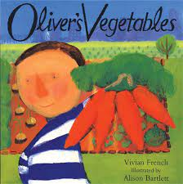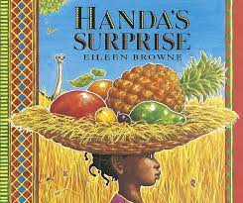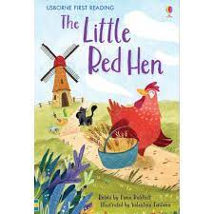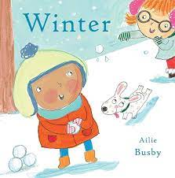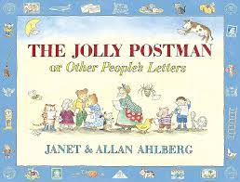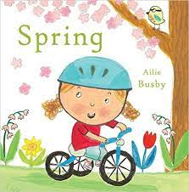

HOW YOU CAN HELP AT HOME:

