Lunchbox Tips
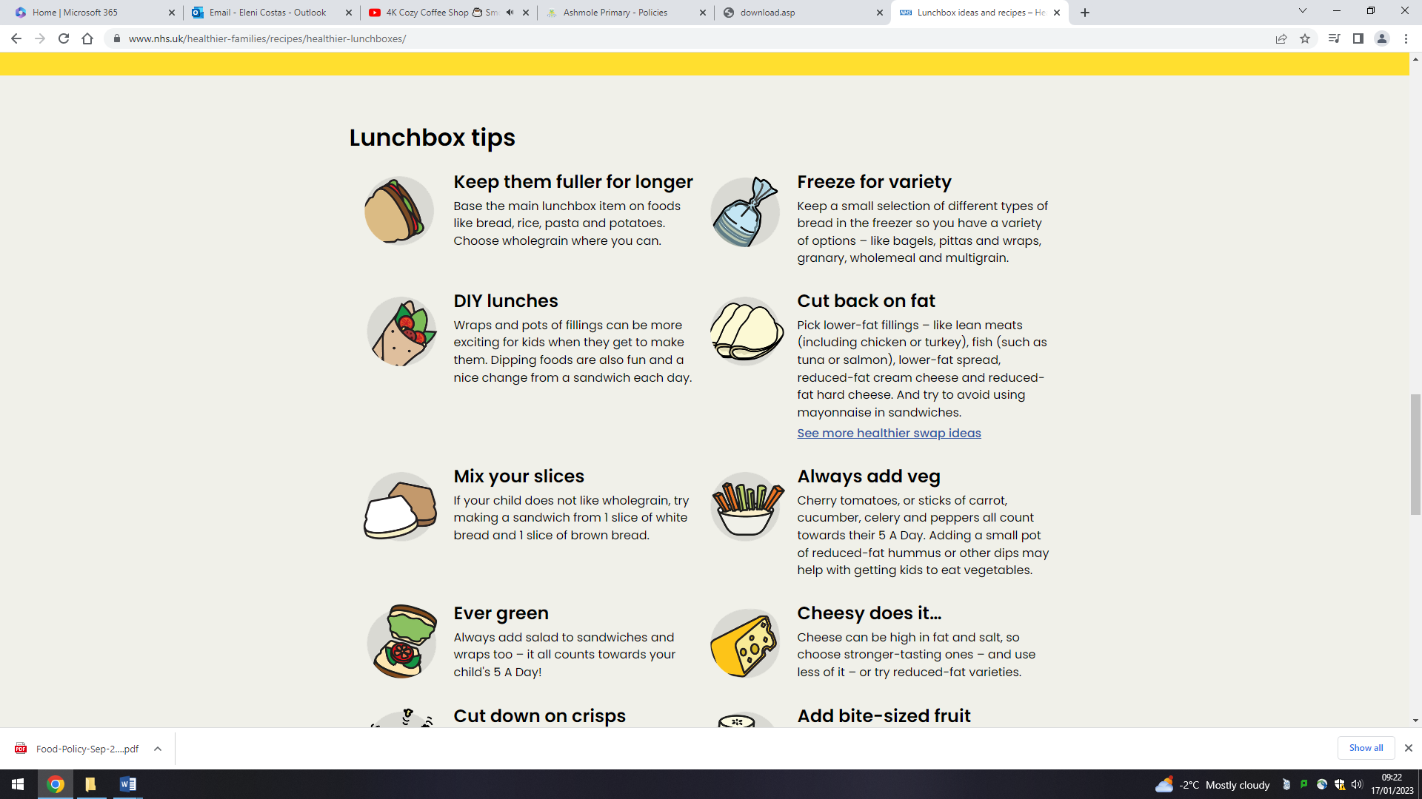
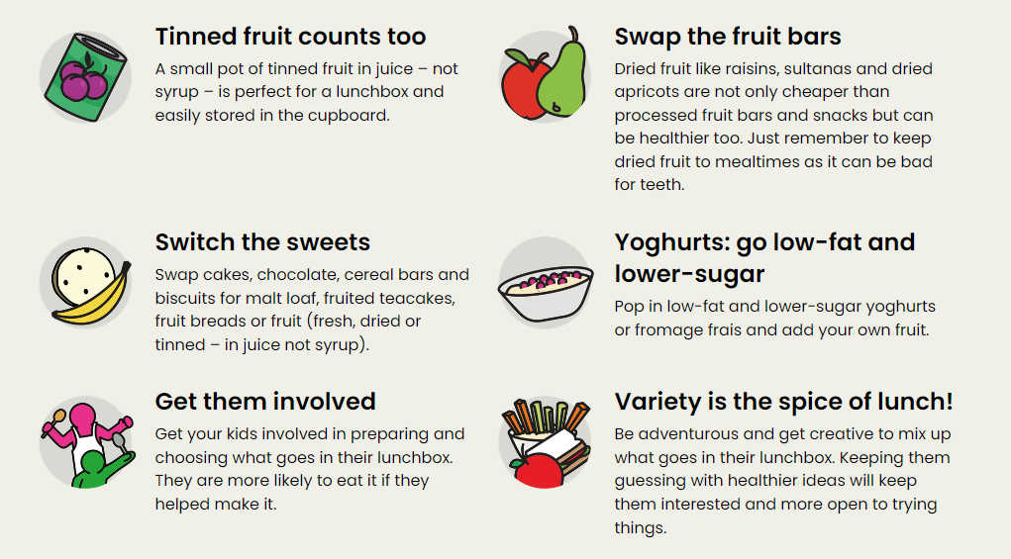

Some healthy swaps
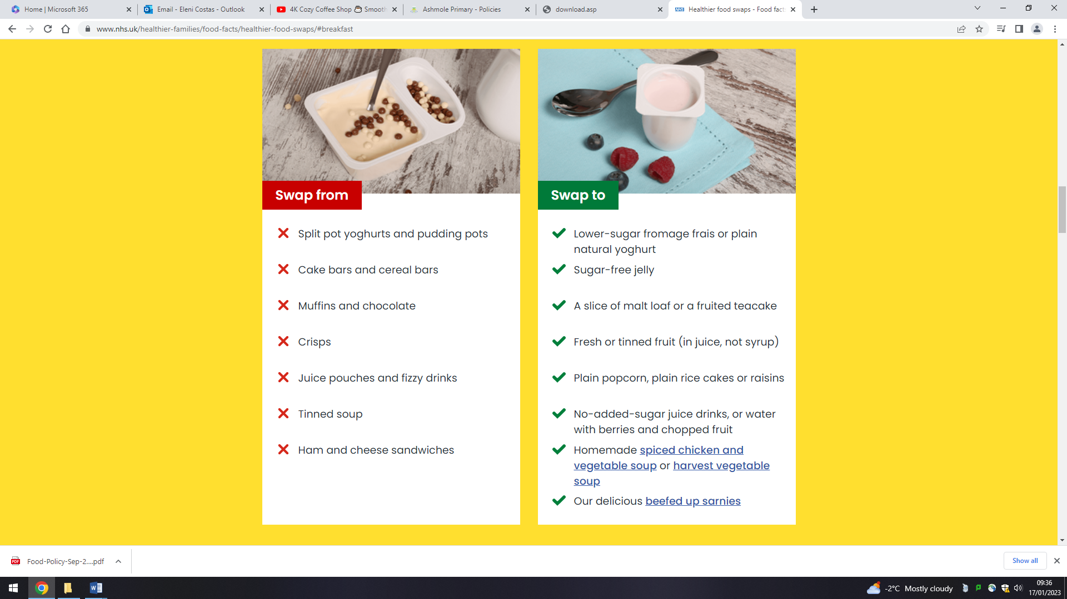

Healthy Lunchbox ideas
Cheesy coleslaw with  Wholemeal pitta  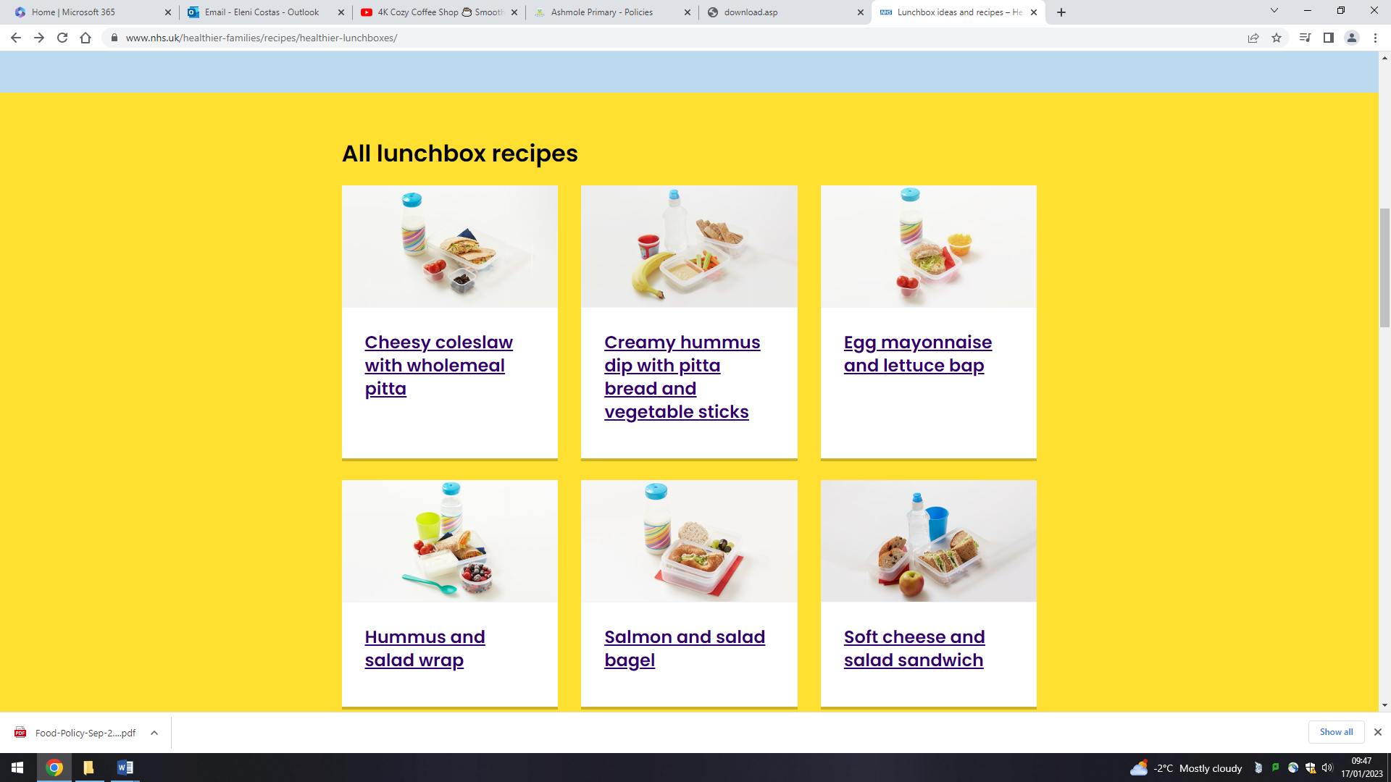 | Creamy hummus dip with pitta bread and vegetable sticks | Egg mayonnaise and lettuce bap
Hummus and salad wrap  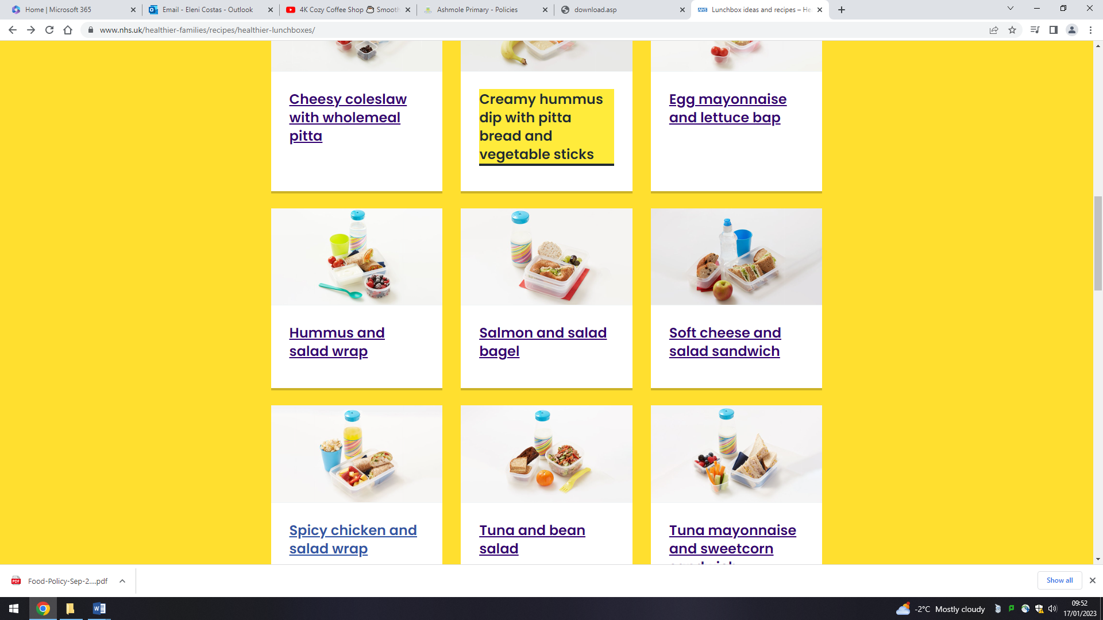 | Salmon and salad bagel | Soft cheese and salad sandwich
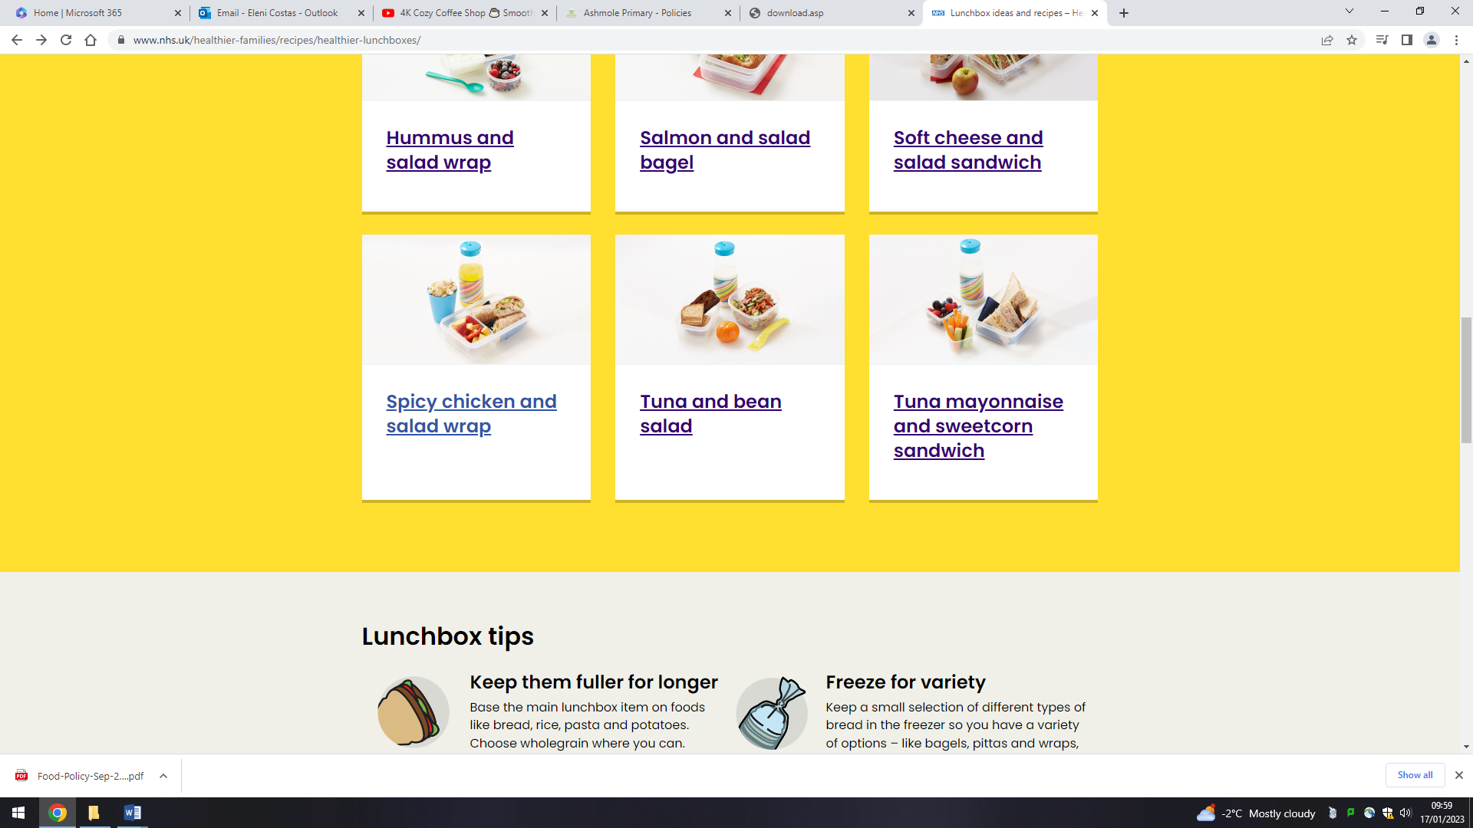  Spicy chicken and salad wrap | Tuna and bean salad | Tuna mayonnaise and sweetcorn salad

For more tips and ideas click on the link below! Always ensure that the recipes you select DO NOT contain nuts or seeds.
https://www.nhs.uk/healthier-families/recipes/healthier-lunchboxes/

